YEARS 3 / 4 DOJO HOMEWORK – SUMMER HALF TERM 1
Homework activities for this term are outlined below.
You will receive ‘Dojo Points’ for each task completed and at the end of term; your homework will be displayed in the hall for everyone to see.
If you complete all of the tasks, you will receive a homework celebration certificate and a bonus 10 dojo points!
All tasks need to be completed and returned by Thursday 23rd May.
HOMEWORK TASKS WORTH 1 DOJO POINT | HOMEWORK TASKS WORTH 3 DOJO POINTS | HOMEWORK TASKS WORTH 5 DOJO POINTS
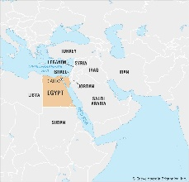  Geography: How long would it take you to get from the UK to Egypt? Plan your route including times and directions. | 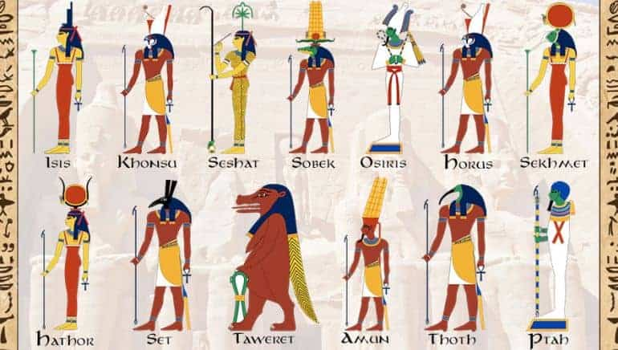  English: The ancient Egpytians believed in many different gods. Can you have a go at designing your own and writing about them? | 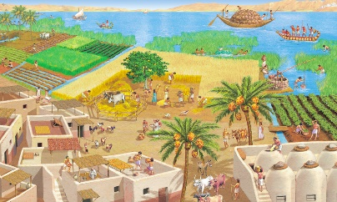  History: Imagine you lived in Ancient Egypt. Write a diary entry from the time. You can decide how wealthy you were. What do you eat? Do you have a job?
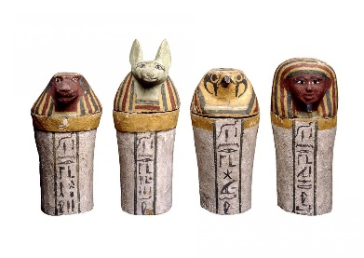  History: Have a look at these objects. What do you think they would have been used for and why? | Geography: Where did the Ancient Egyptians live? Research where most Ancient Egyptian settlements were located and add to a map of Egypt. | 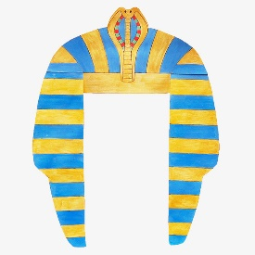  DT: The pharaohs were well known for their impressive headdresses. Can you have a go at making your own? Why not research colours and materials?

