1  MULTIPLICATION OLYMPICS | 9 X 7 |  | 30 | 6 x 9 |  | 59 | 9 X 4 |  | 88 | 8 x 3
2 | 8 x 4 |  | 31 | 12 x 3 |  | 60 | 7 x 6 |  | 89 | 8 x 7
3 | 7 x 10 |  | 32 | 3 x 8 |  | 61 | 4 x 8 |  | 90 | 0 x 0
4 | 9 x 9 |  | 33 | 8 X 8 |  | 62 | 12 X 2 |  | 91 | 4 x 1
5 | 6 x 2 |  | 34 | 6 x 8 |  | 63 | 3 x 6 |  | 92 | 11 X 3
6 | 4 x 7 |  | 35 | 11 x 7 |  | 64 | 4 x 10 |  | 93 | 10 x 7
7 | 9 X 2 |  | 36 | 10 x 1 |  | 65 | 9 x 11 |  | 94 | 9 x 8
8 | 12 x 12 |  | 37 | 10 x 5 |  | 66 | 3 x 12 |  | 95 | 5 x 7
9 | 5 X 9 |  | 38 | 3 x 5 |  | 67 | 3 x 10 |  | 96 | 3 x 9
10 | 7 X 7 |  | 39 | 12 x 11 |  | 68 | 4 X 4 |  | 97 | 6 X 4
11 | 11 x 6 |  | 40 | 6 x 6 |  | 69 | 4 x 9 |  | 98 | 10 x 8
12 | 5 x 11 |  | 41 | 2 x 9 |  | 70 | 4 x 11 |  | 99 | 7 x 5
13 | 4 x 6 |  | 42 | 12 x 7 |  | 71 | 6 x 5 |  | 100 | 12 X 5
14 | 9 x 5 |  | 43 | 11 x 8 |  | 72 | 7 x 2
15 | 8 X 12 |  | 44 | 2 x 6 |  | 73 | 5 x 12 | 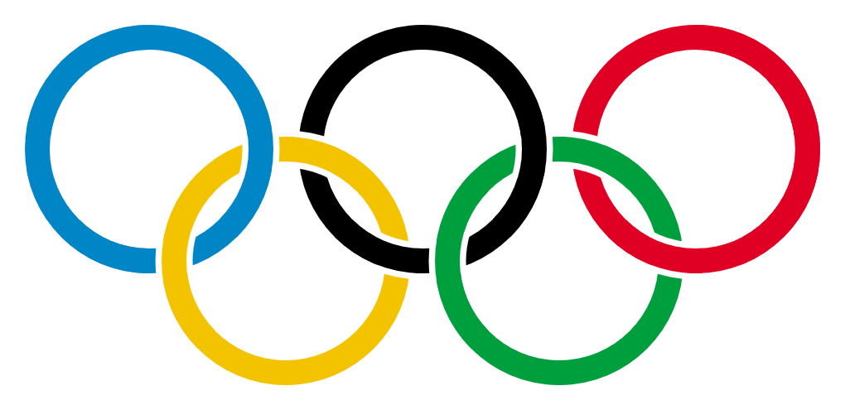  Name  Date  Time  Score
16 | 10 x 10 |  | 45 | 4 x 5 |  | 74 | 2 x 10
17 | 7 x 3 |  | 46 | 4 x 9 |  | 75 | 4 x 12
18 | 5 x 8 |  | 47 | 8 x 2 |  | 76 | 7 x 8
19 | 3 x 3 |  | 48 | 7 x 9 |  | 77 | 6 x 10
20 | 10 x 11 |  | 49 | 12 x 8 |  | 78 | 12 x 6
21 | 11 x 2 |  | 50 | 9 X 4 |  | 79 | 7 x 12
22 | 2 x 7 |  | 51 | 5 X 5 |  | 80 | 2 X 2
23 | 6 x 12 |  | 52 | 10 x 12 |  | 81 | 11 x 0
24 | 5 x 7 |  | 53 | 8 x 11 |  | 82 | 2 x 12
25 | 10 x 6 |  | 54 | 4 x 3 |  | 83 | 2 X 4
26 | 9 x 12 |  | 55 | 2 x 5 |  | 84 | 8 x 5
27 | 5 x 4 |  | 56 | 5 x 10 |  | 85 | 7 x 11
28 | 11 x 11 |  | 57 | 9 x 3 |  | 86 | 9 x 6
29 | 7 x 4 |  | 58 | 8 x 10 |  | 87 | 10 x 11

