Rural Church Schools Academy Trust
Art

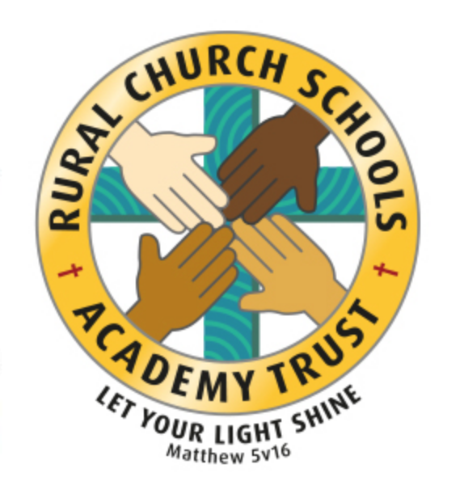

RCSAT Curriculum Overview

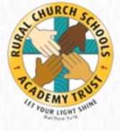
Curriculum Overview 2021

LET YOUR LIGHT SHINE Matthew v5:16

Article 29: Children’s education should develop each child’s personality, talents and abilities to the fullest. It should encourage children to respect others, human rights and their own and other cultures. It should also help them learn to live peacefully, protect the environment and respect other people.

Our Curriculum Policy details our intent behind our curriculum, how we implement it and our desired impact. At RCSAT, the school curriculum consists of all those activities designed or encouraged within its organisational framework to provide the intellectual, emotional, personal, social, spiritual and physical development of all its pupils. It includes not only the subject specific curriculum but also the ‘informal’ programme of enrichment and extra-curricular activities.
The curriculum at RCSAT, developed over a number of years, is firmly rooted in and stems directly from our Vision, Mission and Core Values;
Our Vision – ‘Let your Light shine’ Matthew v5:16
Our Mission – ‘A Caring Christian Family Where We Grow Together’
Our Core Values – WE aim to create an enjoyable, inclusive, safe and nurturing environment that allows all children to develop spiritually, morally and socially. – every child is a child of God, made to contribute to our world.
WE aim to create an inspiring environment, which encourages enthusiasm for lifelong learning and establishes an expectation of high standards – knowing the way, showing the way and going the way.
WE aim to encourage caring, sensitive and inclusive attitudes where individuals feel secure, valued and respected by others. – like Jesus showed us through his teachings

WE aim to provide a broad and connected curriculum which challenges and develops the potential of each child – as Jesus needed his disciples to support and guide, so we look to others with more knowledge

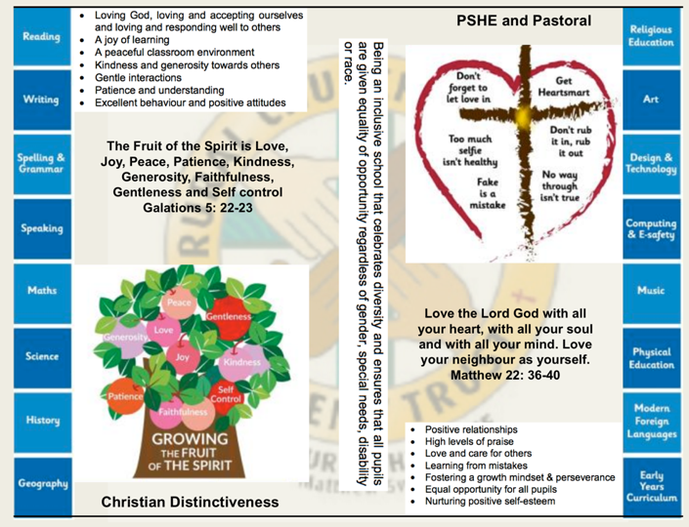
WE aim to develop a positive relationship between home, school and our wider community- as a family – as brothers and sisters.

The RCSAT curriculum is designed to
Embody - the Christian values we live by
Enable – all children to flourish in mind, body and spirit
Ensure – that all pupils are given the experiences to ‘Let their Light Shine.’

Intent:
The schools within RCSAT are strongly committed to helping our children grow and develop the skills required to be successful in life. Our curriculum is designed to promote every child’s individuality giving them the skills, knowledge and understanding to prepare them for the future. At RCSAT, our Connected Curriculum is planned around the development of Knowledge, Skills and Understanding. We ensure a curriculum that nurtures fascination and imagination and promotes an appreciation of creativity & individuality. One that also works in strong partnership with parents and carers to ensure high standards, engendering a strong sense of community, where all children and families are key to the delivery of a challenging, inspirational and innovative curriculum.
As a trust, we provide varied opportunities throughout their time with us, which promote independent, interactive and collaborative learning that builds on the children’s natural curiosity and eagerness to learn. We teach children to aspire to be the best possible version of themselves through our key drivers.
Our key drivers are:
- Inspirational and connected curriculum which instils a love of learning
- Curiosity and appreciation of God’s world through our Christian Values
- A culture of care for everyone in our community and in the world around us (RRSA, Global Learning, British Values)
- Aspiring to become the best person God created us to be – Let your light shine (Matthew 5:16)
Academic success comes through creativity and problem solving; responsibility and resilience, as well as physical development, well-being and mental health all being key elements in supporting the whole child through their learning journey.
Our curriculum also celebrates diversity and utilises the skills and knowledge of the community to enhance our curriculum while supporting the children’s emotional and spiritual development.
Implementation:
Our curriculum is driven by a desire to develop the whole child and therefore delivers much more than just the National Curriculum. Our connected curriculum provides opportunities for the children to learn about managing themselves, relationships and situations.
Our curriculum is not simply a set of encounters from which children form ad hoc memories; it is designed to be remembered in detail – to be stored in our children’s long-term memories so that they can later build on it, forming an ever wider and deeper pool of knowledge. Our curriculum is connected. It is planned vertically between year groups, horizontally within the academic year and diagonally to build on prior knowledge.
Autumn Term | Spring Term | Summer Term
History based enquiry | STEM based enquiry | Geography based enquiry

Our connected curriculum stems from a key question linked to a specific concept which then underpins the children’s learning. Knowledge around this concept is delivered through primary sources such as high-quality texts, music, art and technologies, enabling connections to be made across a range of National Curriculum subjects. Our teachers skillfully plan to ensure the children in their class experience a curriculum that inspires a love for learning.
Our curriculum is predominantly organised around rich and engaging, high-quality texts, making links and connecting to all curriculum areas where relevant. There is always an overarching text which connects the curriculum across the school. Beneath which sit key texts in each year group. Subject leads ensure progression and coverage of knowledge, skills and understanding are weaved into a meaningful and cohesive curriculum drawing in learning based on local, national and international events
Medium term plans outline the learning to take place for the term and are developed as mind maps using the phrases; As Artists, As Geographers, As Historians, As Writers, As Readers, As Mathematicians, As Musicians, As Programmers, As Designers, As Performers, As respectful, responsible citizens to frame ideas and concepts to be taught. The core basic skills of English and Maths are planned and delivered to reflect the National Curriculum 2014 changes and many elements of the new statutory orders are reflected in our practice.
We also feel that the following are necessary to support the implementation of our connected curriculum;
Learning Environment – We work hard to make sure that our learning environment supports the development of the whole child both inside, outside and beyond. Our classrooms are well organised and resourced allowing children to choose resources independently to support their learning.
Our outdoor areas have been developed to enhance our connected curriculum with developments such as: running paths, outdoor stage, mini woodland, outdoor reading provision, wilderness area and forest schools. This enables pupils to explore at break and lunch-times and gives teachers a range of resource to tap into to support teaching and learning at various points within the year.
Learning Partners – It is important that as a school we engage with external partner, locally, nationally and internationally to bring added dimensions to our curriculum offer. We partner with artists, musicians, coaches, poets, cultural organisations, engineers, other schools to bring expertise and difference to our curriculum offer. These may be short term projects over a few weeks or much longer endeavours. It is through these partnerships that we may light a spark of interest, enthusiasm and passion within our children that they may carry forward with them into their future lives and schooling.
New Pedagogies – As we continue to develop our curriculum, our approach to teaching and learning also develops. We take a blended learning approach where multiple disciplines will be touched upon within a lesson. It may be a ‘Science’ based lesson where problem solving, maths, literacy and art disciplines are enveloped within the taught session. Project based inquiry learning coupled with direct instruction ensure that our curriculum is relevant and provides children with opportunities to develop the skills of communication, collaboration, critical thinking, citizenship and creativity whilst also building their own character.
Impact:
Through our connected approach:
Our children will have the capacity to control and express their emotions, and handle interpersonal relationships whilst keeping themselves safe.
Our children will become confident and successful lifelong learners, demonstrating the Christian Values to ensuring they let their individual lights shine as they make the right choices about their learning.
Our curriculum has an ambition for high achievement of all pupils irrespective of their background or starting point.
Our curriculum promotes a love of learning.

The curriculum also includes those features which produce the school's ethos (i.e. the ‘hidden curriculum’) such as the quality of relationships and the values exemplified by the way the school sets about its task.
Our aim is to provide a curriculum which will firstly expand the pupil’s knowledge, experience and imaginative understanding, and thus his/her awareness of moral and Christian values and capacity for enjoyment, and secondly, enable the pupil to enter the world after formal education is over as an active participant in society and a responsible contributor to it, capable of achieving as much independence as possible.
There is an Act of Worship every day. Worship is a time where we come together to reflect on the school’s vision and to learn about the ‘person, love & work of Jesus’ which is central to the school’s vision and curriculum The daily Act of Worship promotes the Christian and Learning values which permeate the ethos of the school. As such, Worship is an essential part of the school day and the contributions of staff, pupils, clergy and other visitors are valued highly.

Art Curriculum: Educating for Wisdom, Knowledge and Skills

4

The Vocabulary, Knowledge and Skills for Art are delivered through the following topics and Curriculum content is taught across the year as shown:

Art Year A

Year Group | Autumn 1 | Autumn 2 | Spring 1 | Spring 2 | Summer 1 | Summer 2
Year 1/ 2 | Self portraits- sketching, pastels | Giuseppe Archimboldo- fruit portraits | Paint and colour mixing  Piet Mondrian- primary colours/shape | Changing materials- clay and charcoal art | Patterns/ prints/ textiles  Traditional African print
Year 3/ 4 | Features of art from history- Mosaics |  | Sketching- portraits  Hilma af Klint (Female Swedish artist) |  | Painting- Brush techniques and washes
Year 5/ 6 | Using different tools and techniques to represent Herbert St John Jones Art- Nantwich buidings. Watrcolours/ oils |  | Using line, tone, shape and colour to show movement. Godalming Postcards- line and shadow |  | Printing using a criteria – Ancient Eygptian tomb printing
Year Group | Autumn 1 |  | Autumn 2 |  | Spring 1 | Spring 2 |  | Summer 1 |  | Summer 2
Year 1/ 2 | Sketching- thick and thin lines and shading  Wallisy Kandinsky-lines and shapes |  |  | Notable artists- Van Gogh sunflowers  Pastels/ viewfinders |  |  | Sculpture cut, roll, coil |  | Create moods- paint/ collage rip and tear  Henri Matisse collage/Hokusai waves
Year 3/ 4 | Historical art- cave paintings | Clay- sculpture |  | Drawing and painting techniques- compare artists  J.S Lowry /Leonardo Di Vinci |  |  | Digital images/  impressionism –Monet. Garden/ water/ reflection
Year 5/ 6 | Art from history- WW2 Ethel  Leontine Gabain |  |  | Oil pastels, acrylic- space art  Peter Thorpe- modern artst |  |  | Watercolours- natural pallet  Henri Rousseau

Art Year B

Why is Art Important?
Art, craft and design stimulates creativity and imagination. It provides visual, tactile and sensory experiences and a unique way of understanding and responding to the world. Pupils use colour, form, texture, pattern and different materials and processes to communicate what they see, feel and think. Through art and design activities, they learn to make informed value judgements and aesthetic and practical decisions, becoming actively involved in shaping environments. They explore ideas and meanings in the work of artists, craftspeople and designers. They learn about the diverse roles and functions of art, craft and design in contemporary life, and in different times and cultures. Understanding, appreciation and enjoyment of the visual arts have the power to enrich our personal and public lives.

RCSAT’s Vision for Art

On completion of the art curriculum at RCSAT, pupils will have developed:
- The ability to use art vocabulary (for example line, shape, pattern, colour, texture, form) to talk about their own work and that of others.
- Experience of using a range of art materials and tools, e.g. textiles, acrylic, clay, pastel, collage, pencil.
- Experience of using a computer to create and manipulate artwork.
- The ability to draw and paint from observation and imagination.
- A knowledge and understanding of other artists and designers.
- The ability to select and use materials, tools and techniques to create a range of 2D and 3D artwork.
- The ability to reflect on and evaluate their own work and that of others.
- Enjoyment of art.

National Curriculum for Art

Key stage 1

Pupils should be taught:
- to use a range of materials creatively to design and make products
- to use drawing, painting and sculpture to develop and share their ideas, experiences and imagination
- to develop a wide range of art and design techniques in using colour, pattern, texture, line, shape, form and space
- about the work of a range of artists, craft makers and designers, describing the differences and similarities between different practices and disciplines, and making links to their own work.

Key stage 2

Pupils should be taught to develop their techniques, including their control and their use of materials, with creativity, experimentation and an increasing awareness of different kinds of art, craft and design.
Pupils should be taught:
- to create sketch books to record their observations and use them to review and revisit ideas
- to improve their mastery of art and design techniques, including drawing, painting and sculpture with a range of materials [for example, pencil, charcoal, paint, clay]
- about great artists, architects and designers in history

A Year 1 Artist at RCSAT

  - I can show how people feel in paintings and drawings.
  - I can create moods in art work.
  - I can use pencils to create lines of different thickness in drawings.
  - I can name the primary and secondary colours.
  - I can create a repeating pattern in print.
  - I can cut, roll and coil materials.
  - I can create a printed piece of art by pressing, rolling, rubbing and stamping.
  - I can make a clay pot.
  - I can join two clay finger pots together.
  - I can use IT to create a picture.
  - I can describe what I can see and give an opinion about the work of an artist.
  - I can ask questions about a piece of art.

A Year 2 Artist at RCSAT

- I can choose and use three different grades of pencil when drawing.
- I can use charcoal, pencil and pastel to create art.
- I can use a viewfinder to focus on a specific part of an artefact before drawing it.
- I can mix paint to create all the secondary colours.
- I can create brown with paint.
- I can create tints with paint by adding white.
- I can create tones with paint by adding black.
- I can use different effects within an IT paint package.
- I can suggest how artists have used colour, pattern and shape.
- I can create a piece of art in response to the work of another artist.

A Year 3 Artist at RCSAT

- I can show facial expressions in my art.
- I can use sketches to produce a final piece of art.
- I can use different grades of pencil to shade and to show different tones and textures.
- I can create a background using a wash.
- I can use a range of brushes to create different effects in painting.
- I can identify the techniques used by different artists.
- I can use digital images and combine with other media in my art.
- I can use IT to create art which includes my own work and that of others.
- I can compare the work of different artists.
- I recognise when art is from different cultures.
- I recognise when art is from different historical periods.

A Year 4 Artist at RCSAT

- I can show facial expressions and body language in sketches and paintings.
- I can use marks and lines to show texture in my art.
- I can use line, tone, shape and colour to represent figure and forms in movement.
- I can show reflections in my art.
- I can print onto different materials using at least four colours.
- I can sculpt clay and other mouldable materials.
- I can integrate my digital images into my art.
- I can experiment with the styles used by other artists.
- I can explain some of the features of art from historical periods.

A Year 5 Artist at RCSAT

- I can identify and draw objects and use marks and lines to produce texture.
- I can successfully use shading to create mood and feeling.
- I can organise line, tone, shape and colour to represent figures and forms in movement.
- I can express emotion in my art.
- I can create an accurate print design following criteria.
- I can use images which I have created, scanned and found; altering them where necessary to create art.
- I can research the work of an artist and use their work to replicate a style.

A Year 6 Artist at RCSAT

- I can explain why I have used different tools to create art.
- I can explain why I have chosen specific techniques to create my art.
- I can explain the style of my work and how it has been influenced by a famous artist.
- I can over print to create different patterns.
- I can use feedback to make amendments and improvement to my art.
- I can use a range of e-resources to create art.

