Rural Church Schools Academy Trust
Design

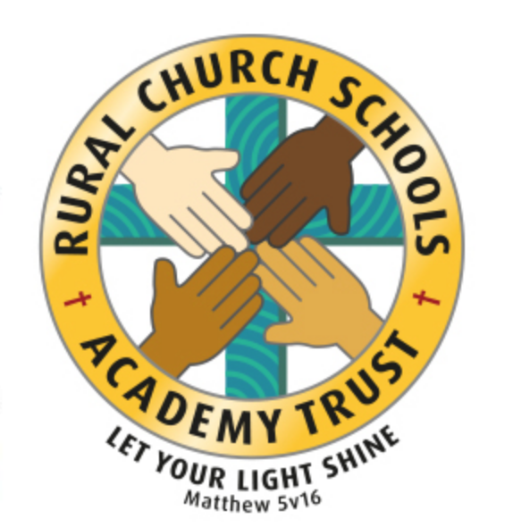

RCSAT Curriculum Overview

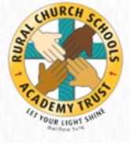
Curriculum Overview 2021

LET YOUR LIGHT SHINE Matthew v5:16

Article 29: Children’s education should develop each child’s personality, talents and abilities to the fullest. It should encourage children to respect others, human rights and their own and other cultures. It should also help them learn to live peacefully, protect the environment and respect other people.

Our Curriculum Policy details our intent behind our curriculum, how we implement it and our desired impact. At RCSAT, the school curriculum consists of all those activities designed or encouraged within its organisational framework to provide the intellectual, emotional, personal, social, spiritual and physical development of all its pupils. It includes not only the subject specific curriculum but also the ‘informal’ programme of enrichment and extra-curricular activities.
The curriculum at RCSAT, developed over a number of years, is firmly rooted in and stems directly from our Vision, Mission and Core Values;
Our Vision – ‘Let your Light shine’ Matthew v5:16
Our Mission – ‘A Caring Christian Family Where We Grow Together’
Our Core Values – WE aim to create an enjoyable, inclusive, safe and nurturing environment that allows all children to develop spiritually, morally and socially. – every child is a child of God, made to contribute to our world.
WE aim to create an inspiring environment, which encourages enthusiasm for lifelong learning and establishes an expectation of high standards – knowing the way, showing the way and going the way.
WE aim to encourage caring, sensitive and inclusive attitudes where individuals feel secure, valued and respected by others. – like Jesus showed us through his teachings

WE aim to provide a broad and connected curriculum which challenges and develops the potential of each child – as Jesus needed his disciples to support and guide, so we look to others with more knowledge

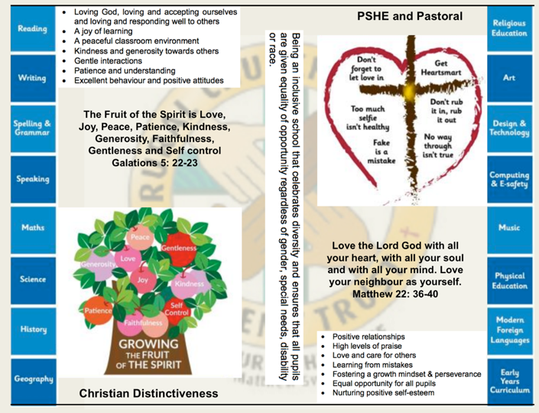
WE aim to develop a positive relationship between home, school and our wider community- as a family – as brothers and sisters.

The RCSAT curriculum is designed to
Embody - the Christian values we live by
Enable – all children to flourish in mind, body and spirit
Ensure – that all pupils are given the experiences to ‘Let their Light Shine.’

Intent:
The schools within RCSAT are strongly committed to helping our children grow and develop the skills required to be successful in life. Our curriculum is designed to promote every child’s individuality giving them the skills, knowledge and understanding to prepare them for the future. At RCSAT, our Connected Curriculum is planned around the development of Knowledge, Skills and Understanding. We ensure a curriculum that nurtures fascination and imagination and promotes an appreciation of creativity & individuality. One that also works in strong partnership with parents and carers to ensure high standards, engendering a strong sense of community, where all children and families are key to the delivery of a challenging, inspirational and innovative curriculum.
As a trust, we provide varied opportunities throughout their time with us, which promote independent, interactive and collaborative learning that builds on the children’s natural curiosity and eagerness to learn. We teach children to aspire to be the best possible version of themselves through our key drivers.
Our key drivers are:
- Inspirational and connected curriculum which instils a love of learning
- Curiosity and appreciation of God’s world through our Christian Values
- A culture of care for everyone in our community and in the world around us (RRSA, Global Learning, British Values)
- Aspiring to become the best person God created us to be – Let your light shine (Matthew 5:16)
Academic success comes through creativity and problem solving; responsibility and resilience, as well as physical development, well-being and mental health all being key elements in supporting the whole child through their learning journey.
Our curriculum also celebrates diversity and utilises the skills and knowledge of the community to enhance our curriculum while supporting the children’s emotional and spiritual development.
Implementation:
Our curriculum is driven by a desire to develop the whole child and therefore delivers much more than just the National Curriculum. Our connected curriculum provides opportunities for the children to learn about managing themselves, relationships and situations.
Our curriculum is not simply a set of encounters from which children form ad hoc memories; it is designed to be remembered in detail – to be stored in our children’s long-term memories so that they can later build on it, forming an ever wider and deeper pool of knowledge. Our curriculum is connected. It is planned vertically between year groups, horizontally within the academic year and diagonally to build on prior knowledge.
Autumn Term | Spring Term | Summer Term
History based enquiry | STEM based enquiry | Geography based enquiry

Our connected curriculum stems from a key question linked to a specific concept which then underpins the children’s learning. Knowledge around this concept is delivered through primary sources such as high-quality texts, music, art and technologies, enabling connections to be made across a range of National Curriculum subjects. Our teachers skillfully plan to ensure the children in their class experience a curriculum that inspires a love for learning.
Our curriculum is predominantly organised around rich and engaging, high-quality texts, making links and connecting to all curriculum areas where relevant. There is always an overarching text which connects the curriculum across the school. Beneath which sit key texts in each year group. Subject leads ensure progression and coverage of knowledge, skills and understanding are weaved into a meaningful and cohesive curriculum drawing in learning based on local, national and international events
Medium term plans outline the learning to take place for the term and are developed as mind maps using the phrases; As Artists, As Geographers, As Historians, As Writers, As Readers, As Mathematicians, As Musicians, As Programmers, As Designers, As Performers, As respectful, responsible citizens to frame ideas and concepts to be taught. The core basic skills of English and Maths are planned and delivered to reflect the National Curriculum 2014 changes and many elements of the new statutory orders are reflected in our practice.
We also feel that the following are necessary to support the implementation of our connected curriculum;
Learning Environment – We work hard to make sure that our learning environment supports the development of the whole child both inside, outside and beyond. Our classrooms are well organised and resourced allowing children to choose resources independently to support their learning.
Our outdoor areas have been developed to enhance our connected curriculum with developments such as: running paths, outdoor stage, mini woodland, outdoor reading provision, wilderness area and forest schools. This enables pupils to explore at break and lunch-times and gives teachers a range of resource to tap into to support teaching and learning at various points within the year.
Learning Partners – It is important that as a school we engage with external partner, locally, nationally and internationally to bring added dimensions to our curriculum offer. We partner with artists, musicians, coaches, poets, cultural organisations, engineers, other schools to bring expertise and difference to our curriculum offer. These may be short term projects over a few weeks or much longer endeavours. It is through these partnerships that we may light a spark of interest, enthusiasm and passion within our children that they may carry forward with them into their future lives and schooling.
New Pedagogies – As we continue to develop our curriculum, our approach to teaching and learning also develops. We take a blended learning approach where multiple disciplines will be touched upon within a lesson. It may be a ‘Science’ based lesson where problem solving, maths, literacy and art disciplines are enveloped within the taught session. Project based inquiry learning coupled with direct instruction ensure that our curriculum is relevant and provides children with opportunities to develop the skills of communication, collaboration, critical thinking, citizenship and creativity whilst also building their own character.
Impact:
Through our connected approach:
Our children will have the capacity to control and express their emotions, and handle interpersonal relationships whilst keeping themselves safe.
Our children will become confident and successful lifelong learners, demonstrating the Christian Values to ensuring they let their individual lights shine as they make the right choices about their learning.
Our curriculum has an ambition for high achievement of all pupils irrespective of their background or starting point.
Our curriculum promotes a love of learning.

The curriculum also includes those features which produce the school's ethos (i.e. the ‘hidden curriculum’) such as the quality of relationships and the values exemplified by the way the school sets about its task.
Our aim is to provide a curriculum which will firstly expand the pupil’s knowledge, experience and imaginative understanding, and thus his/her awareness of moral and Christian values and capacity for enjoyment, and secondly, enable the pupil to enter the world after formal education is over as an active participant in society and a responsible contributor to it, capable of achieving as much independence as possible.
There is an Act of Worship every day. Worship is a time where we come together to reflect on the school’s vision and to learn about the ‘person, love & work of Jesus’ which is central to the school’s vision and curriculum The daily Act of Worship promotes the Christian and Learning values which permeate the ethos of the school. As such, Worship is an essential part of the school day and the contributions of staff, pupils, clergy and other visitors are valued highly.

Designer Curriculum: Educating for Wisdom, Knowledge and Skills

4

Design

The Vocabulary, Knowledge and Skills for Design are delivered through the following topics and Curriculum content is taught across the year as shown:

Design Year A
Year Group | Autumn 1 | Autumn 2 | Spring 1 | Spring 2 | Summer 1 | Summer 2
Year 1/ 2 | Healthy fruit/ vegetable salad  Safe cutting and peeling | Moving toys  Sock puppets- simple stitch | Own invention- recycling | Baking- measuring | Animal slider/ lever | Den building- Making a model stronger
Year 3/ 4 | Food- pizza  Hygiene, kitchen safety, describe how ingredients come together |  | Viking longboat  Measure/ cut/make holes |  | Textile habitats- running and cross stitch
Year 5/ 6 | Textiles- joining fabrics to make a cushion. Running, cross stitch, blanket stitch |  | Electrical mechanisms- carousels |  | Egyptian shaduf levers

Design Year B

Year Group | Autumn 1 | Autumn 2 | Spring 1 | Spring 2 | Summer 1 | Summer 2
Year 1/ 2 | Transport- wheels and axels |  | Castles and drawbridges-making models stronger |  | Boats-join materials in different ways
Year 3/ 4 | Textiles- choose for suitability and appearance- weaving |  | Design make and evaluate- lever model arm. Present products in interesting way |  | Design make, adapt and evaluate-bridges
Year 5/ 6 | Food technology- rations  Hygiene, kitchen safety |  | Design Easter Eggs  Market research |  | Mechanisms- pulley systems

Why is Design & Technology Important?
Design and technology prepare pupils to participate in tomorrow’s rapidly changing technologies. They learn to think and intervene creatively to improve quality of life. The subject calls for pupils to become autonomous and creative problem solvers, as individuals and members of a team. They must look for needs, wants and opportunities and respond to them by developing a range of ideas and making products and systems. They combine practical skills with an understanding of aesthetics, social and environmental issues, function and industrial practices. As they do so, they reflect on and evaluate present and past design and technology, its uses and effects. Through design and technology, all pupils can become discriminating and informed users of products, and become innovators.

RCSAT’s Vision for Design & Technology

On completion of the Design & Technology curriculum at RCSAT, pupils will have developed:
- Experience of using their imagination to design and make products that solve real and relevant problems.
- The ability to work constructively and productively with others.
- The ability to carry out research, show initiative and ask questions to understand a user’s needs.
- A good knowledge of which tools, equipment and materials to use to make their products and how to use them responsibly and safely.
- A knowledge of important inventors and their inventions and how they have improved people’s lives.
- An enjoyment for design and technology

National Curriculum for Design & Technology

The National Curriculum for Design & Technology at Key Stages 1 and 2 can be downloaded from the ‘Curriculum’ tab of the school website.

A Year 1 Designer at RCSAT

- I can use my own ideas to make something.
- I can describe how something works.
- I can cut food safely.
- I can make a product which moves.
- I can make my model stronger.
- I can explain to someone else how I want to make my product.
- I can choose appropriate resources and tools.
- I can make a simple plan before making.

A Year 2 Designer at RCSAT

- I can think of an idea and plan what to do next.
- I can choose tools and materials and explain why I have chosen them.
- I can join materials and components in different ways.
- I can explain what went well with my work.
- I can use different textiles and explain why I have chosen them
- I can measure materials to use in a model or structure.
- I can describe the ingredients I am using when preparing food.

A Year 3 Designer at RCSAT

- I can prove that my design meets some set criteria.
- I can follow a step-by-step plan, choosing the right equipment and materials.
- I can design a product and make sure that it looks attractive.
- I can choose a textile for both its suitability and its appearance.
- I can select the most appropriate tools and techniques for a given task.
- I can make a product which uses both electrical and mechanical components.
- I can work accurately to measure, make cuts and make holes.
- I can describe how food ingredients come together.

A Year 4 Designer at RCSAT

- I can use ideas from other people when I am designing.
- I can produce a plan and explain it.
- I can evaluate and suggest improvements for my designs.
- I can evaluate products for both their purpose and appearance.
- I can explain how I have improved my original design.
- I can present a product in an interesting way.
- I can measure accurately.
- I can persevere and adapt my work when my original ideas do not work.
- I know how to be both hygienic and safe when using food.

A Year 5 Designer at RCSAT

- I can come up with a range of ideas after collecting information from different sources.
- I can produce a detailed, step-by-step plan.
- I can suggest alternative plans; outlining the positive features and draw backs.
- I can explain how a product will appeal to a specific audience.
- I can evaluate appearance and function against original criteria.
- I can use a range of tools and equipment competently.
- I can make a prototype before make a final version.
- I show that I can be both hygienic and safe in the kitchen.

A Year 6 Designer at RCSAT

- I can use market research to inform my plans and ideas.
- I can follow and refine my plans.
- I can justify my plans in a convincing way.
- I can show that I consider culture and society in my plans and designs.
- I show that I can test and evaluate my products.
- I can explain how products should be stored and give reasons.
- I can evaluate my product against

