Rural Church Schools Academy Trust
History

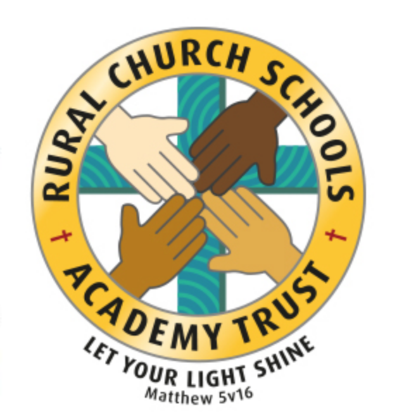

RCSAT Curriculum Overview

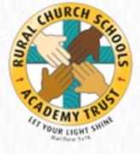
Curriculum Overview 2021

LET YOUR LIGHT SHINE Matthew v5:16

Article 29: Children’s education should develop each child’s personality, talents and abilities to the fullest. It should encourage children to respect others, human rights and their own and other cultures. It should also help them learn to live peacefully, protect the environment and respect other people.

Our Curriculum Policy details our intent behind our curriculum, how we implement it and our desired impact. At RCSAT, the school curriculum consists of all those activities designed or encouraged within its organisational framework to provide the intellectual, emotional, personal, social, spiritual and physical development of all its pupils. It includes not only the subject specific curriculum but also the ‘informal’ programme of enrichment and extra-curricular activities.
The curriculum at RCSAT, developed over a number of years, is firmly rooted in and stems directly from our Vision, Mission and Core Values;
Our Vision – ‘Let your Light shine’ Matthew v5:16
Our Mission – ‘A Caring Christian Family Where We Grow Together’
Our Core Values – WE aim to create an enjoyable, inclusive, safe and nurturing environment that allows all children to develop spiritually, morally and socially. – every child is a child of God, made to contribute to our world.
WE aim to create an inspiring environment, which encourages enthusiasm for lifelong learning and establishes an expectation of high standards – knowing the way, showing the way and going the way.
WE aim to encourage caring, sensitive and inclusive attitudes where individuals feel secure, valued and respected by others. – like Jesus showed us through his teachings

WE aim to provide a broad and connected curriculum which challenges and develops the potential of each child – as Jesus needed his disciples to support and guide, so we look to others with more knowledge

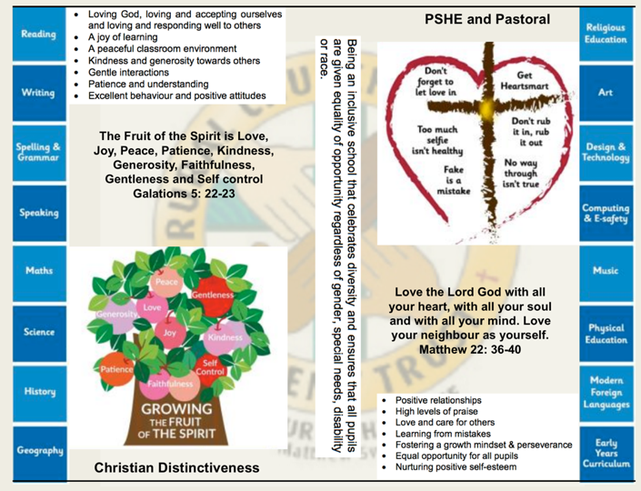
WE aim to develop a positive relationship between home, school and our wider community- as a family – as brothers and sisters.

The RCSAT curriculum is designed to
Embody - the Christian values we live by
Enable – all children to flourish in mind, body and spirit
Ensure – that all pupils are given the experiences to ‘Let their Light Shine.’

Intent:
The schools within RCSAT are strongly committed to helping our children grow and develop the skills required to be successful in life. Our curriculum is designed to promote every child’s individuality giving them the skills, knowledge and understanding to prepare them for the future. At RCSAT, our Connected Curriculum is planned around the development of Knowledge, Skills and Understanding. We ensure a curriculum that nurtures fascination and imagination and promotes an appreciation of creativity & individuality. One that also works in strong partnership with parents and carers to ensure high standards, engendering a strong sense of community, where all children and families are key to the delivery of a challenging, inspirational and innovative curriculum.
As a trust, we provide varied opportunities throughout their time with us, which promote independent, interactive and collaborative learning that builds on the children’s natural curiosity and eagerness to learn. We teach children to aspire to be the best possible version of themselves through our key drivers.
Our key drivers are:
- Inspirational and connected curriculum which instils a love of learning
- Curiosity and appreciation of God’s world through our Christian Values
- A culture of care for everyone in our community and in the world around us (RRSA, Global Learning, British Values)
- Aspiring to become the best person God created us to be – Let your light shine (Matthew 5:16)
Academic success comes through creativity and problem solving; responsibility and resilience, as well as physical development, well-being and mental health all being key elements in supporting the whole child through their learning journey.
Our curriculum also celebrates diversity and utilises the skills and knowledge of the community to enhance our curriculum while supporting the children’s emotional and spiritual development.
Implementation:
Our curriculum is driven by a desire to develop the whole child and therefore delivers much more than just the National Curriculum. Our connected curriculum provides opportunities for the children to learn about managing themselves, relationships and situations.
Our curriculum is not simply a set of encounters from which children form ad hoc memories; it is designed to be remembered in detail – to be stored in our children’s long-term memories so that they can later build on it, forming an ever wider and deeper pool of knowledge. Our curriculum is connected. It is planned vertically between year groups, horizontally within the academic year and diagonally to build on prior knowledge.
Autumn Term | Spring Term | Summer Term
History based enquiry | STEM based enquiry | Geography based enquiry

Our connected curriculum stems from a key question linked to a specific concept which then underpins the children’s learning. Knowledge around this concept is delivered through primary sources such as high-quality texts, music, art and technologies, enabling connections to be made across a range of National Curriculum subjects. Our teachers skillfully plan to ensure the children in their class experience a curriculum that inspires a love for learning.
Our curriculum is predominantly organised around rich and engaging, high-quality texts, making links and connecting to all curriculum areas where relevant. There is always an overarching text which connects the curriculum across the school. Beneath which sit key texts in each year group. Subject leads ensure progression and coverage of knowledge, skills and understanding are weaved into a meaningful and cohesive curriculum drawing in learning based on local, national and international events
Medium term plans outline the learning to take place for the term and are developed as mind maps using the phrases; As Artists, As Geographers, As Historians, As Writers, As Readers, As Mathematicians, As Musicians, As Programmers, As Designers, As Performers, As respectful, responsible citizens to frame ideas and concepts to be taught. The core basic skills of English and Maths are planned and delivered to reflect the National Curriculum 2014 changes and many elements of the new statutory orders are reflected in our practice.
We also feel that the following are necessary to support the implementation of our connected curriculum;
Learning Environment – We work hard to make sure that our learning environment supports the development of the whole child both inside, outside and beyond. Our classrooms are well organised and resourced allowing children to choose resources independently to support their learning.
Our outdoor areas have been developed to enhance our connected curriculum with developments such as: running paths, outdoor stage, mini woodland, outdoor reading provision, wilderness area and forest schools. This enables pupils to explore at break and lunch-times and gives teachers a range of resource to tap into to support teaching and learning at various points within the year.
Learning Partners – It is important that as a school we engage with external partner, locally, nationally and internationally to bring added dimensions to our curriculum offer. We partner with artists, musicians, coaches, poets, cultural organisations, engineers, other schools to bring expertise and difference to our curriculum offer. These may be short term projects over a few weeks or much longer endeavours. It is through these partnerships that we may light a spark of interest, enthusiasm and passion within our children that they may carry forward with them into their future lives and schooling.
New Pedagogies – As we continue to develop our curriculum, our approach to teaching and learning also develops. We take a blended learning approach where multiple disciplines will be touched upon within a lesson. It may be a ‘Science’ based lesson where problem solving, maths, literacy and art disciplines are enveloped within the taught session. Project based inquiry learning coupled with direct instruction ensure that our curriculum is relevant and provides children with opportunities to develop the skills of communication, collaboration, critical thinking, citizenship and creativity whilst also building their own character.
Impact:
Through our connected approach:
Our children will have the capacity to control and express their emotions, and handle interpersonal relationships whilst keeping themselves safe.
Our children will become confident and successful lifelong learners, demonstrating the Christian Values to ensuring they let their individual lights shine as they make the right choices about their learning.
Our curriculum has an ambition for high achievement of all pupils irrespective of their background or starting point.
Our curriculum promotes a love of learning.

The curriculum also includes those features which produce the school's ethos (i.e. the ‘hidden curriculum’) such as the quality of relationships and the values exemplified by the way the school sets about its task.
Our aim is to provide a curriculum which will firstly expand the pupil’s knowledge, experience and imaginative understanding, and thus his/her awareness of moral and Christian values and capacity for enjoyment, and secondly, enable the pupil to enter the world after formal education is over as an active participant in society and a responsible contributor to it, capable of achieving as much independence as possible.
There is an Act of Worship every day. Worship is a time where we come together to reflect on the school’s vision and to learn about the ‘person, love & work of Jesus’ which is central to the school’s vision and curriculum The daily Act of Worship promotes the Christian and Learning values which permeate the ethos of the school. As such, Worship is an essential part of the school day and the contributions of staff, pupils, clergy and other visitors are valued highly.

History Curriculum: Educating for Wisdom, Knowledge and Skills

4

The Vocabulary, Knowledge and Skills for History are delivered through the following topics and Curriculum content is taught across the year as shown:

History Year A
Year Group | Autumn 1 | Autumn 2 | Spring 1 | Spring 2 | Summer 1 |  | Summer 2
Year 1/ 2 | Victorian child  (toys/ objects) | Person- Florence Nightingale | Inventors from the past  (linked to materials) |  | Person and event- Nelson Mandela | Person- David Attenborough  (History of conservation)
Year 3/ 4 | Romans |  | Vikings |  | Ancient Greece
Year 5/ 6 | Local history study  Great fire of Nantwich/ architecture/ trade |  | Victorians  Monarchs and significant turning point in time- electricity |  | Ancient Egypt

History Year B

Year Group | Autumn 1 | Autumn 2 | Spring 1 | Spring 2 | Summer 1 | Summer 2
Year 1/ 2 | Transport from the past- first plane flight/ cars | Event- First space travel | Local history study  Beeston Castle |  | People and events- Seafarers from the past
Year 3/ 4 | Stone age to iron age |  | History of Chester zoo |  | Local history study  River Weaver/ canals/ salt trade
Year 5/ 6 | Significant event in history- World War 2 |  | The Mayans |  | The Inca Empire

Why is History Important?

History fires pupils’ curiosity about the past in Britain and the wider world. Pupils consider how the past influences the present, what past societies were like, how these societies organised their politics, and what beliefs and cultures influenced people’s actions. As they do this, pupils develop a chronological framework for their knowledge of significant events and people. They see the diversity of human experience, and understand more about themselves as individuals and members of society. What they learn can influence their decisions about personal choices, attitudes and values.

In history, pupils find evidence, weigh it up and reach their own conclusions. To do this they need to be able to research, sift through evidence, and argue for their point of view – skills that are prized in adult life.

RCSATs Vision for History

On completion of the History curriculum at RCSAT, pupils will have developed:
- A good knowledge and understanding of people and events from a range of historical periods.
- The ability to think carefully about history and communicate their ideas to an audience.
- The ability to use historical sources and evidence and make use of it to support their explanations.
- The ability to reflect upon, discuss and evaluate the past.
- An enthusiasm for history which develops their sense of curiosity about the past.
- An ability to recognise the impact of history on today and consider how we can learn from it

A Year 1 Historian at RCSAT

  - I can use words and phrases like: old, new and a long time ago.
  - I can recognise that some objects belonged to the past.
  - I can explain how I have changed since I was born.
  - I can explain how some people have helped us to have better lives.
  - I can ask and answer questions about old and new objects.
  - I can spot old and new things in a picture.
  - I can explain what an object from the past might have been used for.
  - I can recognise significant historical events, people and places in my own locality.

A Year 2 Historian at RCSAT

- I can use words and phrases like: before, after, past, present, then and now.
- I can recount the life of someone famous from Britain who lived in the past. I can explain what they did earlier and what they did later.
- I can give examples of things that were different when my grandparents were children.
- I can find out things about the past by talking to an older person.
- I can answer questions using books and the internet.
- I can research the life of a famous person from the past using different sources of evidence.

A Year 3 Historian at RCSAT

- I can explain where the first civilizations were located.
- I can describe key features of ancient civilizations.
- I can recognise the achievements of ancient civilisations.
- I can describe hunter gatherers and early farmers, for example Skara Brae
- I can explain how our locality has changed over time.
- I can describe events from the past using dates when things happened.
- I can use a timeline within a specific period of history to set out the order that things may have happened.
- I can use my mathematical knowledge to work out how long ago events happened.
- I can use research skills to find answers to specific historical questions about Ancient Egypt.
- I can research in order to find similarities and differences between two or more periods of history.

- I can summarise how Britain may have learnt from other countries and civilizations (historically and more recently).

A Year 4 Historian at RCSAT

- I can plot events on a timeline using centuries.
- I can use my mathematical skills to round up time differences into centuries and decades.
- I can explain how the lives of wealthy people were different from the lives of poorer people.
- I can explain how historic items and artefacts can be used to help build up a picture of life in the past.
- I can explain some of the times when Britain has been invaded.
- I can explain how an event from the past has shaped our life today.
- I can research two versions of an event and explain how they differ.
- I can research what it was like for children in a given period of history and present my findings to an audience.
- I can describe a key event from Britain’s past using a range of evidence from different sources.

A Year 5 Historian at RCSAT

- I can draw a timeline with different historical periods showing key historical events or lives of significant people, including Ancient Greece
- I can summarise how Britain may have learnt from other countries and civilizations (historically and more recently).
- I can compare two or more historical periods; explaining things which changed and things which stayed the same.
- I can explain how Parliament affects decision making in England.
- I can test out a hypothesis in order to answer questions.
- I can use research skills to find answers to specific historical questions about Ancient Greece.
- I can describe a key event from Britain’s past using a range of evidence from different sources.

A Year 6 Historian at RCSAT

- I can place features of historical events and people from the past societies and periods in a chronological framework.
- I can summarise the main events from a period of history, explaining the order of events and what happened.

- I can summarise how Britain has had a major influence on the world.
- I can identify and explain differences, similarities and changes between different periods of history.
- I can identify and explain propaganda.
- I can describe a key event from Britain’s past using a range of evidence from different sources.
- I can describe the features of historical events and way of life from periods I have studied; presenting to an audience.

