Rural Church Schools Academy Trust
Geography

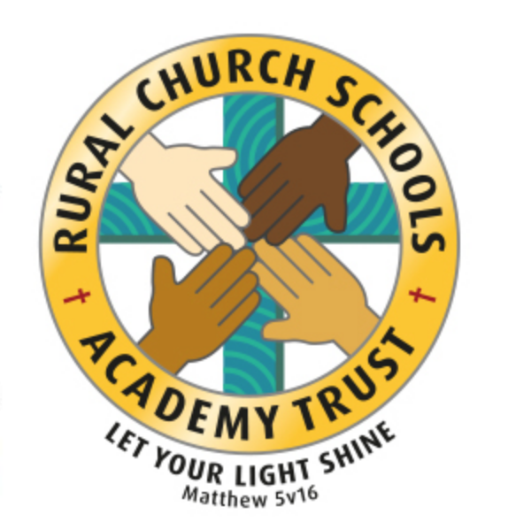

RCSAT Curriculum Overview

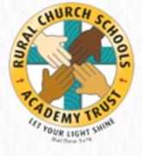
Curriculum Overview 2021

LET YOUR LIGHT SHINE Matthew v5:16

Article 29: Children’s education should develop each child’s personality, talents and abilities to the fullest. It should encourage children to respect others, human rights and their own and other cultures. It should also help them learn to live peacefully, protect the environment and respect other people.

Our Curriculum Policy details our intent behind our curriculum, how we implement it and our desired impact. At RCSAT, the school curriculum consists of all those activities designed or encouraged within its organisational framework to provide the intellectual, emotional, personal, social, spiritual and physical development of all its pupils. It includes not only the subject specific curriculum but also the ‘informal’ programme of enrichment and extra-curricular activities.
The curriculum at RCSAT, developed over a number of years, is firmly rooted in and stems directly from our Vision, Mission and Core Values;
Our Vision – ‘Let your Light shine’ Matthew v5:16
Our Mission – ‘A Caring Christian Family Where We Grow Together’
Our Core Values – WE aim to create an enjoyable, inclusive, safe and nurturing environment that allows all children to develop spiritually, morally and socially. – every child is a child of God, made to contribute to our world.
WE aim to create an inspiring environment, which encourages enthusiasm for lifelong learning and establishes an expectation of high standards – knowing the way, showing the way and going the way.
WE aim to encourage caring, sensitive and inclusive attitudes where individuals feel secure, valued and respected by others. – like Jesus showed us through his teachings

WE aim to provide a broad and connected curriculum which challenges and develops the potential of each child – as Jesus needed his disciples to support and guide, so we look to others with more knowledge

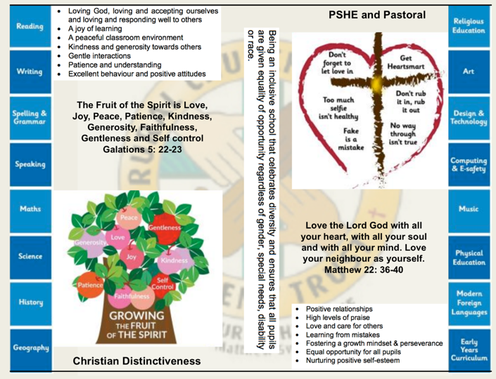
WE aim to develop a positive relationship between home, school and our wider community- as a family – as brothers and sisters.

The RCSAT curriculum is designed to
Embody - the Christian values we live by
Enable – all children to flourish in mind, body and spirit
Ensure – that all pupils are given the experiences to ‘Let their Light Shine.’

Intent:
The schools within RCSAT are strongly committed to helping our children grow and develop the skills required to be successful in life. Our curriculum is designed to promote every child’s individuality giving them the skills, knowledge and understanding to prepare them for the future. At RCSAT, our Connected Curriculum is planned around the development of Knowledge, Skills and Understanding. We ensure a curriculum that nurtures fascination and imagination and promotes an appreciation of creativity & individuality. One that also works in strong partnership with parents and carers to ensure high standards, engendering a strong sense of community, where all children and families are key to the delivery of a challenging, inspirational and innovative curriculum.
As a trust, we provide varied opportunities throughout their time with us, which promote independent, interactive and collaborative learning that builds on the children’s natural curiosity and eagerness to learn. We teach children to aspire to be the best possible version of themselves through our key drivers.
Our key drivers are:
- Inspirational and connected curriculum which instils a love of learning
- Curiosity and appreciation of God’s world through our Christian Values
- A culture of care for everyone in our community and in the world around us (RRSA, Global Learning, British Values)
- Aspiring to become the best person God created us to be – Let your light shine (Matthew 5:16)
Academic success comes through creativity and problem solving; responsibility and resilience, as well as physical development, well-being and mental health all being key elements in supporting the whole child through their learning journey.
Our curriculum also celebrates diversity and utilises the skills and knowledge of the community to enhance our curriculum while supporting the children’s emotional and spiritual development.
Implementation:
Our curriculum is driven by a desire to develop the whole child and therefore delivers much more than just the National Curriculum. Our connected curriculum provides opportunities for the children to learn about managing themselves, relationships and situations.
Our curriculum is not simply a set of encounters from which children form ad hoc memories; it is designed to be remembered in detail – to be stored in our children’s long-term memories so that they can later build on it, forming an ever wider and deeper pool of knowledge. Our curriculum is connected. It is planned vertically between year groups, horizontally within the academic year and diagonally to build on prior knowledge.
Autumn Term | Spring Term | Summer Term
History based enquiry | Science based enquiry | Geography based enquiry

Our connected curriculum stems from a key question linked to a specific concept which then underpins the children’s learning. Knowledge around this concept is delivered through primary sources such as high-quality texts, music, art and technologies, enabling connections to be made across a range of National Curriculum subjects. Our teachers skillfully plan to ensure the children in their class experience a curriculum that inspires a love for learning.
Our curriculum is predominantly organised around rich and engaging, high-quality texts, making links and connecting to all curriculum areas where relevant. There is always an overarching text which connects the curriculum across the school. Beneath which sit key texts in each year group. Subject leads ensure progression and coverage of knowledge, skills and understanding are weaved into a meaningful and cohesive curriculum drawing in learning based on local, national and international events
Medium term plans outline the learning to take place for the term and are developed as mind maps using the phrases; As Artists, As Geographers, As Historians, As Writers, As Readers, As Mathematicians, As Musicians, As Programmers, As Designers, As Performers, As respectful, responsible citizens to frame ideas and concepts to be taught. The core basic skills of English and Maths are planned and delivered to reflect the National Curriculum 2014 changes and many elements of the new statutory orders are reflected in our practice.
We also feel that the following are necessary to support the implementation of our connected curriculum;
Learning Environment – We work hard to make sure that our learning environment supports the development of the whole child both inside, outside and beyond. Our classrooms are well organised and resourced allowing children to choose resources independently to support their learning.
Our outdoor areas have been developed to enhance our connected curriculum with developments such as: running paths, outdoor stage, mini woodland, outdoor reading provision, wilderness area and forest schools. This enables pupils to explore at break and lunch-times and gives teachers a range of resource to tap into to support teaching and learning at various points within the year.
Learning Partners – It is important that as a school we engage with external partner, locally, nationally and internationally to bring added dimensions to our curriculum offer. We partner with artists, musicians, coaches, poets, cultural organisations, engineers, other schools to bring expertise and difference to our curriculum offer. These may be short term projects over a few weeks or much longer endeavours. It is through these partnerships that we may light a spark of interest, enthusiasm and passion within our children that they may carry forward with them into their future lives and schooling.
New Pedagogies – As we continue to develop our curriculum, our approach to teaching and learning also develops. We take a blended learning approach where multiple disciplines will be touched upon within a lesson. It may be a ‘Science’ based lesson where problem solving, maths, literacy and art disciplines are enveloped within the taught session. Project based inquiry learning coupled with direct instruction ensure that our curriculum is relevant and provides children with opportunities to develop the skills of communication, collaboration, critical thinking, citizenship and creativity whilst also building their own character.
Impact:
Through our connected approach:
Our children will have the capacity to control and express their emotions, and handle interpersonal relationships whilst keeping themselves safe.
Our children will become confident and successful lifelong learners, demonstrating the Christian Values to ensuring they let their individual lights shine as they make the right choices about their learning.
Our curriculum has an ambition for high achievement of all pupils irrespective of their background or starting point.
Our curriculum promotes a love of learning.

The curriculum also includes those features which produce the school's ethos (i.e. the ‘hidden curriculum’) such as the quality of relationships and the values exemplified by the way the school sets about its task.
Our aim is to provide a curriculum which will firstly expand the pupil’s knowledge, experience and imaginative understanding, and thus his/her awareness of moral and Christian values and capacity for enjoyment, and secondly, enable the pupil to enter the world after formal education is over as an active participant in society and a responsible contributor to it, capable of achieving as much independence as possible.
There is an Act of Worship every day. Worship is a time where we come together to reflect on the school’s vision and to learn about the ‘person, love & work of Jesus’ which is central to the school’s vision and curriculum The daily Act of Worship promotes the Christian and Learning values which permeate the ethos of the school. As such, Worship is an essential part of the school day and the contributions of staff, pupils, clergy and other visitors are valued highly.

Geography Curriculum: Educating for Wisdom, Knowledge and Skills

4

Geography

The Vocabulary, Knowledge and Skills for Geography are delivered through the following topics and Curriculum content is taught across the year as shown:

Geography Year A

Year Group | Autumn 1 | Autumn 2 | Spring 1 | Spring 2 | Summer 1 | Summer 2
Year 1/ 2 | Seasonal and daily weather- UK |  | Hot and cold parts of the world- North and South Poles |  | Contrasting (non- European) locality- Africa
Year 3/ 4 | Volcanoes  Roman Geography- Chester/ Hadrian’s wall |  | UK Geography- major cities | Europe study  3/ 4 countries in depth | Europe study- Similarities and differences between countries  Conservation
Year 5/ 6 | OS Mapping and fieldwork school and village |  | UK- Counties and cities |  | World’s biggest deserts

Geography Year B

Year Group | Autumn 1 | Autumn 2 | Spring 1 | Spring 2 | Summer 1 | Summer 2
Year 1/ 2 | UK- 4 countries and capital cities |  | Simple map work- School and its grounds- |  | Continents | Seas and oceans
Year 3/ 4 | UK islands- choices to live in a place |  | Mapping and fieldwork- Chester zoo |  | European river study
Year 5/ 6 | Human and physical features of Europe ( inc Russia) |  | Time zones  Countries of North America |  | South America

Why is Geography Important?
Geography provokes and answers questions about the natural and human worlds, using different scales of enquiry to view them from different perspectives. It develops knowledge of places and environments throughout the world, an understanding of maps, and a range of investigative and problem-solving skills both inside and outside the classroom. As such, it prepares pupils for adult life and employment. Geography is a focus within the curriculum for understanding and resolving issues about the environment and sustainable development. It is also an important link between the natural and social sciences. As pupils study geography, they encounter different societies and cultures. This helps them realise how nations rely on each other. It can inspire them to think about their own place in the world, their values, and their rights and responsibilities to other people and the environment.

RCSAT’s Vision for Geography

On completion of the Geography curriculum at RCSAT, pupils will have developed:
- Good knowledge of where places are and what they are like.
- Good understanding of geographical vocabulary.
- Good understanding of fieldwork and other geographical skills and techniques: observing, questioning, planning, collecting, recording, concluding, communicating, reflecting and responding.
- Good understanding of their responsibilities within their own society.
- Insight into the sustainability of a dynamically changing world.
- Interest in geography and curiosity to find out about the world and the people who live there.

A Year 1 Geographer at RCSAT

  - I can keep a weather chart and answer questions about the weather.
  - I can explain where I live and tell someone my address.
  - I can explain some of the main things that are in hot and cold places.
  - I can explain the clothes that I would wear in hot and cold places.
  - I can explain how the weather changes throughout the year and name the seasons.
  - I can name the four countries in the United Kingdom and locate them on a map.
  - I can name some of the main towns and cities in the United Kingdom.

A Year 2 Geographer at RCSAT

  - I can say what I like and do not like about the place I live in.
  - I can say what I like and do not like about a different place.
  - I can describe a place outside Europe using geographical words.
  - I can describe some of the features of an island.
  - I can describe the key features of a place from a picture using words like beach, coast, forest, hill, mountain, ocean, valley.
  - I can explain how jobs may be different in other locations.
  - I can explain how an area has been spoilt or improved and give my reasons.
  - I can explain the facilities that a village, town and city may need and give reasons.
  - I can name the continents of the world and locate them on a map.
  - I can name the world oceans and locate them on a map.
  - I can name the capital cities of England, Wales, Scotland and Ireland.
  - I can find where I live on a map of the United Kingdom.

A Year 3 Geographer at RCSAT

  - I can explain why people are attracted to live by rivers.
  - I can explain why many cities are situated on or close to rivers.
  - I can explain the course of a river.
  - I can name and locate many of the world’s most famous rivers in an atlas.
  - I can use the correct geographical words to describe a place.
  - I can use some basic Ordnance Survey map symbols.
  - I can use grid references on a map.
  - I can use an atlas by using the index to find places.
  - I can name a number of countries in the northern hemisphere.
  - I can name and locate the capital cities of neighbouring European countries.

  - I know the countries that make up the European Union.
  - I can describe key physical and human characteristics of different countries and cities in Europe.
  - I know about different rivers and mountains in Europe, including natural disasters such as volcanic eruptions and earthquakes.

A Year 4 Geographer at RCSAT

  - I can carry out research to discover features of villages, towns or cities.
  - I can plan a journey to a place in England.
  - I can collect and accurately measure information (e.g. rainfall, temperature, wind speed, noise levels etc).
  - I can explain why people may be attracted to live in cities.
  - I can explain why people may choose to live in one place rather than another.
  - I can explain the difference between the British Isles, Great Britain and the United Kingdom.
  - I can find at least six cities in the UK on a map.
  - I can name and locate some of the main islands that surround the United Kingdom.
  - I can name the areas of origin of the main ethnic groups in the United Kingdom and in our school.
  - I can describe how volcanoes are created.
  - I can locate and name some of the world’s most famous volcanoes.
  - I can describe how earthquakes are created.

A Year 5 Geographer at RCSAT

  - I can plan a journey to a place in another part of the world, taking account of distance and time.
  - I can name and locate many of the world’s most famous mountainous regions in an atlas.
  - I can explain how a location fits into its wider geographical location with reference to human and economical features.
  - I can locate the Tropic of Cancer and Tropic of Capricorn.
  - I can explain why deforestation occurs.
  - I understand what is meant by the term ‘fairtade’.
  - I can explain how a locality is affected by tourism.

A Year 6 Geographer at RCSAT

  - I can use Ordnance Survey symbols and 6 figure grid references.
  - I can answer questions by using a map.
  - I can use maps, aerial photographs, plans and e-resources to describe what a locality might be like.
  - I can describe how some places are similar and dissimilar in relation to their human and physical features.
  - I can name the largest desert in the world and locate desert regions in an atlas.
  - I can identify and name the Tropics of Cancer and Capricorn as well as the Arctic and Antarctic Circles.
  - I can explain how time zones work and calculate time differences

