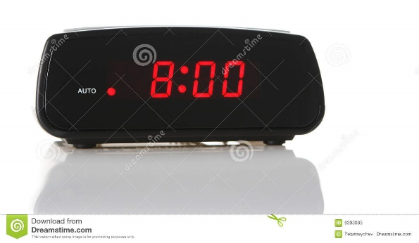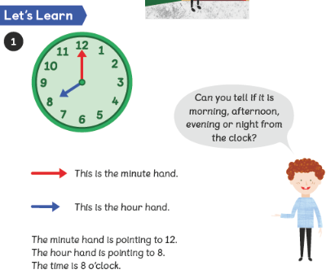

This is what 8 o’clock looks like on a digital clock. The 00 shows that no minutes have gone past 8 o’clock.

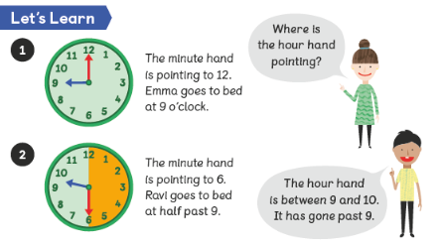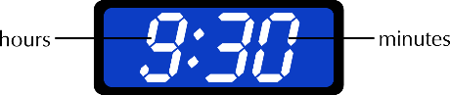

This is what half past 9 or 9 thirty looks like on a digital clock. The 30 shows that 30 minutes have gone past 9 o’clock.

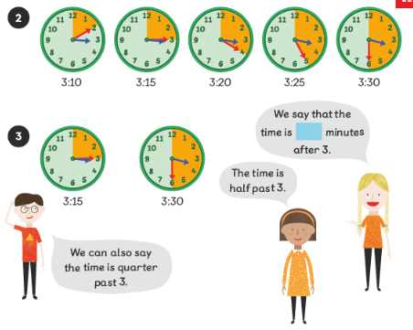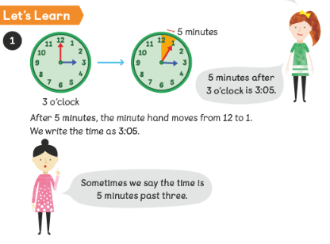Year 2 objectives