Possible Time Activities
- Complete an obstacle course and get someone to time you in seconds. Can you beat your time next go? Keep a log of your times. How much quicker are you each time?
- How many star jumps can you do in one minute? How many times can you write your name in a minute?
- Keep a time diary for a day, for example the times when you get up, have lunch, go to bed.
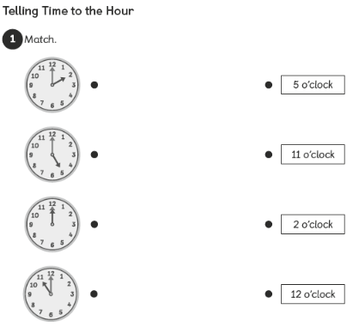
What time does each clock show?

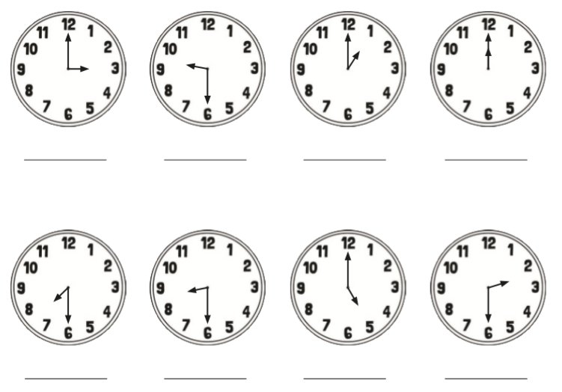

Challenge
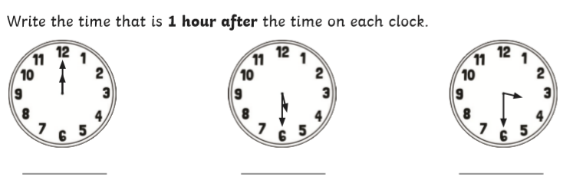
Year 2 objectives- Can you read time to the nearest 5 minutes

