How many **kilograms** do these objects weigh?

Read the scales to measure the mass of the eggs in **grams**.

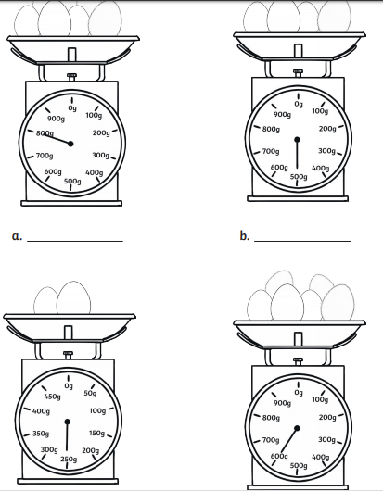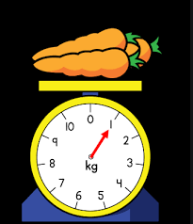

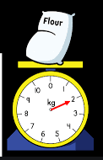

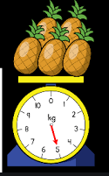

Paul and Lucy have different ideas about how much a cherry might weigh.

Who do you think is right?

.

[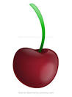](https://www.google.co.uk/url?q=https://www.how-to-draw-funny-cartoons.com/cherry-cartoon.html&sa=U&ved=0ahUKEwjivobN-eXiAhWuRhUIHalxBI4QwW4IPDAT&usg=AOvVaw3yrWJohRyJqlPLepePBthW)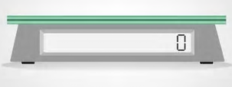

1 cherry will weigh about **10kg**

1 cherries will have a mass of about **10g**