Joined up handwriting- Year 2

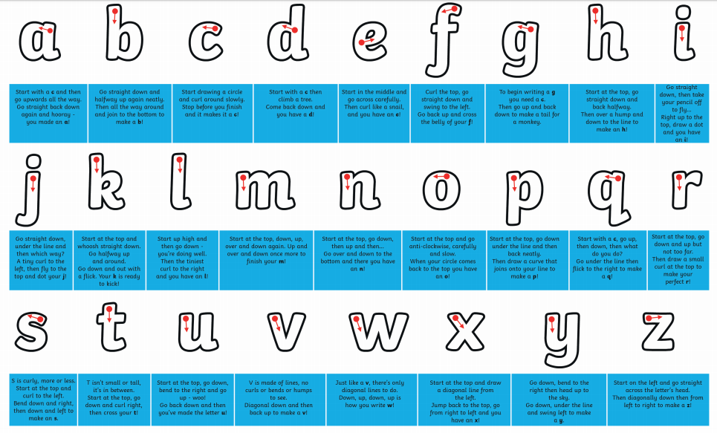
When the children are forming all of their lower case letters correctly as shown below, starting and finishing in the right places, then they are ready to start to join their letters.

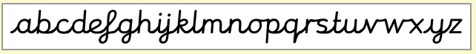
The alphabet below shows how each of the letters should be joined. We do not join capotal letters.

Our aim is to not take the pencil off the paper until we have joined a whole word. When the word is written we go back to cross any ‘t’or dot any ‘i’ or ‘j’ we have written.
There are 3 mains ways to join letters

1.Diagonal joins
Most of the letters join to the next with a diagonal stoke such as a, t and n.

Watch out for b and p as you have to come back on yourself from where the letter finishes to do the diagonal join to the next letter.

2.Horizontal joins
o, r, v and w join to the next letter with a horizontal stroke.

3.Looped joins
5 of the letters are looped round to keep your pen on the page, these are f, g, j, k and y. Be careful to make the loop thin on the k so that it doesn’t look like an R (capital r).

Try writing some of the words below to practise these three types of joining.

Just diagonal-
cat tap pin
bath mint hand

Diagonal and horizontal

one bride love went
pond drain with vote

Now have a go at introducing some looped joins by writing out this poem.
