Year 5/6

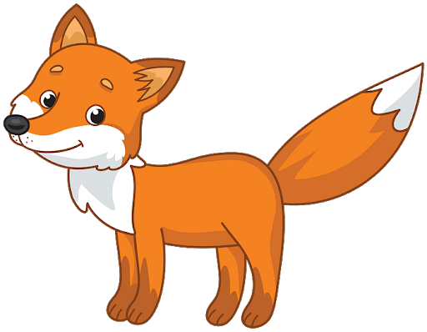Y5/6 Foxes
1.6.20
Good morning and welcome back to a new half term and its June 1st! I hope you have all had a fantastic half term and have been able to do some exploring. I have spent the week hiking, taking in nature and yesterday it was my birthday (not that I am going to tell you my age).
We are still look at the wonders of North America but this half term we are looking more at the man-made side of it and are heading to New York City.

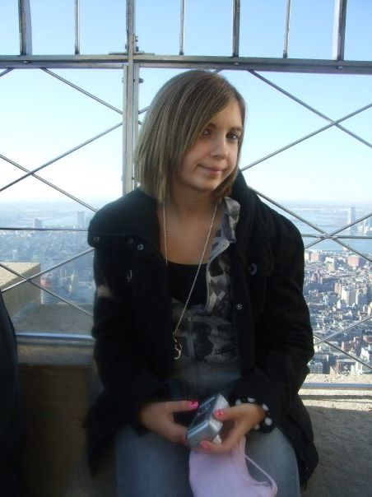
Believe it or not, this is Miss Ramage on top of the Empire State Building at the age of 14.

Welcome to New York Video!

You will find activites to do on PurpleMash, Mathletics as well as ones to do in your homelearning books.

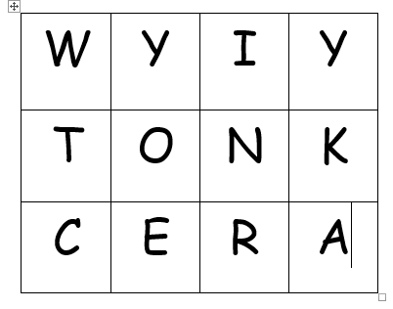
Morning Starter: This week's boggle includes the letters of 'NEW YORK CITY' and an extra 'a'. How many words can you make? What is the longest word you can make?

Year 5
Writing: We are going to be starting to write based on a class book but this week we want to get immersed into New York.
1) Imagine you've just arrived in New York City and are surrounded by skyscrapers and beaming lights, can you write a scene description about what you can see and how it feels?
I have attached a sheet to give you a few clues and somewhere to write it. Click Here to download!
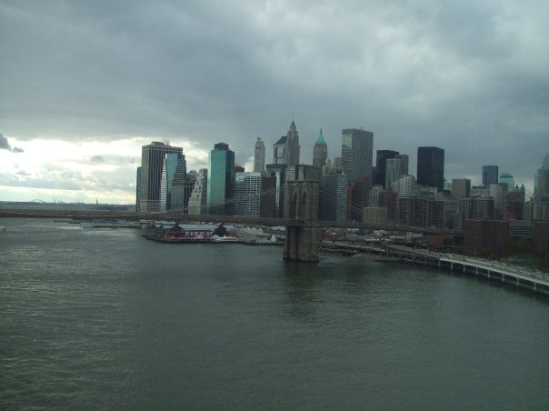
2) In your second writing project for this week, I want you to write me a letter convincing me why I should visit New York and what it has to offer.
It should begin 'Dear Miss Ramage'
You can do this in your home-learning books and if you would like you can email them to me. Consider what may persuade Miss Ramage to visit.

Spelling: In our spellings we are continuing to work out those tricky words that don't always follow a pattern. This time try practising a different five before we start our pattern next week.
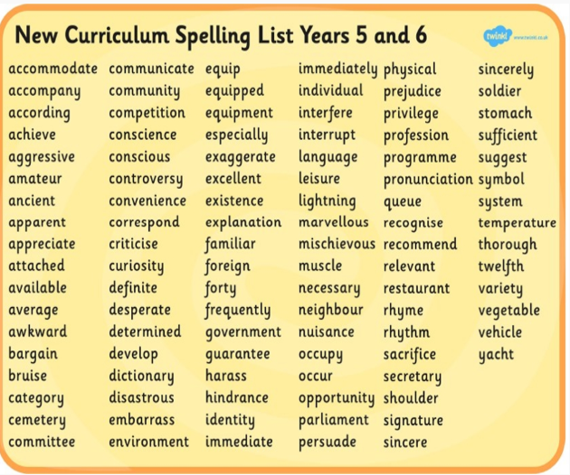

Reading: Our new exciting way of reading together has begun! Have a listen to the three chapters at the very bottom of the webpage and then try and answer the questions that go with them. You could listen to one chapter a day! If we enjoy it, I will upload 4 chapters next week.
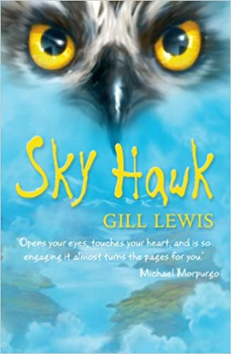
Chapter 1:
- Can you name four of the characters we have met?
-How do you think Rob feels about Iona? Why?
Chapter 2:
-Draw what you think Iona looks like.
Chapter 3:
-Why is Graham so cross with Callum?
-Why does Callum eat his tea so quickly?
-What do you think will happen in Chapter 4?

Maths: In maths, we are carrying on with shape and measure but are moving away from angles.
Can you remember how many mm are in a cm?
Can you remember how many cm are in a m?
Can you remember how many m are in a km?
Click here to learn about measuring lengths
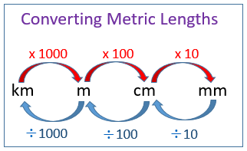
Have a go at the problems below and the activies on mathletics.
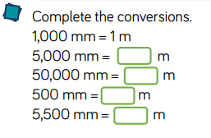
Click here for downloadable activities
Why not have a go at measuring objects at home too.

Year 6
Writing: We are going to be starting to write based on a class book but this week we want to get immersed into New York.
1) Imagine you've just arrived in New York City and are surrounded by skyscrapers and beaming lights, can you write a scene description about what you can see and how it feels?
I have attached a sheet to give you a few clues and somewhere to write it. Click Here to download!

2) In your second writing project for this week, I want you to write me a letter convincing me why I should visit New York and what it has to offer.
It should begin 'Dear Miss Ramage'
You can do this in your home-learning books and if you would like you can email them to me. Consider what may persuade Miss Ramage to visit.

Spelling: In our spellings we are continuing to work out those tricky words that don't always follow a pattern. This time try practising a different five before we start our pattern next week.

Reading: Our new exciting way of reading together has begun! Have a listen to the three chapters at the very bottom of the webpage and then try and answer the questions that go with them. You could listen to one chapter a day! If we enjoy it, I will upload 4 chapters next week.
Chapter 1:
- Can you name four of the characters we have met?
-How do you think Rob feels about Iona? Why?
Chapter 2:
-Draw what you think Iona looks like.
Chapter 3:
-Why is Graham so cross with Callum?
-Why does Callum eat his tea so quickly?
-What do you think will happen in Chapter 4?

Maths: In Maths we are continuing to explore statistics but are moving on to understand what is meant by finding an average of an amount.
Have you ever heard of the mean before?
Click here to watch a clip - we are specifically focusing on the mean!
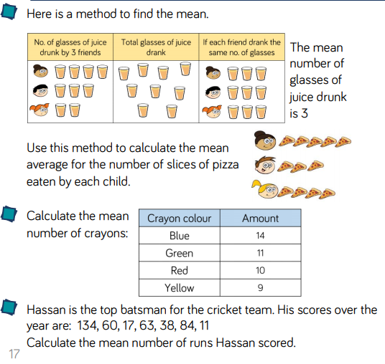
Click here for problem solving questions!
Activites on mathletics too.

Have a go at one of the two challenges below:
Art: The New York Skyline is an impressive one indeed! For your art this week, I want you to have a go at drawing it. I have included some pictures and ideas of what you might like to do or how you might like to do it.
- You could use black card and a white pen or colours to make it stand out.
-You could stick black paper onto a colourful background.
-You could do lots of different coloured buildings and layer them.
The choice is up to you!

