Year 1/2
Week beginning: Monday 1st June 2020 Summer term 2- Week 1 out of 7
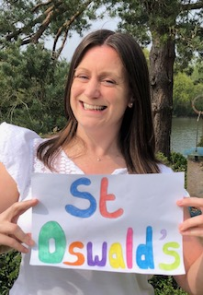 Hello Deer Class
I hope you have had a lovely week off for half term!
Our baby blue tits may have flown the nest but we have some new visitors at school. The house martins have arrived back to the playground!
Do you remember that we had a house martin nest above the veranda outside our classroom last year like the ones below?
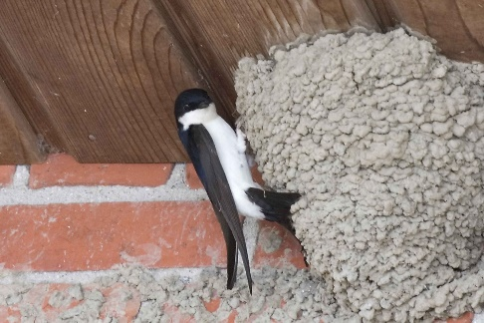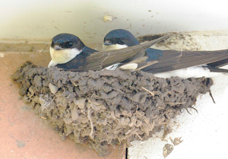
These house martins have flown all the way from South Africa to build their nest at St Oswald's. This is called migration. The birds make this journey as Africa is now getting colder because it is winter time there.
Through our next topic we are going to be learning about the wonderful continent of Africa.
For the next few weeks we will be learning through one of my favourite books which is set in Africa- Meerkat Mail by Emily Gravett.
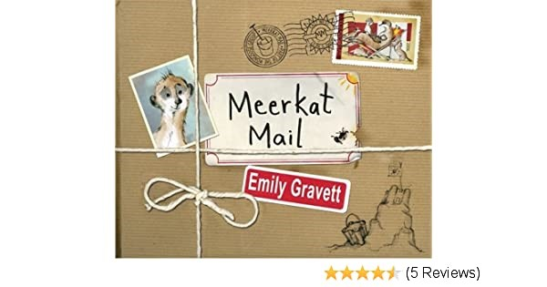

This week I have set you maths work (money), writing (choose from writing a list, letter or place description), geography (Where is Africa?) and computing (African bird, fish and insect research using 'Google' and money matching games).

Have fun completing some of these activities and I look forward to seeing your work if you would like to share it!
Have a lovely week.
Missing you all lots!

Love from Miss Dutton x

Click here to enter online Purple Mash resources
Click here to enter Mathletics
Click here to enter TT Rockstars

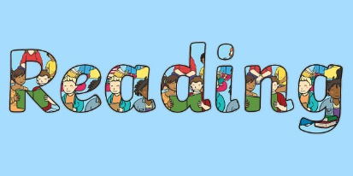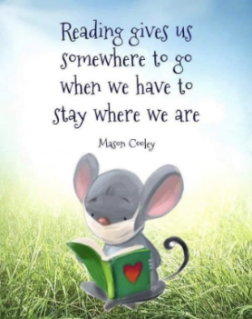

Use the link below to register on the Oxford Owls website. It is easy to set up the registration and it will give you access to a range of ebooks for ages 3-11.
Oxford Owl E Book Registration- link

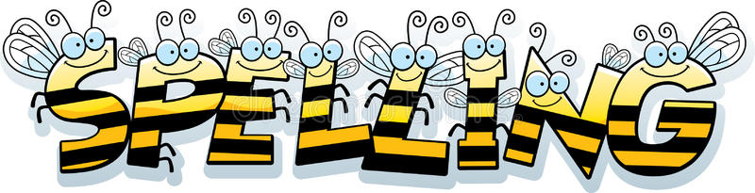
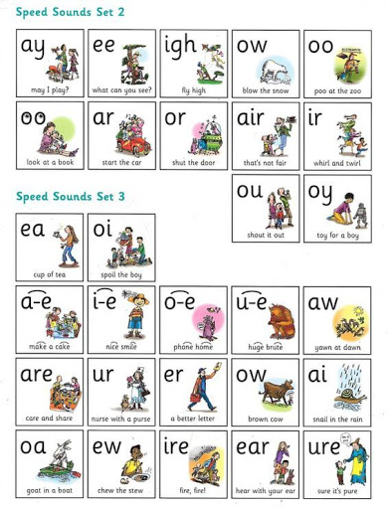
Reading and Spelling - It is really important that you can all read and write words with the sounds below. Keep practising them! Can you choose a sound and write 6 words for it. Try to learn to spell 5 common exception words each week too.
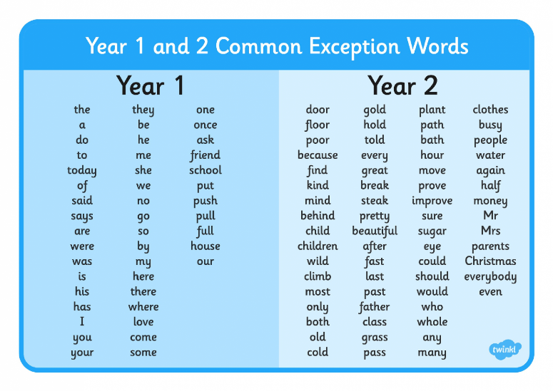

Year 2 children-
Learn to spell these 6 words that sound like they should start with a 'r' sound but actually start with 'wr'.
write wrote wrap wrist wrong wreck

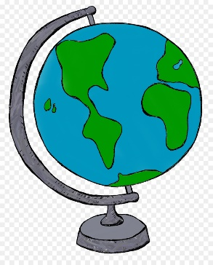Geography
As geographers can you locate Africa on a world map?
Africa is a continent- A huge piece of land that has 54 countries. This is the shape of Africa.
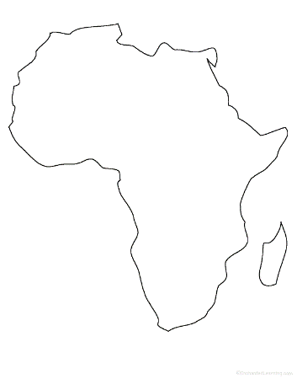and here are its countries marked on 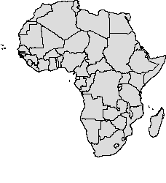
Can you find Africa on this world map?

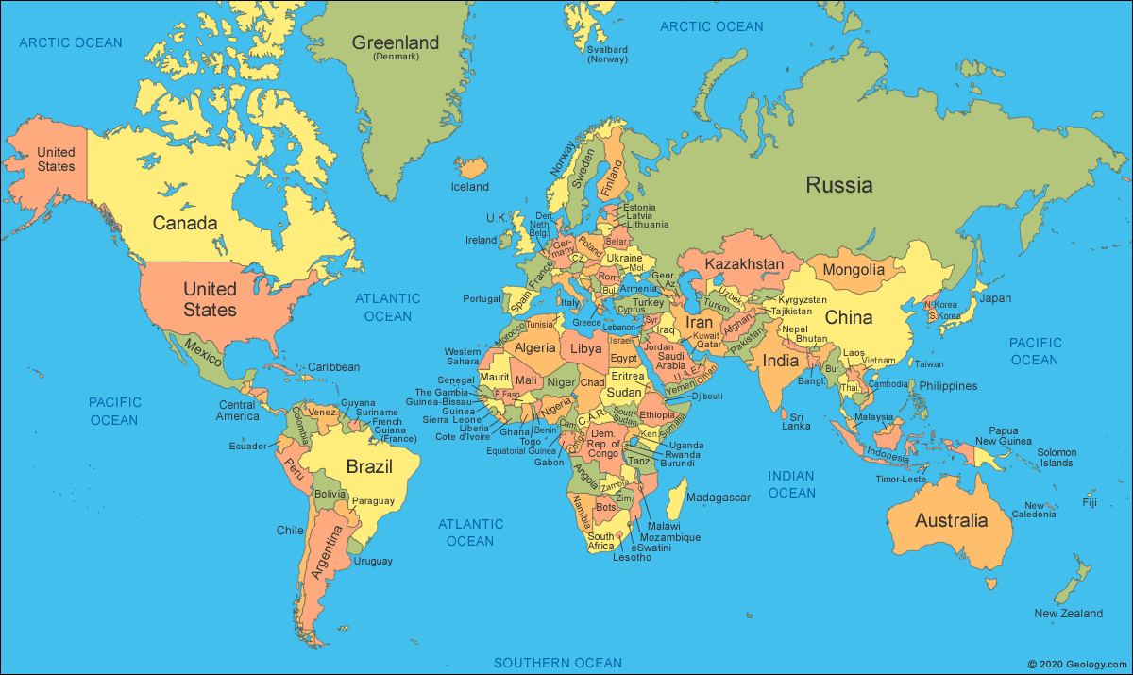
The house martin birds at school have flown from South Africa to the UK and it will have taken them about 6 weeks! Can you trace their journey using your finger on the map? Can you remember the shape of the United Kingdom from our previous teaching?

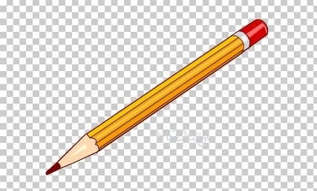
Writing
As writers- Can you write a list, letter or description?
Let's meet the main character of our new book.
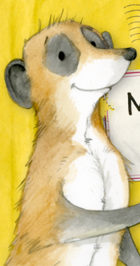 This is Sunny the meerkat.
He lives in the Kalahari Desert in Africa which is so big that it spreads across three countries- Namibia, Botswana and South Africa.
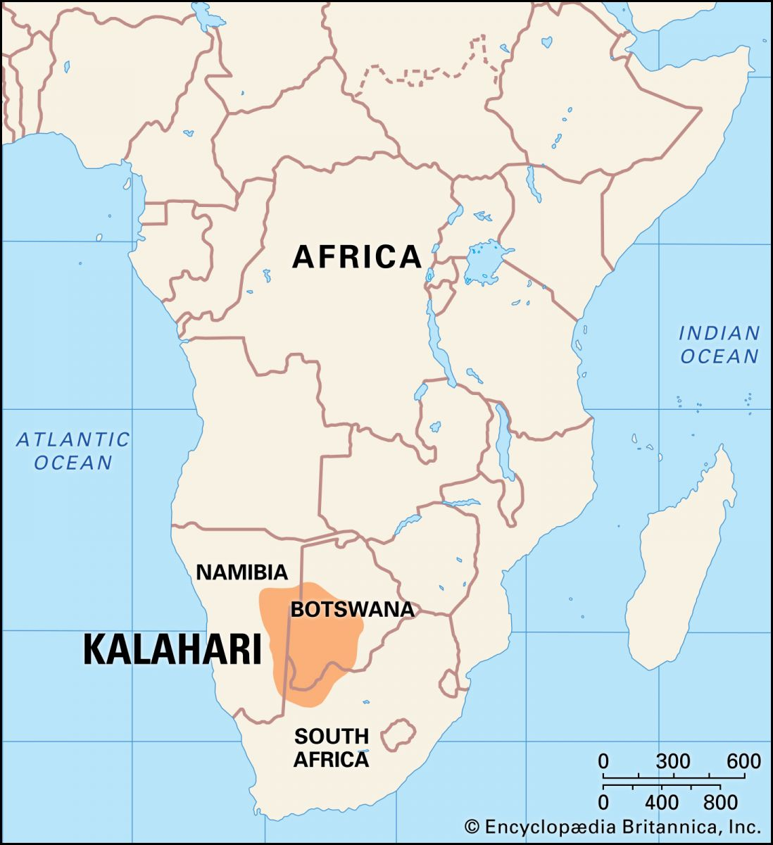
Listen to 'Meerkat Mail' author Emily Gravett read her story by clicking on the link below. You can listen to the whole story or just up until Sunny writes his letter telling his family he is off to find somewhere perfect to live (3 minutes 52 seconds in).
There are also 2 fun videos for you to watch to learn more about meerkats.

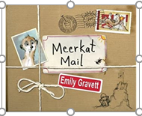
Meerkat Mail by Emily Gravett- video https://www.youtube.com/watch?v=7lEigAZpusI

Meerkat videos https://www.youtube.com/watch?v=uIILtxz0pNw https://www.youtube.com/watch?v=W4og8g_X22o-
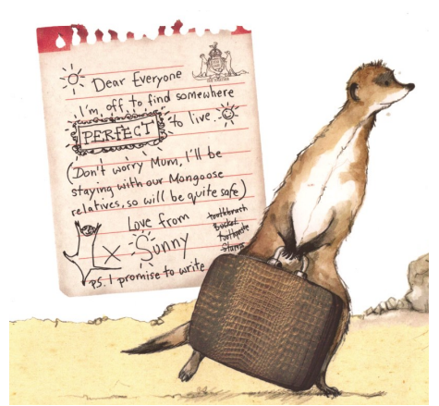
Now choose one of these writing activities to do
Activity 1- Draw the outline of Sunny's suitcase and draw and label the things he might pack to go on his trip. Think about what he and other meerkats like to do, eat, what he might need on his journey.
Activity 2- Write a more detailed letter from Sunny telling his family why he wants to go.
Activity 3- Draw and then write a description of what Sunny's perfect place to live might be like. My perfect home would have ...
Don't forget to use punctuation in sentences such as capital letters, full stops, commas, exclamation marks and question marks. Try to use interesting adjectives (describing words) and conk]junctions (joining words) such as and, but, so, because, when, that, if, or.

Maths
* * * Please keep practising temperature, mass, capacity, time telling, adding, subtracting and counting in 2s, 3s, 5s and 10s to learn your times tables. There are also maths challenges for year 1 and year 2 in the files at the bottom of this page. * * *
As mathematicians- Can you recognise and name the British coins and notes and combine 2 coins to make a total?

This is our first week of two on the topic of money.
Nowadays we tend pay for things using a card and card machine in a shop like this.
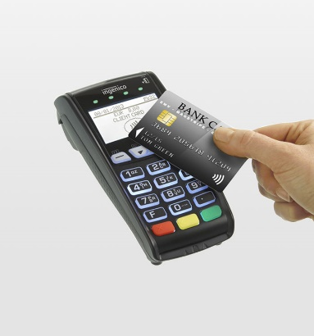
We can also use coins and notes to pay for things.
Here are all of the British coins and notes that we use.
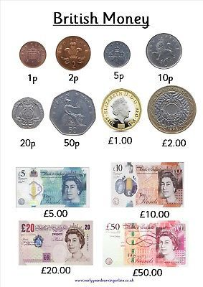They are listed in order of worth.
Notice that the 2 pence coin is bigger than the 5 pence coin even though it is worth less.
The units for money are pounds and pence.
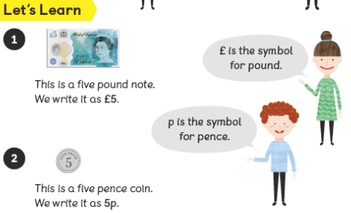
Click on the link below to answer questions about our coins and notes.
Coins and notes worksheet- F

Next week we will be learning how to count money and make larger totals.

Computing- In computing can I use 'Google' as a search engine?
In science so far we have now learned about birds, insects and fish.
Can you use google to find some types of birds, insects and fish that live in Africa? They may look very differenet to the ones that live around us in the UK.
You could write a list of the ones you find or have a go at sketching them.
I have also set you 3 'to do' money games on Purple Mash this week.
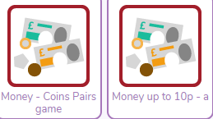
Have fun!

