Year 5/6

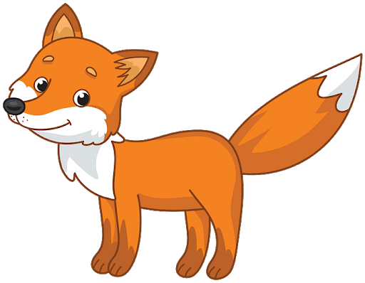Y5/6 Foxes
8.6.20
Good Morning Y5/6 Foxes and welcome to the second week of June. We seem to have lost the sun but hopefully it will return soon! I hope you've enjoyed the start of our New York Unit. We are now starting week 2 and have a brand new book for our writing tasks. Don't forget to listen to the audio book at the bottom of the webpage.

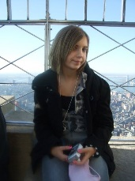
Believe it or not, this is Miss Ramage on top of the Empire State Building at the age of 14.

You will find activites to do on PurpleMash, Mathletics as well as ones to do in your homelearning books.

Don't forget to keep checking mathletics, purplemash and carry on competing on TTrockstars.
If you have forgotten your passwords for any website email: admin@stoswald-worl.cheshire.sch.uk
Click here for TT Rockstars login
Click here for Mathletics login
Click here for Purple Mash login

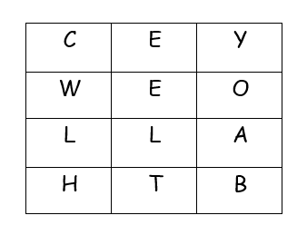
Morning Starter: This week's boggle includes the letters of 'THE YELLOW CAB'. How many words can you make? What is the longest word you can make?

Year 5
Writing: We are starting our new class book - The Man Who Walked Between the Towers. YOUR LESSONS ARE ALL DOWNLOADABLE AND ARE IN AN ORDER.
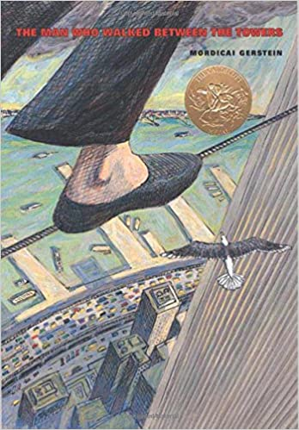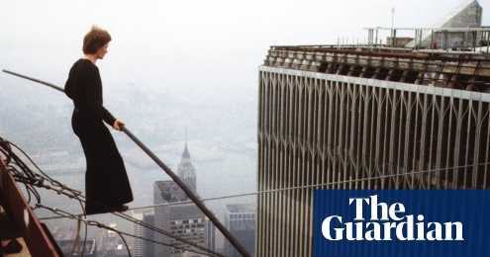
1) What do you think the book might be about? What could the title and picture suggest?
Click here for lesson 1
2) We are now looking at page one of the book. Have a look at the picture and answer the questions below it. 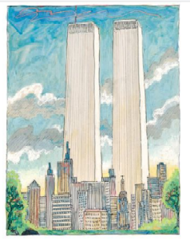
Click here for lesson 2

3) For the third writing lesson this week, we are thinking about how we can improve the text and make it even better. THIS ONE CAN BE DONE ON PURPLEMASH.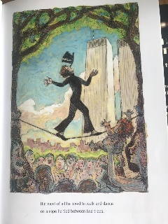
Click here for lesson 3

You can choose whether you do these in your home-learning book or email them back to me. There are some bits on purplemash to help.
Spelling: For spelling this week, we are recapping a pattern that we often struggle with or forget about. 'ly' suffix.
Words: Finally, Firstly, Really, Substantially, Unlikely, Heavenly. Activity on Purplemash to complete.
Reading: Have a listen to the three chapters at the very bottom of the webpage and then try and answer the questions that go with them.
Chapter 4:
- What do you think they have seen? Why?
-Have a go at drawing it.
Chapter 5:
-How does the author describe the bird?.
Chapter 6:
-Can you summarise this chapter in 5 points?
Maths: In maths, we are carrying on with measure.
This week we are thinking about grams and kilograms - can you find 3 different objects in the house that have mass on them? For example a bag of flour.
Fun clip to watch!
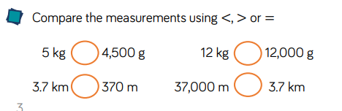
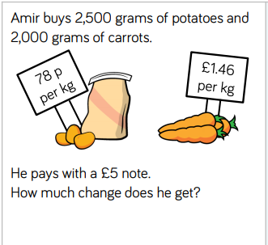
Click here for downloadable activities
Activities on purplemash and mathletics too.

Year 6
Writing: We are starting our new class book - The Man Who Walked Between the Towers. YOUR LESSONS ARE ALL DOWNLOADABLE AND ARE IN AN ORDER.
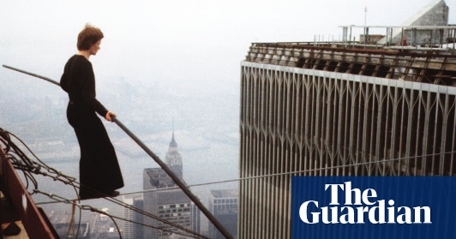
1) What do you think the book might be about? What could the title and picture suggest?
Click here for lesson 1

2) We are now looking at page one of the book. Have a look at the picture and answer the questions below it. 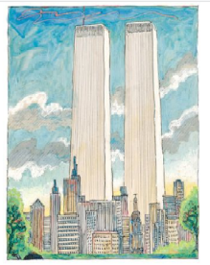
Click here for lesson 2

3) For the third writing lesson this week, we are thinking about how we can improve the text and make it even better. THIS ONE CAN BE DONE ON PURPLEMASH.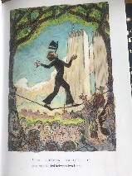
Click here for lesson 3

You can choose whether you do these in your home-learning book or email them back to me. There are some bits on purplemash to help.
Spelling: For spelling this week, we are recapping a pattern that we often struggle with or forget about. 'ly' suffix.
Words: Finally, Firstly, Really, Substantially, Unlikely, Heavenly. Activity on Purplemash to complete.
Reading: Have a listen to the three chapters at the very bottom of the webpage and then try and answer the questions that go with them.
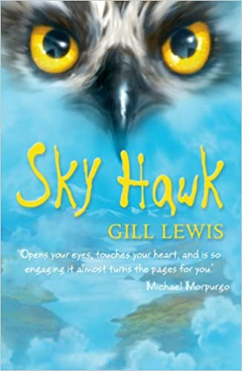
Chapter 4:
- What do you think they have seen? Why?
-Have a go at drawing it.
Chapter 5:
-How does the author describe the bird?.
Chapter 6:
-Can you summarise this chapter in 5 points?
Maths: In Maths we are continuing to explore statistics and are exploring pie charts.
Have you come across pie charts before? They are one way of representing data. Please email me if you find them hard, they take some time to understand.
Click here for a really helpful video!
If you find it too hard, why not take a circle and try cutting it in half. Then try cutting it in quaters. Purplemash activity to help and then two below.
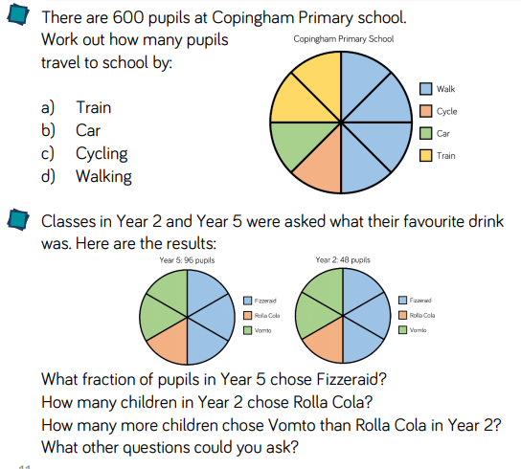

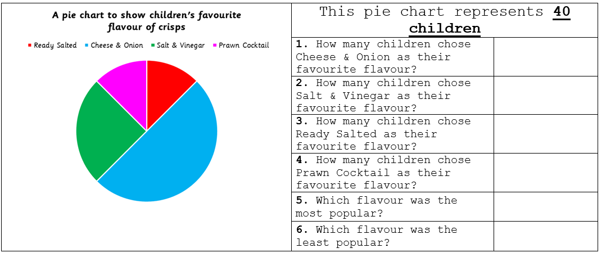
Activites on mathletics and purplemash too.
Have a go at one of the two challenges below:
Art: In art we are exploring 'pop art' and the work of Andy Warhol. Did you know one of his most famous paintings was of soup? Follow the link to look up his art and have a go at your own. He liked to look at colour.

Andy Warhol information
You could:
Draw some household objects
Draw a self-potrait and use lots of colour
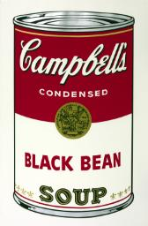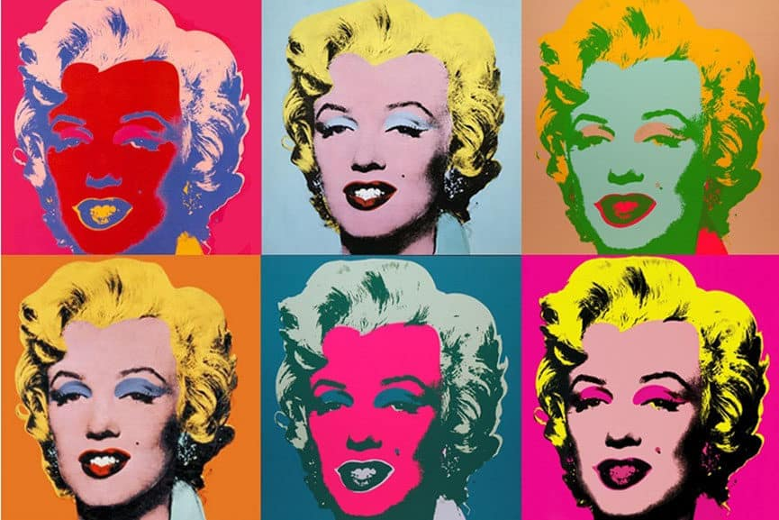
History: Have you ever wondered where the Statue of Liberty came from or why it is there? Your job is to 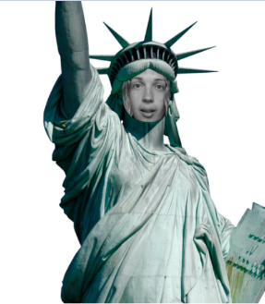research it and then write it from the point of view of the statue herself. You can do this on purplemash or in your home-learning book.
You can also put yourself into it - this is Miss Ramage!

