Adding
Can you add these 1 digit numbers to 2 digit numbers? Use the hundred square to help you to count on. Remember that it is easier to count on from the biggest number.

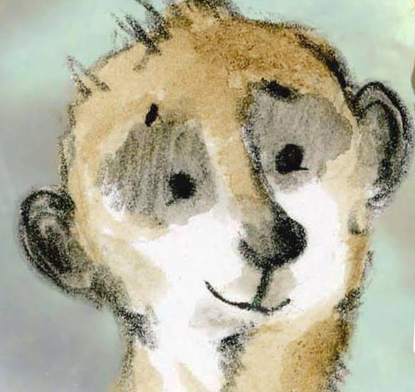

16 + 3 = | 90 + 5 =
24 + 2 = | 2 + 83 =
53 + 6 = | 1 + 99 =
44 + 6 = | 7 + 66 =
57 + 4 = | 88 + 5 =
39 + 3 = | 29 + 7 =
77 + 5 = | 64 + 9 =
61 + 4 = | 91 + 9 =
50 + 6 = | 98 + 3 =

Money adding
27p + 6p = 41p + 8p = 88p + 9p =

Draw your own addition picture
Bin the box below is the word problem and picture for the calculation
5 + 3 = 8

Beth has 5 purple flowers and 3 pink flowers in her garden.
How many flowers does Beth have altogether?

Can you write your own word problem and draw the picture for this calculation

11 + 4 =

Can you add tens numbers to a 2 digit number? When we add a tens number to a 2 digit number only the tens digit changes. Eg 35 + 10 = 45 The ones digit stays the same.
When we count on ten on a hundred square we jump down to the next box. See the examples below.

24 + 10 (1 ten) = 34 47 + 30 ( 3 tens) = 77

Can you solve these?
16 + 10 = | 62 + 20 =
27 + 10 = | 80 + 20 =
36 + 10 = | 23 + 30 =
73 + 10 = | 41 + 40 =
45 + 20 = | 49 + 50 =
Can you add two 2 digit numbers?
We call this way of laying out our maths column addition.
We start by adding the numbers in the ones column (o), then add the numbers in the tens (t) column to get our answer.
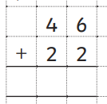
Example
o
o
t
t
Add the ones Then add the tens
6 + 2 = 8 4 tens + 2 tens = 6 tens
6
8
8

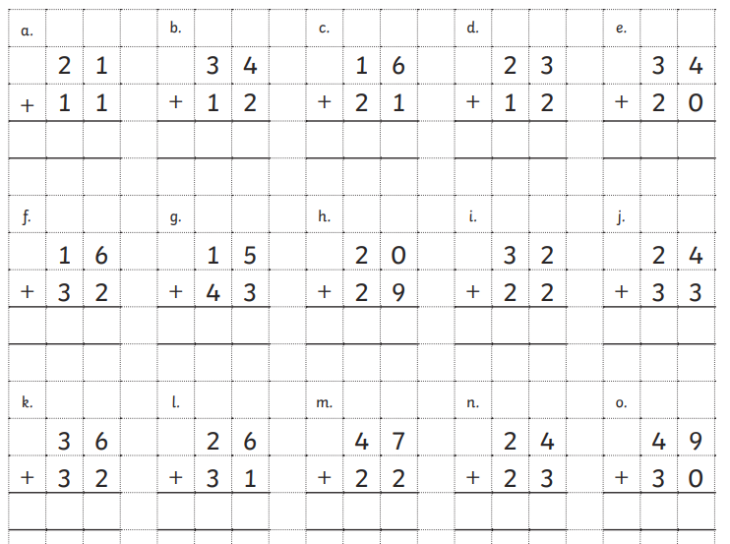
Can you solve these?
Can you solve these word problems using one of the addition methods you have practised above?

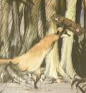
- Sunny walks 16 miles on Monday and 9 miles on Tuesday.
How many miles has he walked altogether?

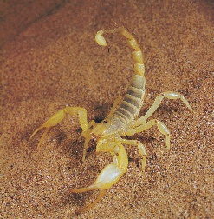
- Sunny eats 37 scorpions in the morning and 20 scorpions in the afternoon.
How many scorpions has he eaten altogether?

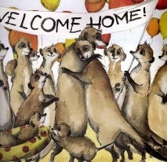
- There are 35 yellow balloons at Sunny’s party and 23 red balloons.
How many balloons does he have altogether?

- Sunny buys a sweet for 15p and a lollipop for 61p.
How much does he spend altogether?

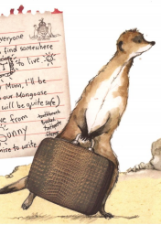
- Sunny’s suitcase weighs 3kg to start with.
He adds 2kg of scorpion snacks.
How heavy is his suitcase now?

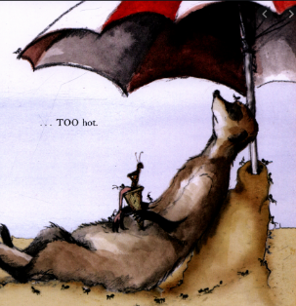
- The temperature in the Kalahari desert is 32 ˚C in the morning.
In the afternoon it is 7 ˚C hotter.
What is the temperature in the afternoon?

Extra challenges

Can you add three numbers?
Tip- To add quickly look to see if there are pairs that total 10.

7 + 3 + 1 = 4 + 4 + 6 =

9 + 2 + 1 = 2 + 8 + 5 =

5 + 8 + 5 = 4 + 4 + 5 =

Can you solve these missing number addition problems?
Count on from the smallest number to the biggest number if you get stuck.

5 + ___ = 10 7 + ___ = 10 ____ + 8 = 10

____ + 10 = 20 ___ + 5 = 15 14 + ___ = 20

11 + ____ = 20 6 + ___ = 11 ____ + 9 = 16

