Year 1/2
Week beginning: Monday 15th June 2020 Summer term 2- Week 3 out of 7
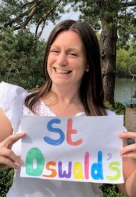 Hello fabulous Deer Class!
What have you been up to this weekend? I did a fun quiz online with the other St Oswald's teachers and watched the new Lion King film because I'm loving our Africa topic!
My favourite part of The Lion King is the first scene where we see the amazing African wildlife and meet baby Simba and I thought I'd share it with you.

The Lion Key scene 1- https://www.youtube.com/watch?v=jAOBcT7pUOsVideo
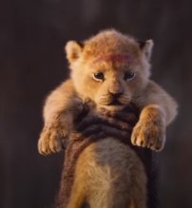
This week I am back in school each day working with our Reception children but I will still be excited to check my emails and Padlet every day so keep sending me your lovely things to see and read.

This week I have set you maths work (adding), writing (Sunny's scorpion recipe), science (learning about arachnids), geography and art (drawing Sunny in his habitat- The Kalahari Desert) and computing (adding- number bond games).
Mr Dooley has also given me some more sports day games for you!

Have fun completing some of these activities and I look forward to seeing your work if you would like to share it!
Have a lovely week.
Missing you all lots!

Love from Miss Dutton x

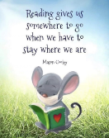
Use the link below to register on the Oxford Owls website. It is easy to set up the registration and it will give you access to a range of ebooks for ages 3-11.
Oxford Owl E Book Registration- link
See the files at the bottom of the page to find a 'Ronald the rhino' reading comprehension activity which has three levels of questions.
Try to read some or all of the story yourself or if it's a little tricky then get an adult to read it to you then answer the questions.

Reading and Spelling - It is really important that you can all read and write words with the sounds below. Keep practising them! Can you choose a sound and write 6 words for it. Try to learn to spell 5 common exception words each week too.
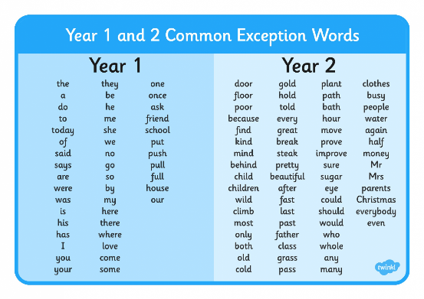
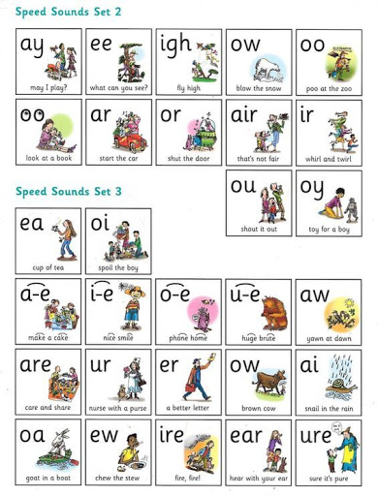
Year 1 children- Check you can spell these words from the list above?

was you your they she/ he/ me/ we/ be

Year 2 children-
Learn to spell these 6 words that sound like they should start with a 'j' sound but actually start with the letter 'g'.

gem germ ginger giant giraffe gentle
Maths
* * * Please keep practising temperature, mass, capacity, time telling, adding, subtracting and counting in 2s, 3s, 5s and 10s to learn your times tables. There are also maths challenges for year 1 and year 2 in the files at the bottom of this page. * * *
As mathematicians- Can you add 2 numbers together to get a total?
Warm up-
1. Count up in 2s, 5s, 10s. Try counting in 3s.
2. Remind yourself of the pairs of numbers which make 10.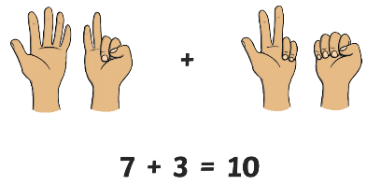
Use your 10 fingers and thumbs to help you if you need to. If 10 is too easy then try pairs for 20.

Adding
Over the next 4 weeks we are going to practise the 4 maths operations- addition, subtraction, multiplication and division. This week your activities are all linked to addition.
Let's remind ourselves about tens and ones in numbers. This will help us with our adding.
The sticks represent ten cubes and the small cubes represent one.
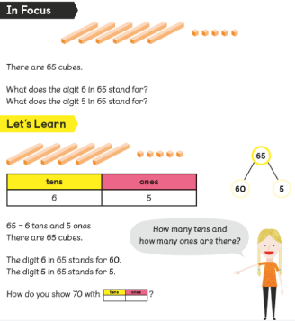
Can you point out the tens and ones digits in the numbers below?
1 1 1 6 2 4 3 0

Click on the links below to find your activities for this week. You don't have to print these you can just write the answers down if you like.
Adding activities- Year 1 objectives
Adding activities- Year 2 objectives

Science
As scientists- Can you name some arachnids and their characteristics?
So far in science we have learned about 4 types of animals-
insects, birds, fish and mammals. Which are your favoruite so far?

This week we are going to learn about another type of animal called arachnids.
Sunny's favourite food- the scorpion is an arachnid! 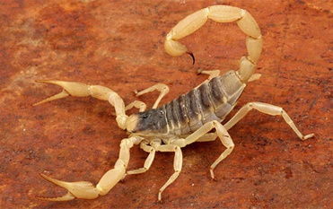
Arachnids are carnivores which means they eat meat.

Challenge 1- Watch the video clip below and tell an adult about the characteristics of arachnids.
All about arachnids https://www.youtube.com/watch?v=6k-0yaLrJjI-video clip

Here are some spiders that live in Africa. They are all very interesting! Which is your favourite?
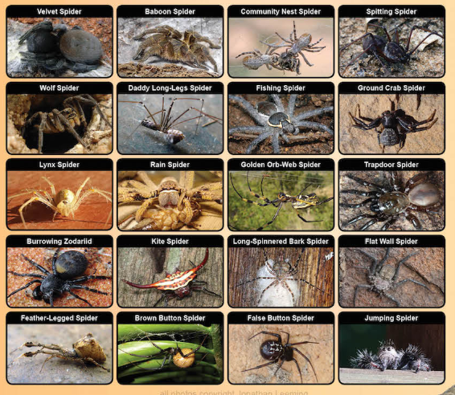
Challenge 2- Draw an arachnid of your choice. Make sure it has 8 legs!

Writing
As writers- Can you write a recipe that Sunny could send back to his family?
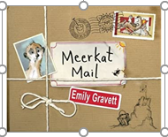
Meerkat Mail by Emily Gravett- https://www.youtube.com/watch?v=7lEigAZpusI story video

On Monday Sunny goes to visit Uncle Bob where there are lots of yummy scorpions to eat!

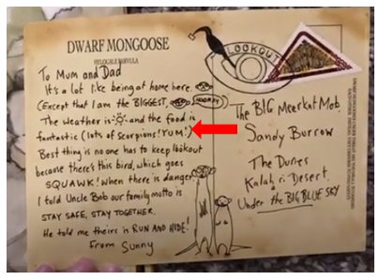
Uncle Bob makes him lots of scrumptious scorpion meals while he is staying there. Sunny wants to share one of Uncle Bob's scorpion recipes with his family and decides to send one home to them with his postcard.
Can you choose a fun scorpion meal and make up a recipe to write?
Here are some fun ideas for meals or you can create your own delicious scorpion meal that Sunny has enjoyed.
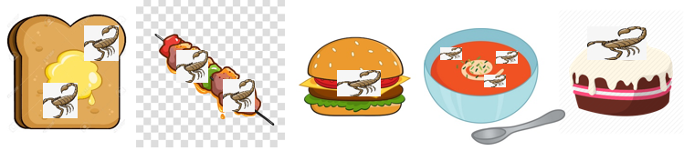
You could use the following desert ingredients- scorpions, beetles, plant roots, eggs, grasshoppers, spiders, termites, lizards, water

You could use the following writing structure to help you
*Title of meal (Make it sound delicious)
*What ingredients you need (A list)
*Instructions for making the meal (Use numbers to order them/ verbs and time words)
*Ending (Maybe finish with a helpful hint or safety tip for making the meal)

You could use these time words in your recipe-
first, second, then, next, after, now, finally
You could use some good verbs (doing words) in your recipe-
mix, fry, chop, mix, cook, stir, bake, slice, pour, whisk, spread, sprinkle

Don't forget to use punctuation in sentences such as capital letters, full stops, commas, maybe even exclamation marks and question marks. Try to use interesting adjectives (describing words) and conjunctions (joining words) such as and, but, so, because, when, that, if, or

Geography and Art
As geographers and artists- Can you draw Sunny in his natural habitat- The Kalahari Desert?
This week Meerkat Mail author Emily Gravett is going to help you draw Sunny the meerkat because she is also the illustrator for our book.
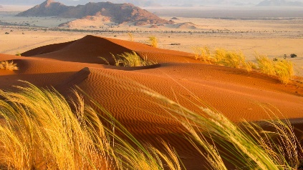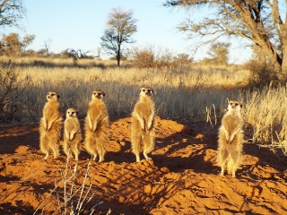
Meerkats live in the Kalahari Desert. This is their home or another word for an animal's home is its habitat.
The Kalahar Desert is hot and dry in Summer time and can reach temperatures of 40, which is very hot!
It was 26 on our hottest day in May! I thought that was hot!
In the winter months the Kalahari Desert's temperature can drop right down to 0.
The word 'Kalahari' comes from an African word meaning 'waterless place' However the sand keeps hold of lots of water even when it is hot so there are plants that can grow well there. 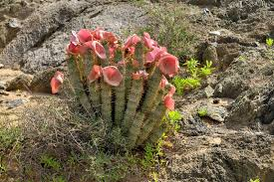

The Kalahari Desert is the natural habitat for many African animals including meerkats. Meerkats are specially suited to live there. They have thin fur to keep them cool in the heat, dark circles around their eyes to stop the glare ofthe sun and sharp claws to dig their burrows in the sand.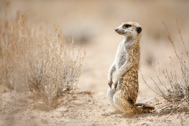
Watch the 2 clips below and then draw Sunny in his habitat- The Kalahari Desert.
Clip 1-Scenes from the Kalahari Desert https://www.youtube.com/watch?v=vu9oA3GQmQ4
Clip 2-Emily Gravett teaches us how to draw Sunny https://www.youtube.com/watch?v=mDBnlYrKQA4

Computing- In computing can I play number bond games?
I have set you some 'to do' number bond bubble games to help you with your adding this week.

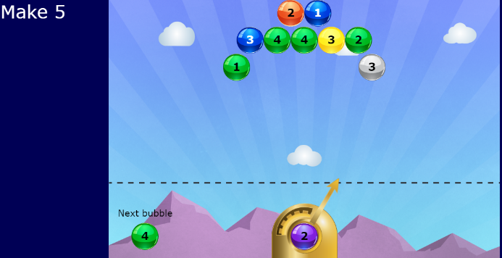

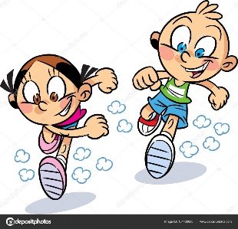
PE-
As sports people- Can you create my own sports Day events
Mr Dooley has sent the following games for you to try at home. Click on the link below.
Sports Day activities- link

Have fun!

