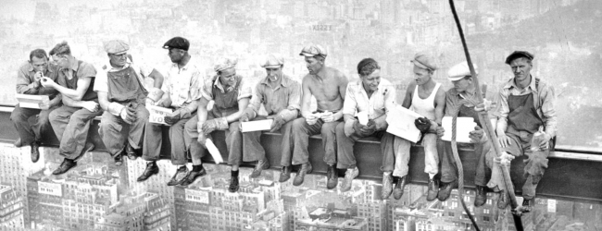

Year 5/6

Y5/6 Foxes
15.6.20
Good Morning Y5/6 Foxes and welcome to the third week of June. It's been a very rainy week, but hopefully that will improve. At the bottom of our webpage you will find a little video to say hello and to talk you through what we are doing this week.
I have also attached a timetable you might like to use to help you with your learning. This is to give you an idea of what learning will look like in school.
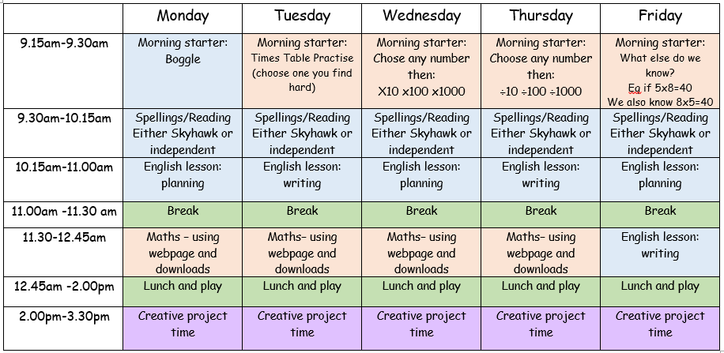

You will find activites to do on PurpleMash, Mathletics as well as ones to do in your homelearning books.
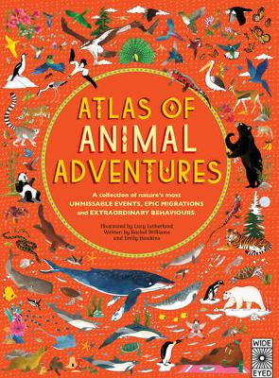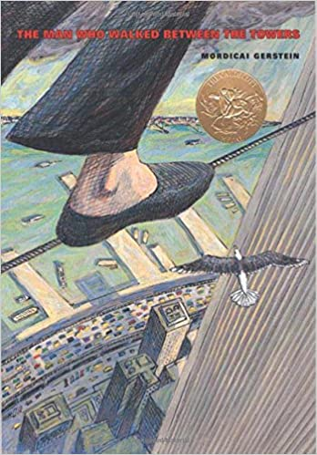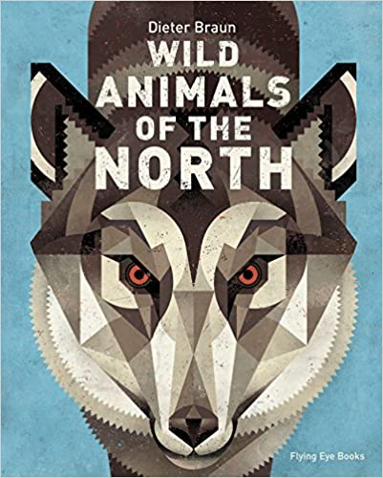
Don't forget to keep checking mathletics, purplemash and carry on competing on TTrockstars.
If you have forgotten your passwords for any website email: admin@stoswald-worl.cheshire.sch.uk
Click here for TT Rockstars login
Click here for Mathletics login
Click here for Purple Mash login

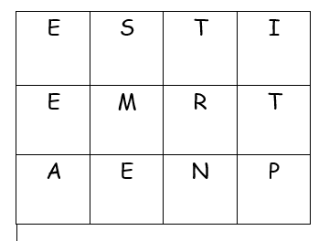
English Morning Starter: This week's boggle includes the letters of 'EMPIRE STATE' and an extra 'n'. How many words can you make? What is the longest word you can make?

Maths Morning Starter: If we know that 5x8=40, what else can we work out?

Year 5
Writing: We are continuing class book - The Man Who Walked Between the Towers. YOUR LESSONS ARE ALL DOWNLOADABLE AND ARE IN AN ORDER.
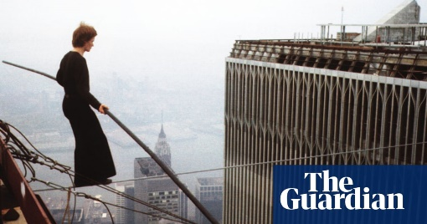
lesson 4) Philippe is planning something extreme. Can you encourage him that it might not be the best idea?
Click here for lesson 4
Lesson 5) Philippe needs to think this through and come up with a plan. Can you help him put one together?
Click here for lesson 5
Lesson 6) Philippe is on the move and has come up with a cunning plan but what would they have been talking about at this point?
Click here for lesson 6
You can choose whether you do these in your home-learning book or email them back to me.
Spelling: For spelling this week, we are looking at the silent letter 'w'. It's quite a tricky one. There are downloable spellings to practise and then if you would like to do it, there is a spelling quiz on purplemash for later on in the week.
Click here for spellings

Reading: Have a listen to the three chapters at the very bottom of the webpage and then try and answer the questions that go with them.
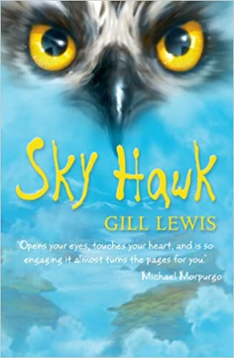
Chapter 7:
- How do you think Callum felt about Iona coming to school? What gives you that impression?
- Did Iona fit in, why?
Chapter 8:
-Can you summarise what has happened in this chapter?
-How does this chapter make you feel? Why?
Chapter 9:
-What do you think about that last paragraph?
-What do you think will happen next?
Maths: In maths, we are carrying on with measure and looking at perimeter.
This week we are looking at perimeter and using our knowledge of measure to help us with this.
Click here for a Miss Ramage tutorial
Remember: Perimeter = paw prints around the edge of the shape. The dog cannot go inside.
Have a go at the activities below this week.
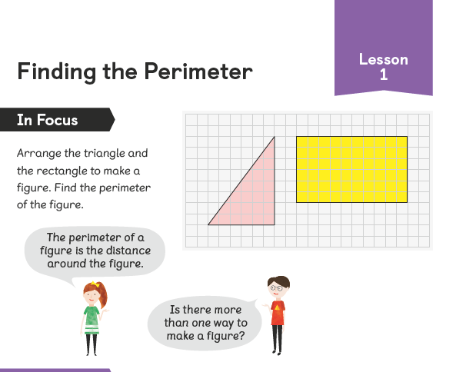
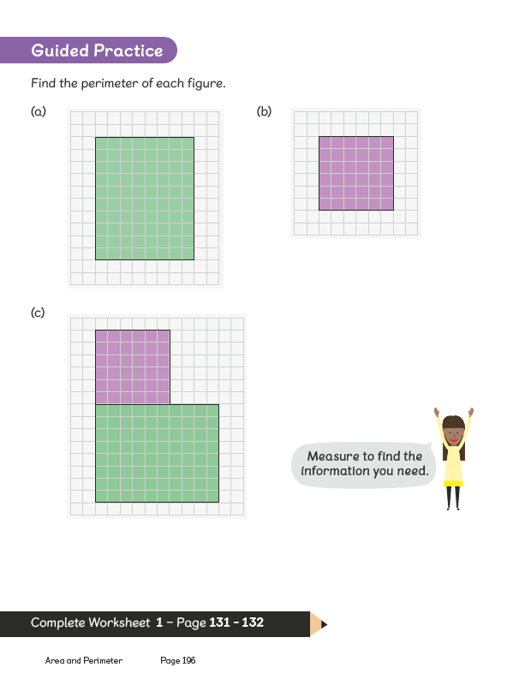
Click here for perimeter questions
Year 6
Writing: We are continuing class book - The Man Who Walked Between the Towers. YOUR LESSONS ARE ALL DOWNLOADABLE AND ARE IN AN ORDER.
lesson 4) Philippe is planning something extreme. Can you encourage him that it might not be the best idea?
Click here for lesson 4
Lesson 5) Philippe needs to think this through and come up with a plan. Can you help him put one together?
Click here for lesson 5
Lesson 6) Philippe is on the move and has come up with a cunning plan but what would they have been talking about at this point?
Click here for lesson 6
You can choose whether you do these in your home-learning book or email them back to me.
Spelling: For spelling this week, we are looking at the silent letter 'w'. It's quite a tricky one. There are downloable spellings to practise and then if you would like to do it, there is a spelling quiz on purplemash for later on in the week.
Click here for spellings
Reading: Have a listen to the three chapters at the very bottom of the webpage and then try and answer the questions that go with them.
Chapter 7:
- How do you think Callum felt about Iona coming to school? What gives you that impression?
- Did Iona fit in, why?
Chapter 8:
-Can you summarise what has happened in this chapter?
-How does this chapter make you feel? Why?
Chapter 9:
-What do you think about that last paragraph?
-What do you think will happen next?
In Maths we are continuing to look at data handling and are moving onto line charts:
Click here for a helpful Miss Ramage video
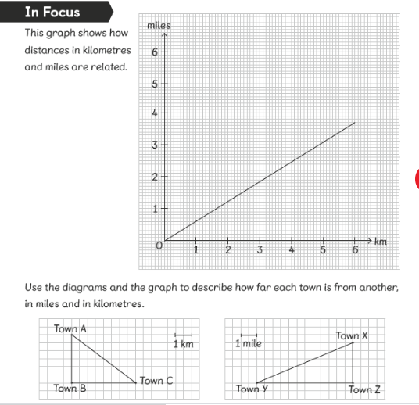

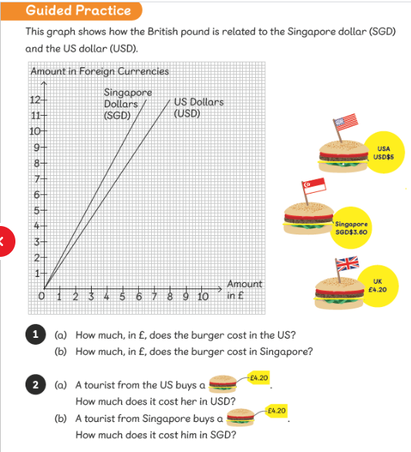
Click here for activities
Click here for activities 2
Have a go at one of the two challenges below:
Art: This is possibly one of the most famous photographs ever taken of New York, ‘lunch on a skyscraper’. Can you have a go at sketching your own version of this? You could even get your family involved and create your own version of this photograph.

History: How many presidents can you name? Don't worry if you find it hard.
https://www.youtube.com/watch?v=0JlhiwNpui0
Can you research and find out about a famous president and how they changed the USA. You might wish to make a poster or fact file about them. Eg. George Washington was the first president.

