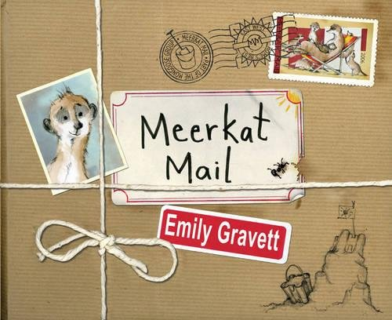
Meerkat Mail comprehension answers

1.dry, hot

2. Stay safe, stay together!

3. perfect

4. He promises to write

5. Uncle Bob

6. He is bigger than them

7. He is itchy because of the termites

8. On a farm

9. Rainy

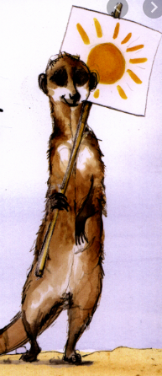
10. He is afraid of the dark

11. choose 3 from- snails, frogs, earthworms, larvae, custaceans, small reptiles, insects

12.’I’m home’- he is feeling happy/ excited/ content/

