Year 5/6

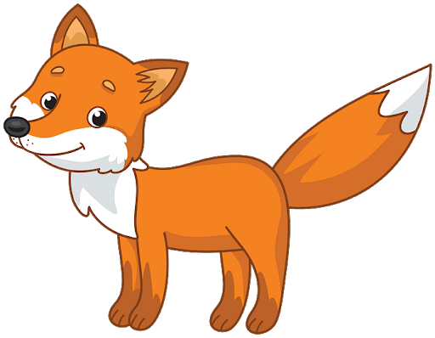**Y5/6 Foxes**

22.6.20

Good Morning Y5/6 Foxes to the last week of June - that's right, we're at the end of another month. Click on the picture below to find out what you are up to this week and to say a little hello.

[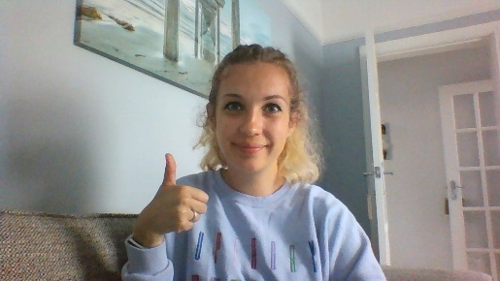](http://www.stoswald-worl.cheshire.sch.uk/uploads/24/files/WIN_20200619_10_37_08_Pro.mp4)

I have also attached a timetable you might like to use to help you with your learning. This is to give you an idea of what learning will look like in school.

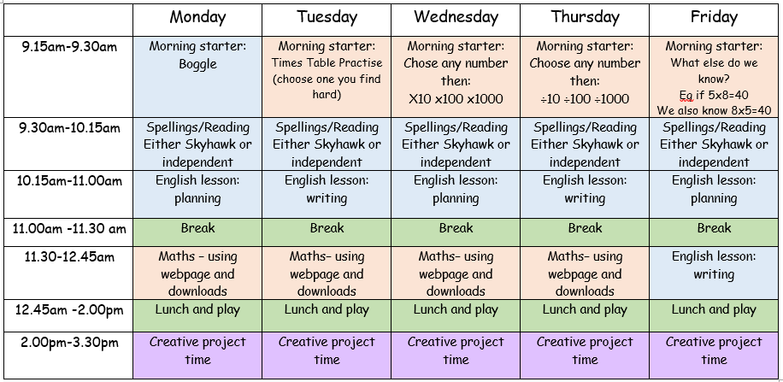

Don't forget to keep checking mathletics, purplemash and carry on competing on TTrockstars.

*If you have forgotten your passwords for any website email: admin@stoswald-worl.cheshire.sch.uk*

[Click here for TT Rockstars login](https://play.ttrockstars.com/auth/school)

[Click here for Mathletics login](https://login.mathletics.com/?_ga=2.224072091.189558914.1584605472-830787568.1515509427)

[Click here for Purple Mash login](https://www.purplemash.com/sch/stoswald-cw5)

[Click here for this week's morning starters](http://www.stoswald-worl.cheshire.sch.uk/uploads/24/files/STARTERS%201.docx)

Year 5

**Writing**: We are continuing class book - The Man Who Walked Between the Towers. **YOUR LESSONS ARE ALL DOWNLOADABLE AND ARE IN AN ORDER.**

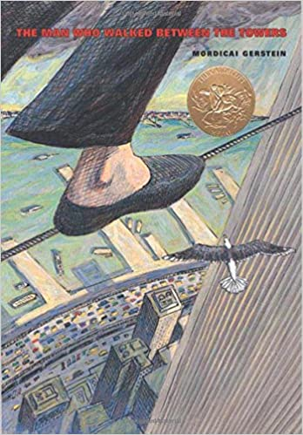      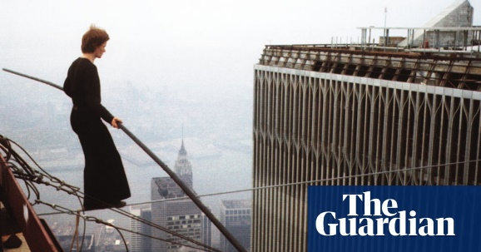

lesson 7) He's arrived on the roof and what a view it is. How might he be feeling?

[Click here for lesson 7](http://www.stoswald-worl.cheshire.sch.uk/uploads/24/files/lesson%207.docx)

Lesson 8) He sends an arrow flying across the night sky - can you imagine watching it?

[Click here for lesson 8](http://www.stoswald-worl.cheshire.sch.uk/uploads/24/files/lesson%208.docx)

Lesson 9) Imagine being one of Philippe's friends. How would you feel watching him?

[Click here for lesson 9](http://www.stoswald-worl.cheshire.sch.uk/uploads/24/files/lesson%209.docx)

You can choose whether you do these in your home-learning book or email them back to me.

**Spelling:**For spelling this week, we are revisiting mixed 'ible' and 'able'. There are downloable spellings to practise and then if you would like to do it, there is a spelling quiz on purplemash for later on in the week.

[*Click here for this week's spelling*](http://www.stoswald-worl.cheshire.sch.uk/uploads/24/files/Year6Autumn1Week5LSCWC.pdf)

**Reading**:   Have a listen to the three chapters at the very bottom of the webpage and then try and answer the questions that go with them.

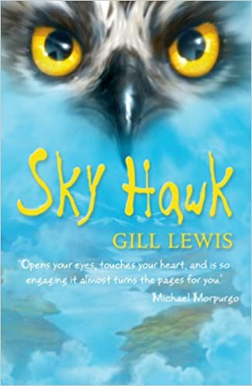

Chapter 10:

- How differently do Callum and Iona react? Are their emotions different?

-Who do you think they might ask for help?

Chapter 11:

-Do you like the character of Hamish? What have we learnt about him?

-Can you draw a picture of this scene?

Chapter 12:

-How did Callum feel watching Iris fly off?

-How do you think you would feel at this point in the story?

**Maths:** In maths, we are moving on from perimeter to look at area, we will be coming back to it though.

This week we are looking at area and using our knowledge of measure and perimeter to help us with this.

[Click here for a Miss Ramage tutorial](http://www.stoswald-worl.cheshire.sch.uk/uploads/24/files/WIN_20200619_10_41_18_Pro.mp4)

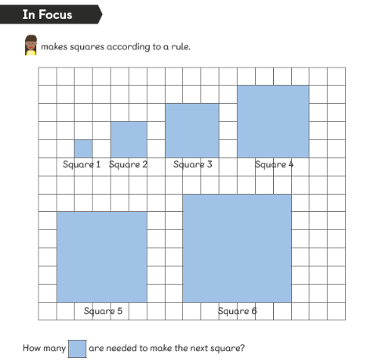

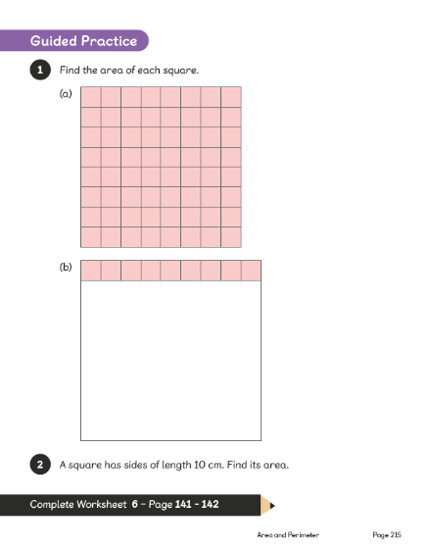

[Click here for area questions 1](http://www.stoswald-worl.cheshire.sch.uk/uploads/24/files/y5%20area%201.docx)

[Click here for area questions 2](http://www.stoswald-worl.cheshire.sch.uk/uploads/24/files/y5%20area%202.docx)

Year 6

**Writing**: We are continuing class book - The Man Who Walked Between the Towers. **YOUR LESSONS ARE ALL DOWNLOADABLE AND ARE IN AN ORDER.**

      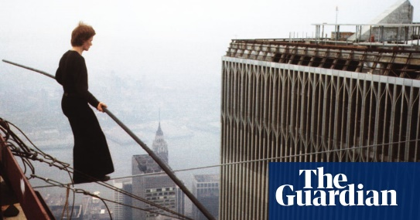

lesson 7) He's arrived on the roof and what a view it is. How might he be feeling?

[Click here for lesson 7](http://www.stoswald-worl.cheshire.sch.uk/uploads/24/files/lesson%207.docx)

Lesson 8) He sends an arrow flying across the night sky - can you imagine watching it?

[Click here for lesson 8](http://www.stoswald-worl.cheshire.sch.uk/uploads/24/files/lesson%208.docx)

Lesson 9) Imagine being one of Philippe's friends. How would you feel watching him?

[Click here for lesson 9](http://www.stoswald-worl.cheshire.sch.uk/uploads/24/files/lesson%209.docx)

You can choose whether you do these in your home-learning book or email them back to me.

**Spelling:**For spelling this week, we are revisiting mixed 'ible' and 'able'. There are downloable spellings to practise and then if you would like to do it, there is a spelling quiz on purplemash for later on in the week.

[*Click here for this week's spelling*](http://www.stoswald-worl.cheshire.sch.uk/uploads/24/files/Year6Autumn1Week5LSCWC.pdf)

**Reading**:   Have a listen to the three chapters at the very bottom of the webpage and then try and answer the questions that go with them.

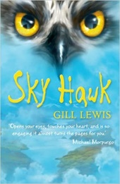

Chapter 10:

- How differently do Callum and Iona react? Are their emotions different?

-Who do you think they might ask for help?

Chapter 11:

-Do you like the character of Hamish? What have we learnt about him?

-Can you draw a picture of this scene?

Chapter 12:

-How did Callum feel watching Iris fly off?

-How do you think you would feel at this point in the story?

In Maths we are going to be looking at the parts of a circle:

[Click here for help a Miss Ramage tutorial](http://www.stoswald-worl.cheshire.sch.uk/uploads/24/files/WIN_20200619_10_40_08_Pro.mp4)

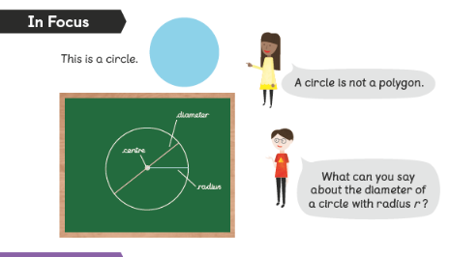

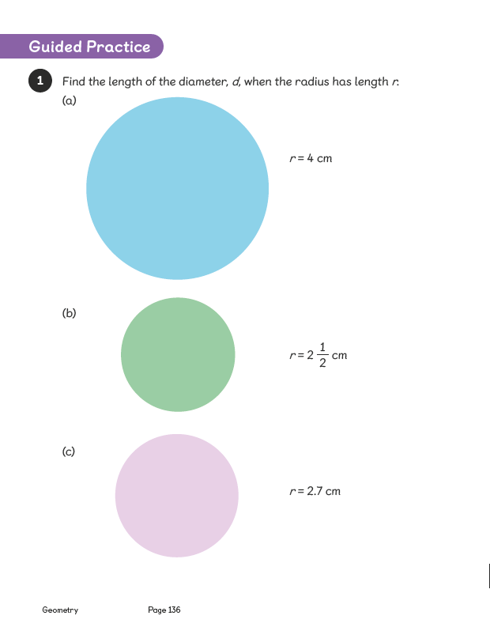

[Click here for activities on circles](http://www.stoswald-worl.cheshire.sch.uk/uploads/24/files/y6%20circles.docx)

Have a go at one of the two challenges below: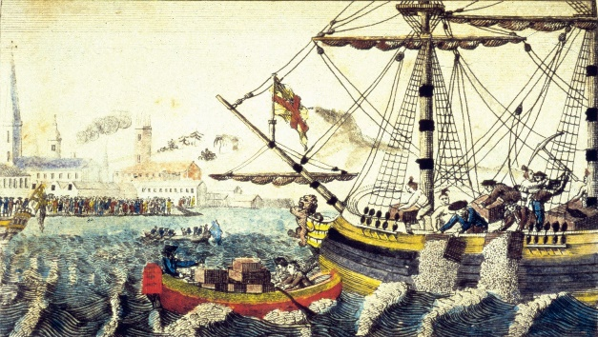

**History: In History this week, we are learning all about the Boston Tea Party. Have you ever heard of it? Below you can learn all about it and there are some activities to have a go at too.**

[Click here to learn all about the Boston Tea Party and for activities too](http://www.stoswald-worl.cheshire.sch.uk/uploads/24/files/boston%20tea%20party.docx)

**Science:** Did you know that the state animal of New York is a beaver? It has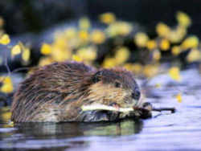 been the state mammal since 1975. Beavers can be found in the United Kingdom too.

[Click here to learn about beavers](https://kids.nationalgeographic.com/animals/mammals/beaver/)

Can you create a fact file about beavers, their habitats and how they have adapted to meet their environments.

*At the bottom of the page there are also some extra packs of maths, spag, reading to keep ploughing through.*