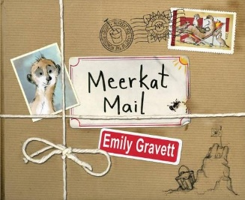
Meerkat Mail comprehension questions

- What are the two words that the author uses to describe the Kalahari Desert?

- What is the meerkat family’s motto?

- Which word does sunny use in his letter to describe the new home he is going to find?

- What promise does Sunny make in his letter to his family?

- Who does Sunny visit on Monday?

- How is Sunny different to Uncle Bob’s mongoose family?

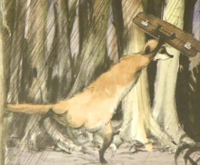
- How does Sunny feel while he is writing his postcard on Tuesday?

- Where does Cousin Edward live?

- What does Sunny change his name to in Thursday’s postcard?

- What is Sunny afraid of in Madagascar?

- Name 3 foods on the menu in the Dive-in restaurant.

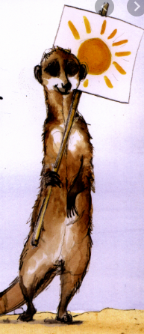
- Which two words does Sunny write on Sunday’s postcard and how does it make him feel?

