Year 5/6

Y5/6 Foxes
29.6.20
Good Morning Y5/6 Foxes, this week we head into July and the last three weeks of term. I am so proud of you all and how hard you are working. Click the picture below for this week's video.

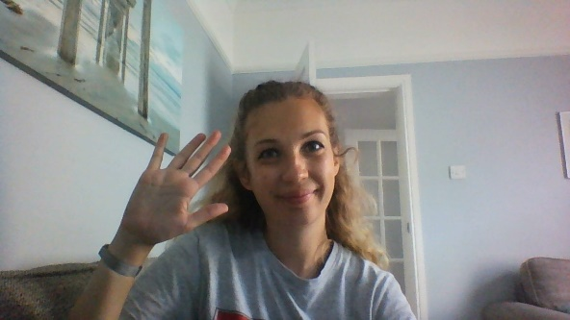
I have also attached a timetable you might like to use to help you with your learning. This is to give you an idea of what learning will look like in school.
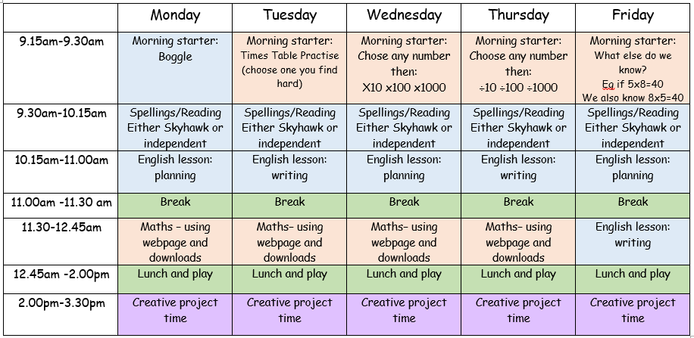

Click here for this week's morning starters

Year 5
Writing: We are continuing class book - The Man Who Walked Between the Towers. YOUR LESSONS ARE ALL DOWNLOADABLE AND ARE IN AN ORDER.
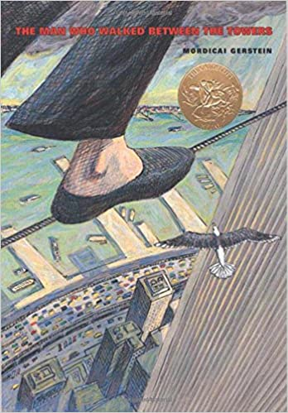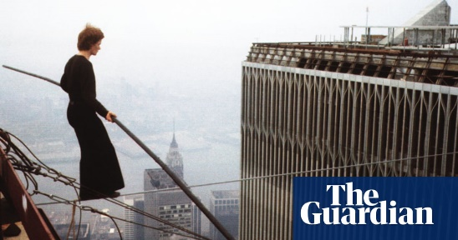
Lesson 10) They've got the rope across but isn't it rather heavy? It could be a close call.
Click here for lesson 10
Lesson 11) The sun is rising; it's time to step foot on the tightrope.
Click here for Lesson 11
Lesson 12) What a view. Philippe is walking on air and can feel the breeze on his face. How is he finding it?
Click here for lesson 12
You can choose whether you do these in your home-learning book or email them back to me.
Spelling: For spelling this week, we are revisiting 'ant'. There are downloable spellings to practise and then if you would like to do it, there is a spelling quiz on purplemash for later on in the week.
Click here for spellings

Reading: Have a listen to the three chapters at the very bottom of the webpage and then try and answer the questions that go with them.

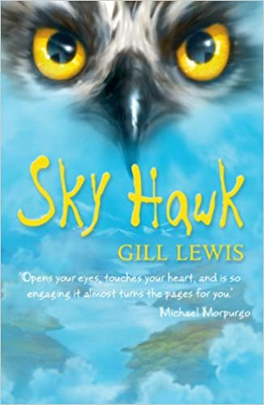
Chapter 13:
- How has Rob and Callum's relationship changed?
-What do you think Iona saw in the photograph?
Chapter 14:
- Why do you think Callum kept the farm hidden and called it his 'secret place'?
-Why did he want do diary entries?
Chapter 15:
-How do you think Iona feels about her mum?
-What has this got to do with Iris?
Maths: In maths, we are continuing with area but moving onto harder compound shapes. You will need all your prior knowledge of area to help you.
Click here for a Miss Ramage tutorial
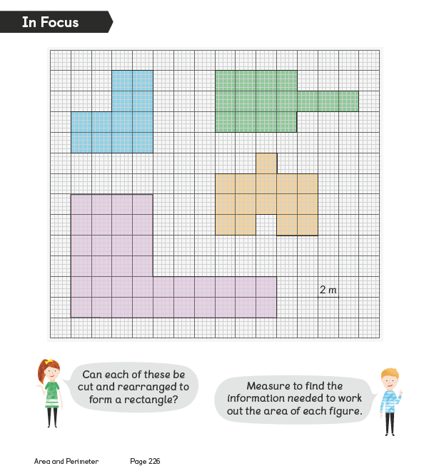
Click here for to see how to do it
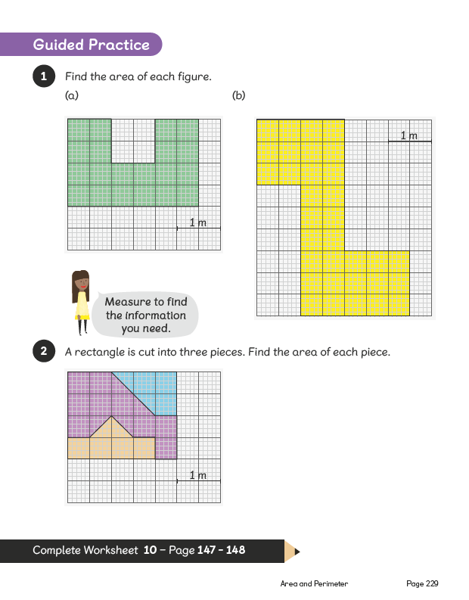
Click here for activities
Click here for more activities

Year 6
Writing: We are continuing class book - The Man Who Walked Between the Towers. YOUR LESSONS ARE ALL DOWNLOADABLE AND ARE IN AN ORDER.
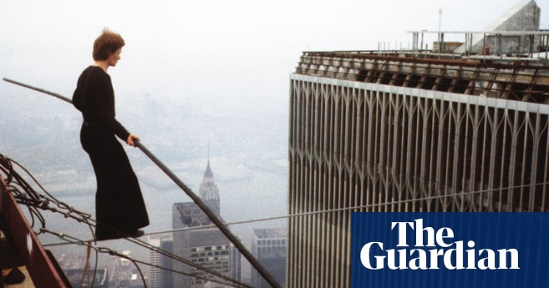
Lesson 10) They've got the rope across but isn't it rather heavy? It could be a close call.
Click here for lesson 10
Lesson 11) The sun is rising; it's time to step foot on the tightrope.
Click here for Lesson 11
Lesson 12) What a view. Philippe is walking on air and can feel the breeze on his face. How is he finding it?
Click here for lesson 12
You can choose whether you do these in your home-learning book or email them back to me.
Spelling: For spelling this week, we are revisiting 'ant'. There are downloable spellings to practise and then if you would like to do it, there is a spelling quiz on purplemash for later on in the week.
Click here for spellings
Reading: Have a listen to the three chapters at the very bottom of the webpage and then try and answer the questions that go with them.
Chapter 13:
- How has Rob and Callum's relationship changed?
-What do you think Iona saw in the photograph?
Chapter 14:
- Why do you think Callum kept the farm hidden and called it his 'secret place'?
-Why did he want do diary entries?
Chapter 15:
-How do you think Iona feels about her mum?
-What has this got to do with Iris?
In Maths: We will be doing the smartie challenge in school. If you would like to join in, you need a tube of smarties and to download the booklet below.
Click here for the smartie challenge
If you cannot access the smartie challenge, have a go at some of the challenges below.
Click here for mixed calculations
Click here for a range of mixed challenges
Have a go at one of the two challenges below: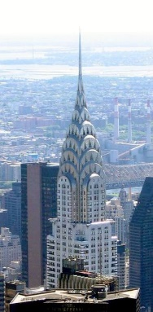
Design Technology: New York is full to bursting with skyscrapers. This week you have a range of activities linked to skyscrapers and their amazing designs. There are 4 activities to work through in the pack below and then a maths challenge to have a go at too. Can you become a 1920's skyscraper designer?
Click here for skyscraper project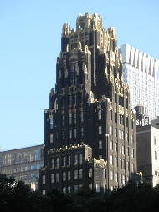
Click here for maths skyscraper challenge

