Division
In year 2 we start to use the sigh for division which looks like this ÷
Remember that division is the opposite to multiplication.
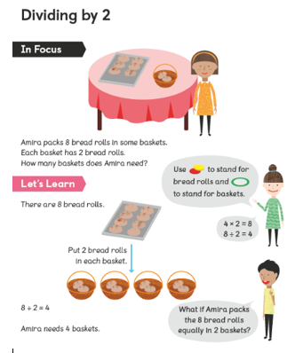
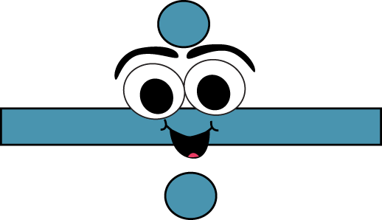
Division
÷ 2
Draw 2 circles to help you divide the number equally using the ‘one for you, one for me’ method.
6 ÷ 2 =
8 ÷ 2 =
10 ÷ 2 =
4 ÷ 2 =
12 ÷ 2 =
2 ÷ 2 =

÷ 3
Draw 3 circles to help you divide the number equally
6 ÷ 3 =
12 ÷ 3 =
9 ÷ 3 =
3 ÷ 3 =
15 ÷ 3 =
18 ÷ 3 =

Division word problems
Can you write the calculation using the ÷ and = signs and find the answer for each problem below?
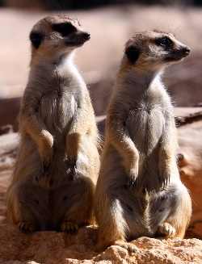
- 8 scorpions are shared equally by 2 meerkats for lunch.
How many do they get each?

_____ ÷ _____ = _____
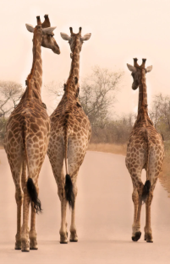
- There are 9 leaves left on a tree.
3 giraffes share them fairly
How many do they get each?

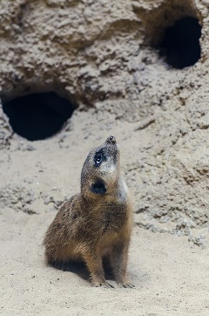
- 12 meerkats live equally between 2 burrows.
How many meerkats live in each burrow?

- 3 zebras have the same number of black stripes.
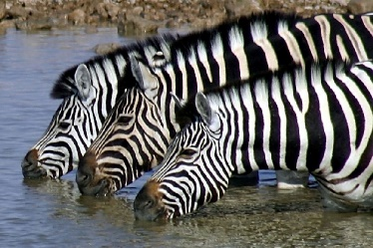
There are 12 stripes altogether,
How many stripes does each zebra have?

