Year 1/2
Week beginning: Monday 6th July 2020 Summer term 2- Week 6 out of 7

Hello Deer Class
I hope you have all had a lovely weekend and have done a bit of relaxing just like this funny, chilled-out meerkat.
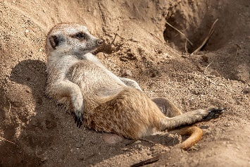
Click on the picture below to hear my introduction to our week's learning.
This week I have set you maths work (dividing numbers equally), writing (create your own animal adventure story), music (learn to sing an African song), science (food chains) and art (silhouette pictures).
In class this week Alba told us that her Nanny had been to Egypt where she had seen the pyramids and ridden on a camel.
Egypt is another country in Africa. Can you find it on the map?
Clue- Look North!
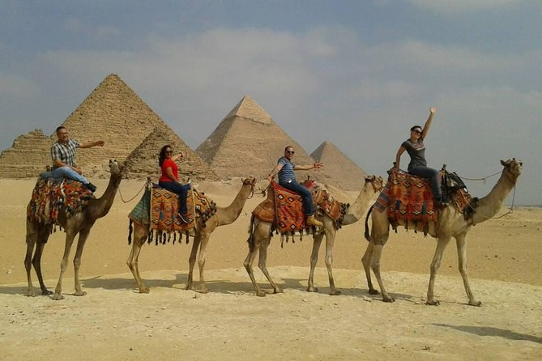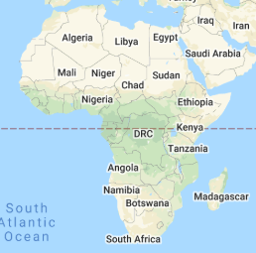

Our year 1 children back in school are working from this webpage, just as you are at home.
We will be following this timetable should you want to do something similar. Please continue to do whatever works for you though as there is no right or wrong answer!
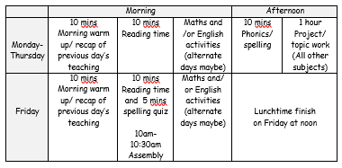
Have fun completing some or all of these activities and I look forward to seeing your work and receiving your emails if you would like to share anything!
Have a lovely week.
Still missing you all lots!

Love from Miss Dutton x

Click here to enter online Purple Mash resources
Click here to enter Mathletics
Click here to enter TT Rockstars

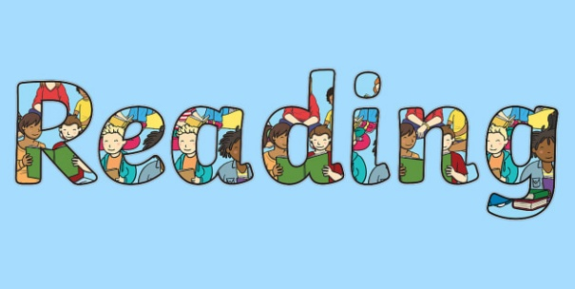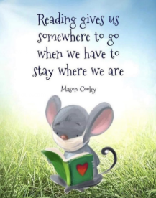
Use the link below to register on the Oxford Owls website. It is easy to set up the registration and it will give you access to a range of ebooks for ages 3-11.
Oxford Owl E Book Registration- link

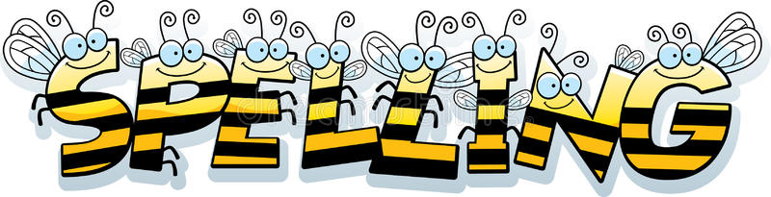
Reading and Spelling - It is really important that you can all read and write words with the sounds below. Keep practising them! Can you choose a sound and write 6 words for it. Try to learn to spell 5 common exception words each week too.
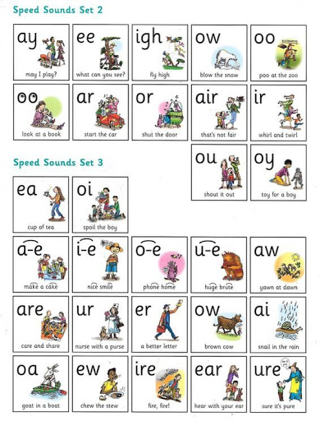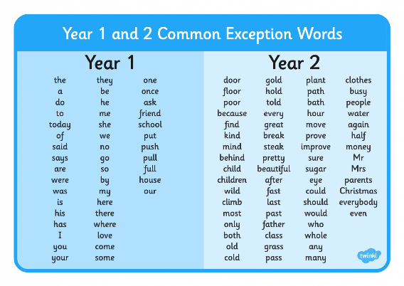
Year 1 children- Check you can spell these words from the list above?

one once ask friend school
Year 2 children-
Last week we learned to spell words that ended in 'al' like jackal. Sometimes this sound at the end of words can be spelled by adding 'el' to the end instead.
This week I would like you to learn to spell these 6 words that end in 'el'.

camel angel model travel tunnel parcel

Maths
* * * Please keep practising temperature, mass, capacity, time telling, adding, subtracting and counting in 2s, 3s, 5s and 10s to learn your times tables. There are also maths challenges for year 1 and year 2 in the files at the bottom of this page. * * *
As mathematicians- Can you divide numbers by sharing equally?

Warm up- Use your fingers to help you with some of these if you get stuck.
What is...
Double 2? Double 10? Double 6? Double 4?
Double 3? Double 1? Double 7? Double 0?
Double 8? Double 9? Double 20? Double 50?

Division
This week your activities are all linked to Division.
Division is the opposite of multiplication which we learned about last week.
Multiplying gives us a bigger answer whereas division gives us a smaller answer.
Division is all about sharing equally and dividing objects and numbers up carefully.
These two girls are packing their bags for a trip and sharing the items.
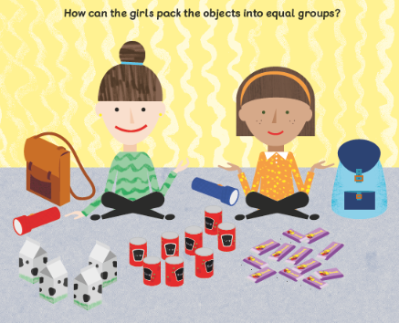
When we divide we do the 'one for you, one for me' method so that it is fair and the groups will be equal.
1.) How many torches will they get each?
2.) How many cartoons of milk will they get each?
3.) Can you see where you can split the cans of beans in half so they get the same amount?
4.) Draw yourself the 2 girls and draw the 12 snack bars next to them by doing the 'one for you, one for me' method to see how many they will get each.
You could draw the 12 bars too if you like and cross them out each time you give one to the girls.

Click on the links below to find your activities for this week. You don't have to print these you can just write the answers down if you like.
There is a number line to 20 and a hundred square too should you need them.

Division- Sharing into equal group- Activities

Using the division sign- Activities

Number line 0-20
100 square

Science
As scientists- Can you draw and label a food chain?

Last week you sorted African animals into these 3 groups.
carnivores that eat meat,
herbivores that eat plants,
omnivores that eat both plants and meat.

This week we are going to learn about food chains.
Click on the link below to hear an explanation.

What is a food chain? https://www.bbc.co.uk/bitesize/topics/zx882hv/articles/z3c2xnb - video

Here are some more examples of food chains all starting with a plant, then herbivores and lastly carnivores.
The predator in the food chain is the animal that hunts other animals.
The prey is the animal that is being hunted.
Can you point out both of these in each food chain?
Sometimes an animal might be both!
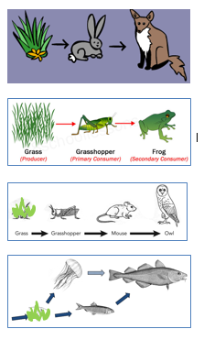
Challenge 1- Play this food chain challenge game where you make African food chains in the Savannah grasslands.
Food chain challenge https://www.bbc.co.uk/bitesize/topics/zbnnb9q/articles/z93vdxs- game

Challenge 2- Draw and label your own food chain for African animals of your choice. Remember to start with a plant and the arrows should be facing the animal who is doing the eating like in the examples above.
Here are some African plants and animals that you might like to pick from for your food chain.
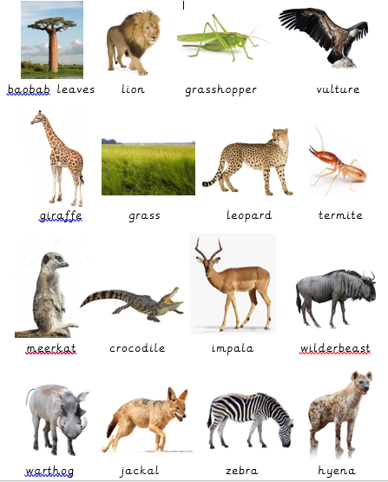

Writing
As writers- Can you write your own adventure story for an African animal of your choice?
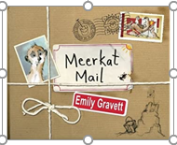 Meerkat Mail by Emily Gravett- https://www.youtube.com/watch?v=7lEigAZpusIstory video

In our book 'Meerkat Mail' Sunny goes on an adventure to different places to find a new home.
This week I would like you to choose a different African animal and write and illustrate an adventure story for them on their journey to find a better place to live.
Maybe your creature is being followed by a predator just like Sunny was! You could draw your predator in each picture as Emily Gravett does.
You might like to follow this story structure

1. Character in their habitat/ home. Feeling unhappy.
2. Choose African places for them to go and visit (marsh, sand dunes, tree, family members, beach, burrow, grasslands, city of Cape Town)
3. Character returns back home and realises that home was always perfect in the first place.
4. Character celebrates with family.
Here are some character ideas for you.
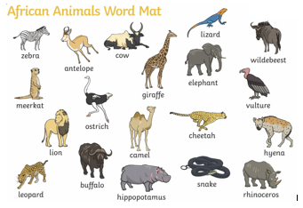

Don't forget to use punctuation in sentences such as capital letters, full stops, commas, maybe even exclamation marks and question marks. Try to use interesting adjectives (describing words) and conjunctions (joining words) such as 'and, but, so, because, when, that, if, or'.

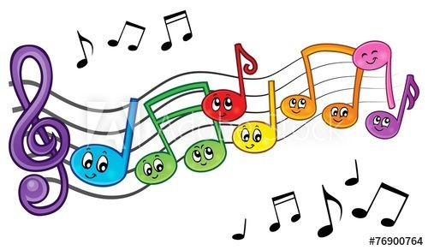
Music
As a musician- can you learn the words to an African song?

This song is called 'Maliswe'.
Maliswe is the name of a young African boy, who like Sunny the meerkat goes on his own adventure. His family sing the song asking for him to come back home.
These are the words for you to try and learn so you can sing along.
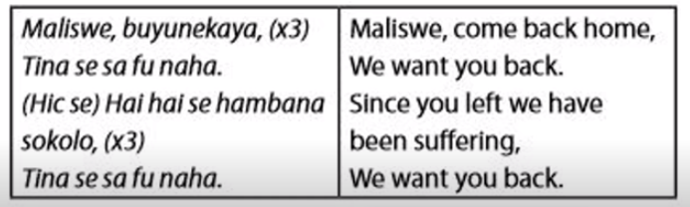
Click on the link below to hear the song.
You might want to play your African shaker instrument along to it too.
Maliswe https://www.youtube.com/watch?v=PkkyWej1Fz4- Song

I can't currently find the actions on the internet so watch this space as I will be attaching a video of the children in school doing the actions for you.

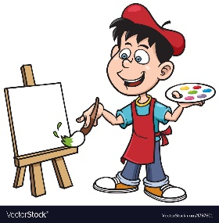
Art
As an artist- can you create a silhouette picture?

Have a go at creating a beautiful sunrise/ sunset background and then add black cut outs or paint on black silhouettes for African animals and plants like these below.
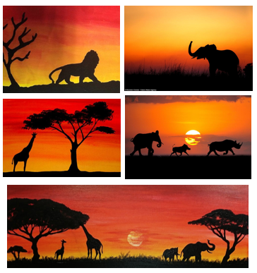
Here are some silhouettes to help you. A silhouette is the dark shape of something seen against a light background.
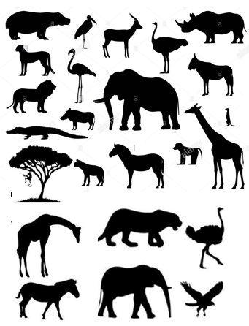
Have fun!

Computing
In computing can I type a postcard?
On Purple Mash I have set you a 'to do' postcard from Africa.
Write a message home as though you are in your favourite part of Africa. Maybe you are in one of these places
-on safari seeing all of the amazing animals
- in Cape Town at the stadium watching a game of football or rugby
-at the top of Table Mountain,
- in Egypt riding on a camel and seeing the pyramids
- on the beach watching sharks swimming in the sea.
There are 2 postcards to pick from...
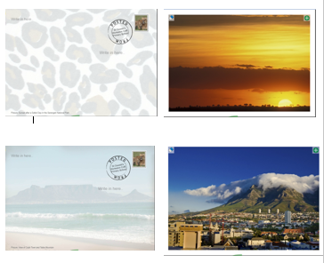

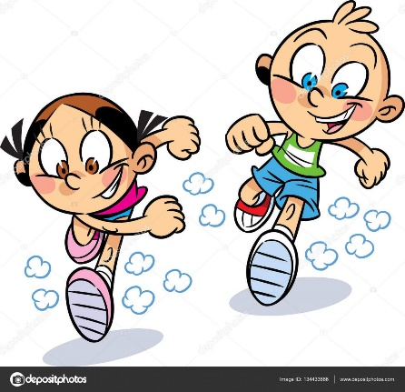
PE
As sports people- Can you try out some orienteering activities?
Mr Dooley has sent you the following message...

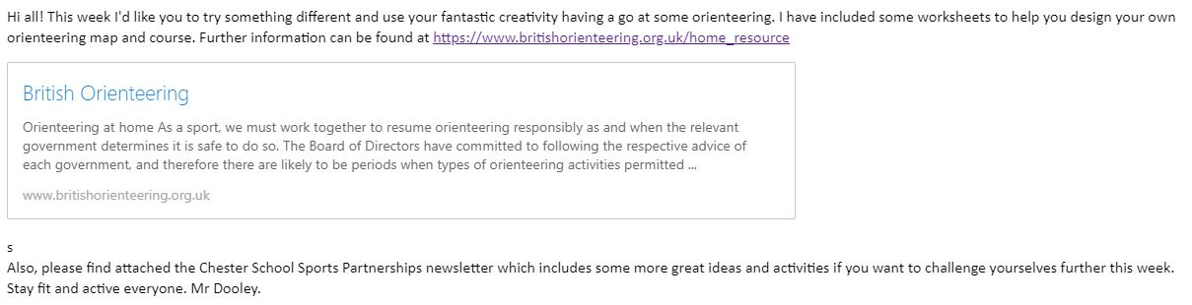
Create your own map
Garden orienteering
Numbered markers
Other activities

Have fun!

