Personal, Social, Emotional Development
- What do you think it would feel like to be in space, who would you want to take with you? Have you ever stayed away from your family? Do you think astronauts miss their families when they are in space?
Maths
- Can you complete the daily maths sheets based on ‘The Dinosaur That Pooped a Planet’?
- Watch some Numberblocks episodes
- Have a go at an activity on Mathletics
- Sing 5 Little Men on a Flying Saucer

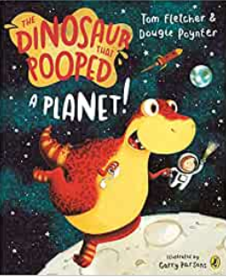

Physical Development

- Join in with Cosmic Kids Yoga Adventure, a tiny T-Rex who learns all about looking after his teeth. You can find the link here

Communication and Language
- Can you talk with a grown up about what you know about space?
- Can you look at the stars at night time and then talk about what you can see?
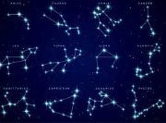
Understanding the World

- Can you complete a task on Purple Mash?
- Can you research your favourite dinosaur? Where would you find the information? How big was it? What did it eat? What colour was it?
- Freeze some dinosaurs in water? How can you rescue them? What could you use? How quickly does the ice melt?
Expressive Arts and Design

- Get some playdough out and make some dinosaurs, add some pasta to decorate
- Join in with some dinosaur or space themed songs here or here
- Create your own planet. What does your planet look like? Do aliens live there? Do they have pets? Get creative and draw your very own space scene!
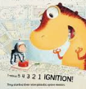
- Can you make a constellation picture using black paper, gold stars and white chalk?
- Make a simple cardboard tube rocket with a deflated balloon taped to it, thread a string through the tube and ask two people to hold either end. Then ask an adult to blow up the balloon and release it. How far will your rocket travel?
- Create a vehicle that you could use to travel into space. What would it look like? You could create a rocket using cardboard tubes, a spacecraft using old boxes or you could design a different type of vehicle to get you there!

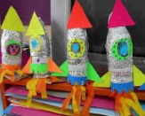

- Listen to Gustav Holstz ‘The Planet Suite –Venus’ here. While you are listening to it, draw what you think the planet might look like. What colour would it be? Can you talk to a grown up about what you think it would be like on the planet?

Literacy
- Visit the Ruth Miskin website and watch a video on any of the sounds you need to practise. The schedule for this half term is here.
- Use Oxford Owl to practise your reading.
- Read a variety of books.
- Interactive Games on Phonics Play Enter the details that appear on the home screen to enter.
- Listen to the story of The Dinosaur Who Pooped a Planet, or listen to it here
- Design your own dinosaur. Make some labels to describe it
- Can you write a postcard to send from a planet
- Can you make a list of ten things you would take with you to space?
- Can you plan a healthy and tasty meal for the dinosaur so that it won’t need to eat up everything in sight?

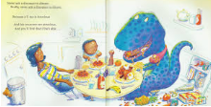

Please share anything with me electronically on Padlet, or by email.

