PAPER MACHE GLOBE CRAFT
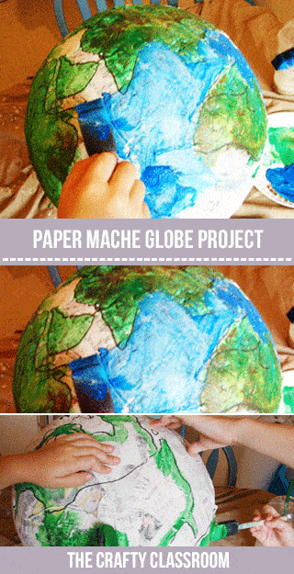
This project is perfect for anytime you’re teaching children about the world they live in. It’s a little messy, but well worth the investment!
Materials:
Paper Mache Recipe
Newspaper
Mixing Bowl
Paint (blue, green, brown, white)
Paintbrushes

Art Project Tutorial:
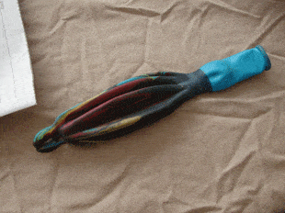

STEP 1

Choosing a balloon: Try to find a punching bag balloon because of it's size and shape when blown up. (Dollar Tree)
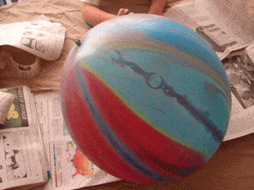

STEP 2

Blow up the balloon, and tie off the end.
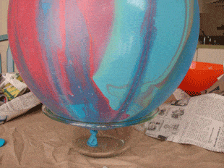

STEP 3

To keep the balloon steady, you can use a small mixing bowl as a base. Tape if necessary.
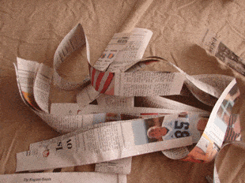

STEP 4

Cut up a pile of newspaper strips. I like them longer better so I cut vertically
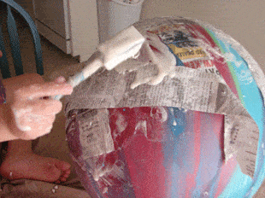

STEP 5

Mix up your Paper Mache and begin to cover your balloon with layers of paper.
View Resource
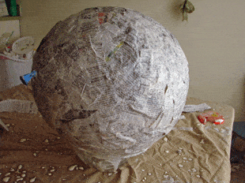

STEP 6

Once you're entire balloon is covered, let it dry. This could take a few of hours
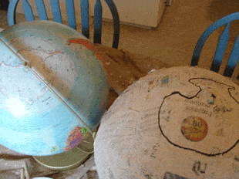

STEP 7

Draw in the continents. Older children can do it on their own, younger children will need a bit of guidence.
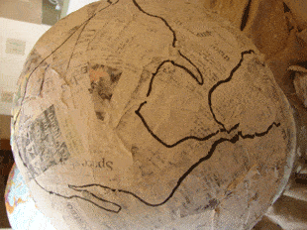

STEP 8

As you draw in the continents, point out the various places where one ends and the other meets.
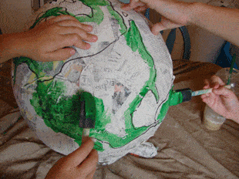

STEP 9

Now for the fun! Start to paint your continents GREEN.
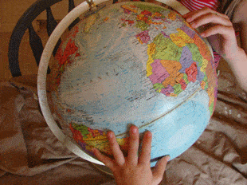

STEP 10

Then let the children feel the globe. Can they find any mountain ranges?
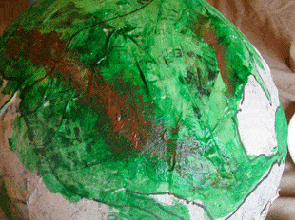

STEP 11

Go through each continent and paint in some Mountains (BROWN) where ever the children feel them.
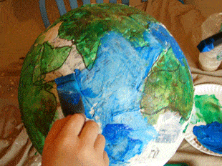

STEP 12

Now it's time for the oceans! Mix up some BLUE paint and fill in the rest! Older children can use different hues of blue to represent currents as well.
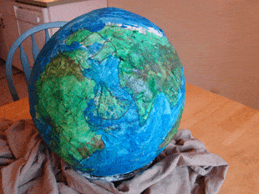

ALL DONE

Once dry you can add in the names of the continents an oceans, draw in an equator, or even wind currents!

