**World War One**

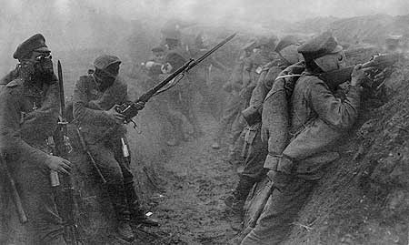

**Soldiers I know about…..**

**Walt Disney**

A famous male soldier from World War One who was the creator of Disney was Walt Disney. Walt Disney was an ambulance driver at the end of World War One from America –he was the designer of Mickey Mouse and other Disney characters.

**Harry Patch**

Harry Patch was the last British soldier alive from World War One. He was born in 1898 and he died in July 2009; I was four when he died and even Maisy was Eighteen months.

**Harry Ogden**

Harry Ogden was my great great grandfather. He was shot in the neck in 1917 and was discharged from the army. Unfortunately he died in 1932 when he was only 42.

**Frederick Beresford**

He was another great, great grandfather.He fought for the Sherwood Foresters however he sadly died in March 1919,only five months after the end of the war. We don’t know how he died, but I imagine he died of his terrible injuries. I have attached his memorial certificate for you to look at.

**What did men do in the war?**

In the war, the main men’s role was to fight. That meant that they were fighting for four years. Including the medical doctors, officers and pilots.

All of the jobs that men did were terrible, if you were a doctor you had to deal with the gruesome injuries, if you were a pilot you had a high chance of being shot down and killed. However, the worst job was probably being a soldier in the trenches because the conditions were so bad and you would feel so sorry for yourself and nervous about gas attacks and going over the top.

**What was food rationing?**

**At the start of the war people bought lots of foodto store at home.**Some shops sold out of food in days. Shops did get more food but then ships carrying food were sunk so people were not given enough food. In 1917 rationing came in and people had to grow their own crops.

Rationing meant you were given a card. It would say how much food you were allowed.Some foods that were rationed were sugar, milk and butchers meat. However, people grew their own food like carrots, potatoes and onions.

Foods that people grew themselves included………..

A recipe used by people during the world using there rations was………

**What goes on in the trenches?**

The trenches were unhygienic, however they protected the men from the enemy. The men had to sleep on the floor, although the officers had a room and a bed.

In the trenches there were rats and dead bodies and the men had to poo in a bucket. After there was a gas attack the Germans would follow with flame throwers and the men would be trapped in the trenches.

**What happened?**

A century ago in 1914 during World War One lots of terrible and tragic things happened. Nearly one million men from Britain died in the war. Ladies and children also fought in world war one; they just said they were men.

In the war you were supposed to be 18 or over to join the army, however younger boys said they were over 18 when they were really under 18. The youngest boy to fight in world war one was 12. The youngest boy to die in world war one was 15.

**What did women do in the war?**

Women’s role in the war was to be nurses, ship builders and most importantly, making weapons. Sometimes women even played football instead of men to entertain people.

[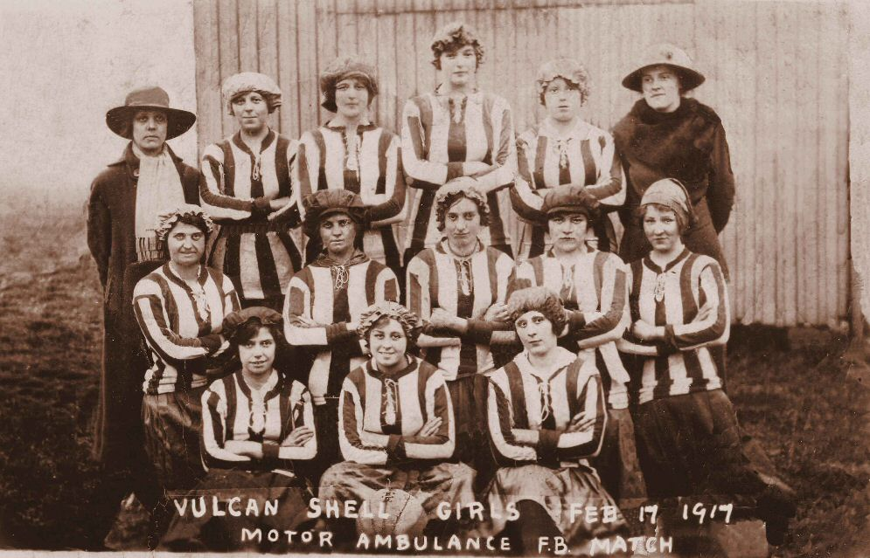](http://www.google.co.uk/url?sa=i&rct=j&q=&esrc=s&frm=1&source=images&cd=&cad=rja&uact=8&docid=kEyeFbYeYjTbcM&tbnid=iCM6hVqqap6DkM:&ved=0CAUQjRw&url=http://www.enuii.org/vulcan_foundry/photographs/staff/caught%20on%20camera.htm&ei=Bkd3U-LpMuiV0QWn-ICgAQ&psig=AFQjCNHJikx4vGznlmF966aNYiPXkxEkhQ&ust=1400412288258628)