YEARS 3/4 DOJO HOMEWORK – SUMMER HALF TERM 2
Homework activities for this term are outlined below.
You will receive ‘Dojo Points’ for each task completed and at the end of half term and they will be celebrated in class for everyone to see.
If you complete all of the tasks, you will receive a bonus 10 dojo points!
Everyone will receive a certificate for taking part.
All tasks need to be completed and returned by Wednesday 16th July
HOMEWORK TASKS WORTH 1 DOJO POINT | HOMEWORK TASKS WORTH 3 DOJO POINTS | HOMEWORK TASKS WORTH 5 DOJO POINTS
Geography: Where are there still remains of the Iron Age? Research and find out.  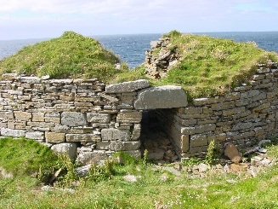 | English: Imagine that you are on a holiday to the Iron Age. Can you write a postcard home? | History: Can you create a timeline for the Iron Age? You can include the Bronze Age and Stone Age too if you like.
Computing: Head to BBC Bitesize. Find out 5 facts about the Iron Age. | Art: What did jewellery in the Iron Age look like? Can you design your own?  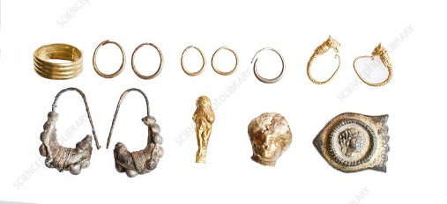 | DT: What did the Iron Age roundhouses look like? Have a go at creating your own. You can get creative with materials too. 