YEARS 5/6 DOJO HOMEWORK – AUTUMN HALF TERM 1
Homework activities for this term are outlined below.
You will receive ‘Dojo Points’ for each task completed and at the end of half term and they will be celebrated in class for everyone to see.
If you complete all of the tasks, you will receive a bonus 10 dojo points!
Everyone will receive a certificate for taking part.
All tasks need to be completed and returned by Wednesday 15TH October.
HOMEWORK TASKS WORTH 1 DOJO POINT | HOMEWORK TASKS WORTH 3 DOJO POINTS | HOMEWORK TASKS WORTH 5 DOJO POINTS
History: Why is New York called New York? Can you find out the History behind its name? | English: New York, New York. Why would you want to visit New York? Create an exciting leaflet all about New York and why we should take a trip. This could also be a video. |   Art: We have explored the work of Andy Warhol but there are so many other amazing American artists. Can you explore the work of a different artist and have a go at replicating their work?
Maths: Mrs Croft is in the USA. She is 6hours behind GMT (Our time). Where could she be? Can you work it out?  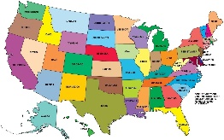 | Geography: Up for a challenge? Can you create a fact file all about a state in the US? It is your choice which state you choose! | DT: New York is known for its skyscrapers and memorable landscape. Can you have a go at building your own skyscraper. How you do it is up to you!  

