YEARS 1 / 2 DOJO HOMEWORK – AUTUMN HALF TERM 1
Homework activities for this term are outlined below.
You will receive ‘Dojo Points’ for each task completed and at the end of the half term; your homework will be celebrated in class for everyone to see.
If you complete all of the tasks, you will receive a homework celebration certificate and a bonus 10 dojo points!
All tasks need to be completed and returned by Wednesday 15th October.
HOMEWORK TASKS WORTH 1 DOJO POINT | HOMEWORK TASKS WORTH 3 DOJO POINTS | HOMEWORK TASKS WORTH 5 DOJO POINTS
Science: Go on a bug hunt. How many different bugs can you find? Where do they hide? You might try pond dipping?  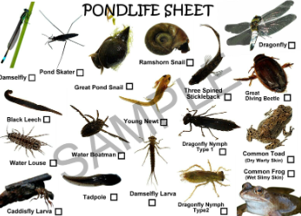 | Music: Can you make a percussion instrument? You could use rice, sticks, cans etc…  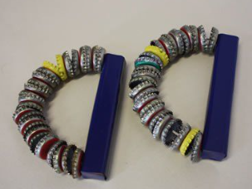 | English: Write a fact file on a penguin – what type will you choose?  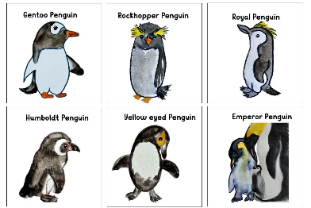
Art: We’ve been looking at the Art of Andy Goldsworthy. Can you collect some natural objects on a walk and make some artwork of your own.  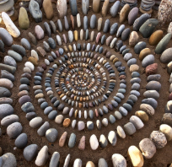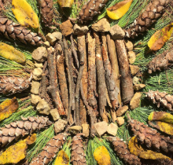 | Maths: Can you make a poster showing numbers up to 10. You might show the number, word, dots or draw some items.  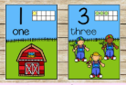 | Geography/Science: Draw a creature you might find at the North or South Pole – can you add some labels?  