Rural Church Schools Academy Trust
PE

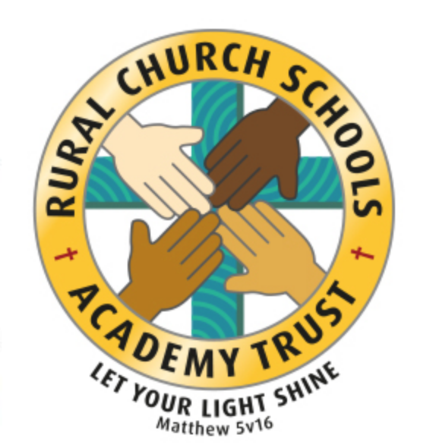

RCSAT Curriculum Overview

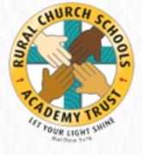
Curriculum Overview 2021

LET YOUR LIGHT SHINE Matthew v5:16

Article 29: Children’s education should develop each child’s personality, talents and abilities to the fullest. It should encourage children to respect others, human rights and their own and other cultures. It should also help them learn to live peacefully, protect the environment and respect other people.

Our Curriculum Policy details our intent behind our curriculum, how we implement it and our desired impact. At RCSAT, the school curriculum consists of all those activities designed or encouraged within its organisational framework to provide the intellectual, emotional, personal, social, spiritual and physical development of all its pupils. It includes not only the subject specific curriculum but also the ‘informal’ programme of enrichment and extra-curricular activities.
The curriculum at RCSAT, developed over a number of years, is firmly rooted in and stems directly from our Vision, Mission and Core Values;
Our Vision – ‘Let your Light shine’ Matthew v5:16
Our Mission – ‘A Caring Christian Family Where We Grow Together’
Our Core Values – WE aim to create an enjoyable, inclusive, safe and nurturing environment that allows all children to develop spiritually, morally and socially. – every child is a child of God, made to contribute to our world.
WE aim to create an inspiring environment, which encourages enthusiasm for lifelong learning and establishes an expectation of high standards – knowing the way, showing the way and going the way.
WE aim to encourage caring, sensitive and inclusive attitudes where individuals feel secure, valued and respected by others. – like Jesus showed us through his teachings

WE aim to provide a broad and connected curriculum which challenges and develops the potential of each child – as Jesus needed his disciples to support and guide, so we look to others with more knowledge

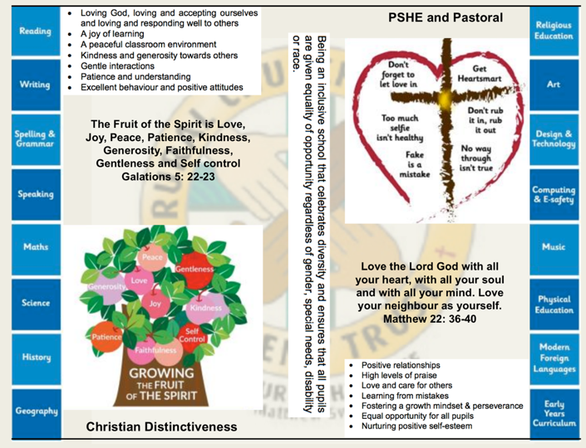
WE aim to develop a positive relationship between home, school and our wider community- as a family – as brothers and sisters.

The RCSAT curriculum is designed to
Embody - the Christian values we live by
Enable – all children to flourish in mind, body and spirit
Ensure – that all pupils are given the experiences to ‘Let their Light Shine.’

Intent:
The schools within RCSAT are strongly committed to helping our children grow and develop the skills required to be successful in life. Our curriculum is designed to promote every child’s individuality giving them the skills, knowledge and understanding to prepare them for the future. At RCSAT, our Connected Curriculum is planned around the development of Knowledge, Skills and Understanding. We ensure a curriculum that nurtures fascination and imagination and promotes an appreciation of creativity & individuality. One that also works in strong partnership with parents and carers to ensure high standards, engendering a strong sense of community, where all children and families are key to the delivery of a challenging, inspirational and innovative curriculum.
As a trust, we provide varied opportunities throughout their time with us, which promote independent, interactive and collaborative learning that builds on the children’s natural curiosity and eagerness to learn. We teach children to aspire to be the best possible version of themselves through our key drivers.
Our key drivers are:
- Inspirational and connected curriculum which instils a love of learning
- Curiosity and appreciation of God’s world through our Christian Values
- A culture of care for everyone in our community and in the world around us (RRSA, Global Learning, British Values)
- Aspiring to become the best person God created us to be – Let your light shine (Matthew 5:16)
Academic success comes through creativity and problem solving; responsibility and resilience, as well as physical development, well-being and mental health all being key elements in supporting the whole child through their learning journey.
Our curriculum also celebrates diversity and utilises the skills and knowledge of the community to enhance our curriculum while supporting the children’s emotional and spiritual development.
Implementation:
Our curriculum is driven by a desire to develop the whole child and therefore delivers much more than just the National Curriculum. Our connected curriculum provides opportunities for the children to learn about managing themselves, relationships and situations.
Our curriculum is not simply a set of encounters from which children form ad hoc memories; it is designed to be remembered in detail – to be stored in our children’s long-term memories so that they can later build on it, forming an ever wider and deeper pool of knowledge. Our curriculum is connected. It is planned vertically between year groups, horizontally within the academic year and diagonally to build on prior knowledge.
Autumn Term | Spring Term | Summer Term
History based enquiry | STEM based enquiry | Geography based enquiry

Our connected curriculum stems from a key question linked to a specific concept which then underpins the children’s learning. Knowledge around this concept is delivered through primary sources such as high-quality texts, music, art and technologies, enabling connections to be made across a range of National Curriculum subjects. Our teachers skillfully plan to ensure the children in their class experience a curriculum that inspires a love for learning.
Our curriculum is predominantly organised around rich and engaging, high-quality texts, making links and connecting to all curriculum areas where relevant. There is always an overarching text which connects the curriculum across the school. Beneath which sit key texts in each year group. Subject leads ensure progression and coverage of knowledge, skills and understanding are weaved into a meaningful and cohesive curriculum drawing in learning based on local, national and international events
Medium term plans outline the learning to take place for the term and are developed as mind maps using the phrases; As Artists, As Geographers, As Historians, As Writers, As Readers, As Mathematicians, As Musicians, As Programmers, As Designers, As Performers, As respectful, responsible citizens to frame ideas and concepts to be taught. The core basic skills of English and Maths are planned and delivered to reflect the National Curriculum 2014 changes and many elements of the new statutory orders are reflected in our practice.
We also feel that the following are necessary to support the implementation of our connected curriculum;
Learning Environment – We work hard to make sure that our learning environment supports the development of the whole child both inside, outside and beyond. Our classrooms are well organised and resourced allowing children to choose resources independently to support their learning.
Our outdoor areas have been developed to enhance our connected curriculum with developments such as: running paths, outdoor stage, mini woodland, outdoor reading provision, wilderness area and forest schools. This enables pupils to explore at break and lunch-times and gives teachers a range of resource to tap into to support teaching and learning at various points within the year.
Learning Partners – It is important that as a school we engage with external partner, locally, nationally and internationally to bring added dimensions to our curriculum offer. We partner with artists, musicians, coaches, poets, cultural organisations, engineers, other schools to bring expertise and difference to our curriculum offer. These may be short term projects over a few weeks or much longer endeavours. It is through these partnerships that we may light a spark of interest, enthusiasm and passion within our children that they may carry forward with them into their future lives and schooling.
New Pedagogies – As we continue to develop our curriculum, our approach to teaching and learning also develops. We take a blended learning approach where multiple disciplines will be touched upon within a lesson. It may be a ‘Science’ based lesson where problem solving, maths, literacy and art disciplines are enveloped within the taught session. Project based inquiry learning coupled with direct instruction ensure that our curriculum is relevant and provides children with opportunities to develop the skills of communication, collaboration, critical thinking, citizenship and creativity whilst also building their own character.
Impact:
Through our connected approach:
Our children will have the capacity to control and express their emotions, and handle interpersonal relationships whilst keeping themselves safe.
Our children will become confident and successful lifelong learners, demonstrating the Christian Values to ensuring they let their individual lights shine as they make the right choices about their learning.
Our curriculum has an ambition for high achievement of all pupils irrespective of their background or starting point.
Our curriculum promotes a love of learning.

The curriculum also includes those features which produce the school's ethos (i.e. the ‘hidden curriculum’) such as the quality of relationships and the values exemplified by the way the school sets about its task.
Our aim is to provide a curriculum which will firstly expand the pupil’s knowledge, experience and imaginative understanding, and thus his/her awareness of moral and Christian values and capacity for enjoyment, and secondly, enable the pupil to enter the world after formal education is over as an active participant in society and a responsible contributor to it, capable of achieving as much independence as possible.
There is an Act of Worship every day. Worship is a time where we come together to reflect on the school’s vision and to learn about the ‘person, love & work of Jesus’ which is central to the school’s vision and curriculum The daily Act of Worship promotes the Christian and Learning values which permeate the ethos of the school. As such, Worship is an essential part of the school day and the contributions of staff, pupils, clergy and other visitors are valued highly.

PE Curriculum: Educating for Wisdom, Knowledge and Skills

4

PE

The Vocabulary, Knowledge and Skills for PE are delivered through the following topics and Curriculum content is taught across the year as shown:

Year A

Year Group | Autumn 1 | Autumn 2 | Spring 1 | Spring 2 | Summer 1 | Summer 2
Year 1/ 2 | Fundamental Movement (Skills 1) | Locomotion 1 | Net & Wall Game Skills 1 | Gymnastics - Pathways - small & long | Dance (Units 1 or 2) | Strike and Field – Catch & Throw
Year 3/ 4 | Invasion Game Skills (Unit 1) | Hockey (Fundamentals) | Racket Sports – Tennis 1 | Gymnastics - Movement | Dance – Topic Theme 1 | Athletics (Unit 1)
Year 5/ 6 | Tag Rugby (Units 1&2) | Hockey – skills and drills | Basketball | Gymnastics - Apparatus | Dance – History 1 | Athletics (Unit 1)

Year B
Year Group | Autumn 1 | Autumn 2 | Spring 1 | Spring 2 | Summer 1 | Summer 2
Year 1/ 2 | Fundamental Movement (Skills 2) | Locomotion 2 | Net & Wall Game Skills 2 | Gymnastics - Pathways – | Dance (Units 3 or 4) | Strike and Field – Catch, Throw & position.
Year 3/ 4 | Invasion Game Skills (Unit 2) | Hockey (Play to learn) | Racket Sports – Tennis 2 | Gymnastics | Dance – Topic theme 2 | Athletics (Unit 2)
Year 5/ 6 | Tag Rugby (Units 2&3) | Hockey – play to compete | Netball | Gymnastics – Evaluating performance | Dance – History 2 | Athletics (Unit 2)

Why is Physical Education Important?
Physical education develops pupils’ physical competence and confidence, and their ability to use these to perform in a range of activities. It promotes physical skilfulness, physical development and a knowledge of the body in action. Physical education provides opportunities for pupils to be creative, competitive and to face up to different challenges as individuals and in groups and teams. It promotes positive attitudes towards active and healthy lifestyles. Pupils learn how to think in different ways to suit a wide variety of creative, competitive and challenging activities. They learn how to plan, perform and evaluate actions, ideas and performances to improve their quality and effectiveness. Through this process pupils discover their aptitudes, abilities and preferences, and make choices about how to get involved in lifelong physical activity.

RCSAT’s Vision for PE

On completion of the PE curriculum at RCSAT, pupils will have developed:

- The willingness to practise skills in a wide range of different activities and situations, alone, in small groups and in teams and to apply these skills in chosen activities to achieve good levels of performance.
- Good levels of physical fitness.
- A healthy lifestyle, achieved by eating sensibly, exercising regularly and making healthy lifestyle choices.
- The ability to remain physically active for sustained periods of time and an understanding of the importance of this in promoting long-term health and well- being.
- The ability to take the initiative and become young leaders.
- Developing levels of originality, imagination and creativity in their techniques, tactics and choreography, knowledge of how to improve their own and others’ performance and the ability to work independently for extended periods of time without the need of guidance or support.
- A keen interest in PE. A willingness to participate eagerly in every lesson, highly positive attitudes and the ability to make informed choices about engaging fully in extra-curricular sport.
- The ability to swim at least 25 metres before the end of Year 6 and knowledge of how to remain safe in and around water.

A Year 1 Sports Person at RCSAT

Games

  - I can throw underarm.
  - I can hit a ball with a bat.
  - I can move and stop safely.
  - I can throw and catch with both hands.
  - I can throw and kick in different ways.

Gymnastics

  - I can make my body curled, tense, stretched and relaxed.
  - I can control my body when travelling and balancing.
  - I can copy sequences and repeat them.
  - I can roll, curl, travel and balance in different ways.

Dance

  - I can move to music.
  - I can copy dance moves.
  - I can perform my own dance moves.
  - I can make up a short dance.
  - I can move safely in a space.

General

  - I can copy actions.
  - I can repeat actions and skills.
  - I can move with control and care.
  - I can use equipment safely.

A Year 2 Sports Person at RCSAT

Games

- I can use hitting, kicking and/or rolling in a game.
- I can decide the best space to be in during a game.
- I can use one tactic in a game.
- I can follow rules.

Gymnastics

- I can plan and perform a sequence of movements.
- I can improve my sequence based on feedback.
- I can think of more than one way to create a sequence which follows some ‘rules’.
- I can work on my own and with a partner.

Dance

- I can change rhythm, speed, level and direction in my dance.
- I can dance with control and coordination.
- I can make a sequence by linking sections together.
- I can use dance to show a mood or feeling.

General

- I can copy and remember actions.
- I can talk about what is different from what I did and what someone else did.

A Year 3 Sports Person at RCSAT

Games

- I can throw and catch with control.
- I am aware of space and use it to support team-mates and to cause problems for the opposition.
- I know and use rules fairly.

Gymnastics

- I can adapt sequences to suit different types of apparatus and criteria.
- I can explain how strength and suppleness affect performance.
- I can compare and contrast gymnastic sequences.

Dance

- I can improvise freely and translate ideas from a stimulus into movement.
- I can share and create phrases with a partner and small group.
- I can repeat, remember and perform phrases.

Athletics

- I can run at fast, medium and slow speeds; changing speed and direction.
- I can take part in a relay, remembering when to run and what to do.

Outdoor and adventurous

- I can follow a map in a familiar context.
- I can use clues to follow a route.
- I can follow a route safely.

A Year 4 Sports Person at RCSAT

Games

- I can catch with one hand.
- I can throw and catch accurately.
- I can hit a ball accurately with control.
- I can keep possession of the ball.
- I can vary tactics and adapt skills depending on what is happening in a game.

Gymnastics

- I can work in a controlled way.
- I can include change of speed and direction.
- I can include a range of shapes.
- I can work with a partner to create, repeat and improve a sequence with at least three phases.

Dance

- I can take the lead when working with a partner or group.
- I can use dance to communicate an idea.

Athletics

- I can run over a long distance.
- I can sprint over a short distance.
- I can throw in different ways.
- I can hit a target.
- I can jump in different ways.

Outdoor and adventurous

- I can follow a map in a (more demanding) familiar context.
- I can follow a route within a time limit.

A Year 5 Sports Person at RCSAT

Games

- I can gain possession by working a team.
- I can pass in different ways.
- I can use forehand and backhand with a racket.
- I can field.
- I can choose a tactic for defending and attacking.
- I can use a number of techniques to pass, dribble and shoot.

Gymnastics

- I can make complex extended sequences.
- I can combine action, balance and shape.
- I can perform consistently to different audiences.

Dance

- I can compose my own dances in a creative way.
- I can perform to an accompaniment.
- My dance shows clarity, fluency, accuracy and consistency.

Athletics

- I can show control when taking off and landing.
- I can throw with accuracy.
- I can combine running and jumping.

Outdoor and adventurous

- I can follow a map in an unknown location.
- I can use clues and a compass to navigate a route.
- I can change my route to overcome a problem.
- I can use new information to change my route.

A Year 6 Sports Person at RCSAT

Games

- I can play to agreed rules.
- I can explain rules.
- I can umpire.
- I can make a team and communicate plan.
- I can lead others in a game situation.

Gymnastics

- I can combine my own work with that of others.
- I can link sequences to specific timings.

Dance

- I can develop sequences in a specific style.
- I can choose my own music and style.

Athletics

- I can demonstrate stamina.

Outdoor and adventurous

- I can plan a route and a series of clues for someone else.

I can plan with others taking account of safety and danger

