Rural Church Schools Academy Trust
Computer User

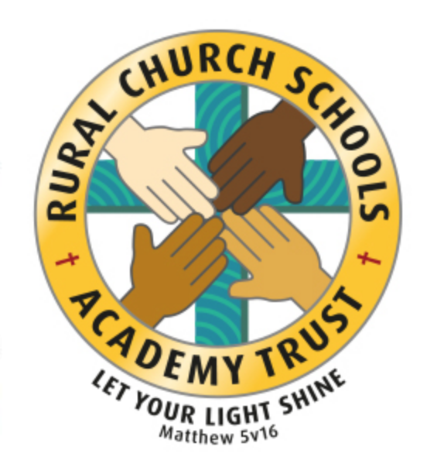

RCSAT Curriculum Overview

Curriculum Overview 2021

LET YOUR LIGHT SHINE Matthew v5:16

Article 29: Children’s education should develop each child’s personality, talents and abilities to the fullest. It should encourage children to respect others, human rights and their own and other cultures. It should also help them learn to live peacefully, protect the environment and respect other people.

Our Curriculum Policy details our intent behind our curriculum, how we implement it and our desired impact. At RCSAT, the school curriculum consists of all those activities designed or encouraged within its organisational framework to provide the intellectual, emotional, personal, social, spiritual and physical development of all its pupils. It includes not only the subject specific curriculum but also the ‘informal’ programme of enrichment and extra-curricular activities.
The curriculum at RCSAT, developed over a number of years, is firmly rooted in and stems directly from our Vision, Mission and Core Values;
Our Vision – ‘Let your Light shine’ Matthew v5:16
Our Mission – ‘A Caring Christian Family Where We Grow Together’
Our Core Values – WE aim to create an enjoyable, inclusive, safe and nurturing environment that allows all children to develop spiritually, morally and socially. – every child is a child of God, made to contribute to our world.
WE aim to create an inspiring environment, which encourages enthusiasm for lifelong learning and establishes an expectation of high standards – knowing the way, showing the way and going the way.
WE aim to encourage caring, sensitive and inclusive attitudes where individuals feel secure, valued and respected by others. – like Jesus showed us through his teachings

WE aim to provide a broad and connected curriculum which challenges and develops the potential of each child – as Jesus needed his disciples to support and guide, so we look to others with more knowledge

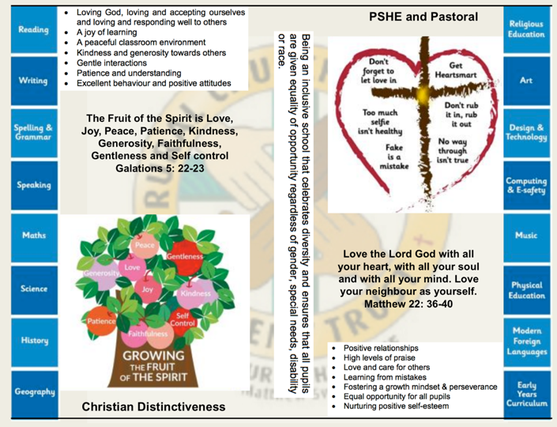
WE aim to develop a positive relationship between home, school and our wider community- as a family – as brothers and sisters.

The RCSAT curriculum is designed to
Embody - the Christian values we live by
Enable – all children to flourish in mind, body and spirit
Ensure – that all pupils are given the experiences to ‘Let their Light Shine.’

Intent:
The schools within RCSAT are strongly committed to helping our children grow and develop the skills required to be successful in life. Our curriculum is designed to promote every child’s individuality giving them the skills, knowledge and understanding to prepare them for the future. At RCSAT, our Connected Curriculum is planned around the development of Knowledge, Skills and Understanding. We ensure a curriculum that nurtures fascination and imagination and promotes an appreciation of creativity & individuality. One that also works in strong partnership with parents and carers to ensure high standards, engendering a strong sense of community, where all children and families are key to the delivery of a challenging, inspirational and innovative curriculum.
As a trust, we provide varied opportunities throughout their time with us, which promote independent, interactive and collaborative learning that builds on the children’s natural curiosity and eagerness to learn. We teach children to aspire to be the best possible version of themselves through our key drivers.
Our key drivers are:
- Inspirational and connected curriculum which instils a love of learning
- Curiosity and appreciation of God’s world through our Christian Values
- A culture of care for everyone in our community and in the world around us (RRSA, Global Learning, British Values)
- Aspiring to become the best person God created us to be – Let your light shine (Matthew 5:16)
Academic success comes through creativity and problem solving; responsibility and resilience, as well as physical development, well-being and mental health all being key elements in supporting the whole child through their learning journey.
Our curriculum also celebrates diversity and utilises the skills and knowledge of the community to enhance our curriculum while supporting the children’s emotional and spiritual development.
Implementation:
Our curriculum is driven by a desire to develop the whole child and therefore delivers much more than just the National Curriculum. Our connected curriculum provides opportunities for the children to learn about managing themselves, relationships and situations.
Our curriculum is not simply a set of encounters from which children form ad hoc memories; it is designed to be remembered in detail – to be stored in our children’s long-term memories so that they can later build on it, forming an ever wider and deeper pool of knowledge. Our curriculum is connected. It is planned vertically between year groups, horizontally within the academic year and diagonally to build on prior knowledge.
Autumn Term | Spring Term | Summer Term
History based enquiry | STEM based enquiry | Geography based enquiry

Our connected curriculum stems from a key question linked to a specific concept which then underpins the children’s learning. Knowledge around this concept is delivered through primary sources such as high-quality texts, music, art and technologies, enabling connections to be made across a range of National Curriculum subjects. Our teachers skillfully plan to ensure the children in their class experience a curriculum that inspires a love for learning.
Our curriculum is predominantly organised around rich and engaging, high-quality texts, making links and connecting to all curriculum areas where relevant. There is always an overarching text which connects the curriculum across the school. Beneath which sit key texts in each year group. Subject leads ensure progression and coverage of knowledge, skills and understanding are weaved into a meaningful and cohesive curriculum drawing in learning based on local, national and international events
Medium term plans outline the learning to take place for the term and are developed as mind maps using the phrases; As Artists, As Geographers, As Historians, As Writers, As Readers, As Mathematicians, As Musicians, As Programmers, As Designers, As Performers, As respectful, responsible citizens to frame ideas and concepts to be taught. The core basic skills of English and Maths are planned and delivered to reflect the National Curriculum 2014 changes and many elements of the new statutory orders are reflected in our practice.
We also feel that the following are necessary to support the implementation of our connected curriculum;
Learning Environment – We work hard to make sure that our learning environment supports the development of the whole child both inside, outside and beyond. Our classrooms are well organised and resourced allowing children to choose resources independently to support their learning.
Our outdoor areas have been developed to enhance our connected curriculum with developments such as: running paths, outdoor stage, mini woodland, outdoor reading provision, wilderness area and forest schools. This enables pupils to explore at break and lunch-times and gives teachers a range of resource to tap into to support teaching and learning at various points within the year.
Learning Partners – It is important that as a school we engage with external partner, locally, nationally and internationally to bring added dimensions to our curriculum offer. We partner with artists, musicians, coaches, poets, cultural organisations, engineers, other schools to bring expertise and difference to our curriculum offer. These may be short term projects over a few weeks or much longer endeavours. It is through these partnerships that we may light a spark of interest, enthusiasm and passion within our children that they may carry forward with them into their future lives and schooling.
New Pedagogies – As we continue to develop our curriculum, our approach to teaching and learning also develops. We take a blended learning approach where multiple disciplines will be touched upon within a lesson. It may be a ‘Science’ based lesson where problem solving, maths, literacy and art disciplines are enveloped within the taught session. Project based inquiry learning coupled with direct instruction ensure that our curriculum is relevant and provides children with opportunities to develop the skills of communication, collaboration, critical thinking, citizenship and creativity whilst also building their own character.
Impact:
Through our connected approach:
Our children will have the capacity to control and express their emotions, and handle interpersonal relationships whilst keeping themselves safe.
Our children will become confident and successful lifelong learners, demonstrating the Christian Values to ensuring they let their individual lights shine as they make the right choices about their learning.
Our curriculum has an ambition for high achievement of all pupils irrespective of their background or starting point.
Our curriculum promotes a love of learning.

The curriculum also includes those features which produce the school's ethos (i.e. the ‘hidden curriculum’) such as the quality of relationships and the values exemplified by the way the school sets about its task.
Our aim is to provide a curriculum which will firstly expand the pupil’s knowledge, experience and imaginative understanding, and thus his/her awareness of moral and Christian values and capacity for enjoyment, and secondly, enable the pupil to enter the world after formal education is over as an active participant in society and a responsible contributor to it, capable of achieving as much independence as possible.
There is an Act of Worship every day. Worship is a time where we come together to reflect on the school’s vision and to learn about the ‘person, love & work of Jesus’ which is central to the school’s vision and curriculum The daily Act of Worship promotes the Christian and Learning values which permeate the ethos of the school. As such, Worship is an essential part of the school day and the contributions of staff, pupils, clergy and other visitors are valued highly.

Computer User Curriculum: Educating for Wisdom, Knowledge and Skills

4

Computing

The Vocabulary, Knowledge and Skills for IT are delivered through the following topics and Curriculum content is taught across the year as shown:

Year A

Year Group | Autumn 1 | Autumn 2 | Spring 1 | Spring 2 | Summer 1 | Summer 2
Year 1/ 2 | Online safety  Exploring Purple Mash  Grouping and sorting  Pictograms |  | Lego builders  Maze explorers  Animated storybooks |  | Coding  Spreadsheets  Technology outside school
Year 3/ 4 | Coding  Online safety  spreadsheets |  | Touch typing  Email  Branching databases |  | Simulations  Graphing
Year 5/ 6 | Coding  Online safety  Spreadsheets |  | Databases  Game creator |  | 3D modelling  Concept maps
Year B

Year Group | Autumn 1 | Autumn 2 | Spring 1 | Spring 2 | Summer 1 | Summer 2
Year 1/ 2 | Coding  Online safety  Spreadsheets |  | Questioning  Effective searching  Creating pictures |  | Making music  Presenting ideas
Year 3/ 4 | Coding  Online safety  Spreadsheets |  | Writing for different audiences  Logo  Animation |  | Effective search  Hardware investigators
Year 5/ 6 | Coding  Online safety  Spreadsheets |  | Blogging  Text adventures |  | Networks  Quizzing

Why is Computing Important?
Computing prepares pupils to participate in a rapidly changing world in which work and other activities are increasingly transformed by access to varied and developing technology. Pupils use computers to find, explore, analyse, exchange and present information responsibly, creatively and with discrimination. They learn how to employ computers to enable rapid access to ideas and experiences from a wide range of people, communities and cultures. Increased capability in the use of computers promotes initiative and independent learning, with pupils being able to make informed judgements about when and where to use computers to best effect, and to consider its implications for home and work both now and in the future.

RCSAT’s Vision for Computing

On completion of the Computing curriculum at RCSAT, pupils will have:
- Used a range of applications and devices with increasing confidence.
- Developed practical skills in the use of information technology and the ability to use them to communicate ideas throughout the curriculum.
- Considered the capabilities and limitations of information technology and the implications and consequences of its use.
- Practical experience of coding and programming.
- Experience of collecting, organising and manipulating data.
- Understood how to connect with others safely and respectfully and the need to act within the law and with integrity.

National Curriculum for Computing

The National Curriculum for Computing at Key Stages 1 and 2 can be downloaded from the ‘Curriculum’ tab of the school website.

Key stage 1

Pupils should be taught to:
- understand what algorithms are; how they are implemented as programs on digital devices; and that programs execute by following precise and unambiguous instructions
- create and debug simple programs
- use logical reasoning to predict the behaviour of simple programs

- use technology purposefully to create, organise, store, manipulate and retrieve digital content
- recognise common uses of information technology beyond school
- use technology safely and respectfully, keeping personal information private; identify where to go for help and support when they have concerns about content or contact on the internet or other online technologies.

Key stage 2

Pupils should be taught to:
- design, write and debug programs that accomplish specific goals, including controlling or simulating physical systems; solve problems by decomposing them into smaller parts
- use sequence, selection, and repetition in programs; work with variables and various forms of input and output
- use logical reasoning to explain how some simple algorithms work and to detect and correct errors in algorithms and programs
- understand computer networks including the internet; how they can provide multiple services, such as the world wide web; and the opportunities they offer for communication and collaboration
- use search technologies effectively, appreciate how results are selected and ranked, and be discerning in evaluating digital content
- select, use and combine a variety of software (including internet services) on a range of digital devices to design and create a range of programs, systems and content that accomplish given goals, including collecting, analysing, evaluating and presenting data and information
- use technology safely, respectfully and responsibly; recognise acceptable/unacceptable behaviour; identify a range of ways to report concerns about content and contact.

A Year 1 Computer User at RCSAT

  - I can create a series of instructions.
  - I can plan a journey for a programmable toy.

  - I can create digital images.
  - I can open digital content.
  - I can save digital content.
  - I can use a website.
  - I can use an IPad or tablet
  - I can record sounds and play back (for example, recording stories, weather reports)

  - I can use technology safely.
  - I know that passwords help to keep my information private

A Year 2 Computer User at RCSAT

- I can use a range of instructions (e.g. direction, angles, turns).
- I can test and amend a set of instructions.
- I can find errors and amend. (debug)
- I can write a simple program and test it.
- I can predict what the outcome of a simple program will be (logical reasoning).
- I understand that algorithms are used on digital devices.
- I understand that programs require precise instructions.
- I can organise digital content.
- I can retrieve and manipulate digital content.
- I can navigate the web to complete simple searches.
- Digital literacy
- I use technology respectfully.
- I know where to go for help if I am concerned.

- I know how technology is used in school and outside of school.

A Year 1 & 2 Safe Computer User at RCSAT

  - I understand the different methods of communication (e.g. email, online forums etc).
  - I know you should only open email from a known source.
  - I know the difference between email and communication systems such as blogs and wikis.
  - I know that websites sometimes include pop-ups that take me away from the main site.
  - I know that bookmarking is a way to find safe sites again quickly.
  - I have begun to evaluate websites and know that everything on the internet is not true.
  - I know that it is not always possible to copy some text and pictures from the internet.
  - I know that personal information should not be shared online.
  - I know I must tell a trusted adult immediately if anyone tries to meet me via the internet.

  - I follow the school’s safer internet rules.
  - I can use the search engines agreed by the school.
  - I know what to do if I find something inappropriate online or something I am unsure of (including identifying people who can help; minimising screen; online reporting using school system etc).
  - I can use the internet for learning and communicating with others, making choices when navigating through sites.
  - I can send and receive email as a class.
  - I can recognise advertising on websites and learn to ignore it.
  - I can use a password to access the secure network.

A Year 3 Computer User at RCSAT

- I can design a sequence of instructions, including directional instructions.
- I can write programs that accomplish specific goals.
- I can work with various forms of input.
- I can work with various forms of output.
- I can use a range of software for similar purposes.
- I can collect information.
- I can design and create content.
- I can present information.
- I can search for information on the web in different ways.
- I can manipulate and improve digital images.
- I use technology respectfully and responsibly.
- I know different ways I can get help if I am concerned.
- I understand what computer networks do and how they provide multiple services.
- I can discern where it is best to use technology and where it adds little or no value.

A Year 4 Computer User at RCSAT

- I can experiment with variables to control models.
- I can give an on-screen robot specific instructions that takes them from A to B.
- I can make an accurate prediction and explain why I believe something will happen (linked to programming).
- I can de-bug a program

- I can select and use software to accomplish given goals.
- I can collect and present data.
- I can produce and upload a pod cast.
- I recognise acceptable and unacceptable behaviour using technology.

A Year 3 & 4 Safe Computer User at RCSAT

- I understand the need for rules to keep me safe when exchanging learning and ideas online.
- I recognise that information on the internet may not be accurate or reliable and may be used for bias, manipulation or persuasion.
- I understand that the internet contains fact, fiction and opinion and begin to distinguish between them.
- I use strategies to verify information, e.g. cross-checking.
- I understand the need for caution when using an internet search for images and what to do if I find an unsuitable image.
- I understand that copyright exists on most digital images, video and recorded music.
- I understand the need to keep personal information and passwords private.
- I understand that if I make personal information available online it may be seen and used by others.
- I know how to respond if asked for personal information or feel unsafe about content of a message.
- I recognise that cyber bullying is unacceptable and will be sanctioned in line with the school’s policy.
- I know how to report an incident of cyber bullying.
- I know the difference between online communication tools used in school and those used at home.
- I understand the need to develop an alias for some public online use.
- I understand that the outcome of internet searches at home may be different than at school.

- I follow the school’s safer internet rules.
- I recognise the difference between the work of others which has been copied (plagiarism) and re-structuring and re-presenting materials in ways which are unique and new.
- I can identify when emails should not be opened and when an attachment may not be safe.
- I can explain and demonstrate how to use email safely.

A Year 5 Computer User at RCSAT

- I can combine sequences of instructions and procedures to turn devices on and off.
- I can use technology to control an external device.
- I can design algorithms that use repetition & 2-way selection.
- I can analyse information.
- I can evaluate information.
- I understand how search results are selected and ranked.
- I can edit a film.
- I understand that you have to make choices when using technology and that not everything is true and/or safe.

A Year 6 Computer User at RCSAT

- I can design a solution by breaking a problem up.
- I recognise that different solutions can exist for the same problem.
- I can use logical reasoning to detect errors in algorithms.
- I can use selection in programs.
- I can work with variables.
- I can explain how an algorithm works.
- I can explore ‘what if’ questions by planning different scenarios for controlled devices.
- I can select, use and combine software on a range of digital devices.
- I can use a range of technology for a specific project.
- I can discuss the risks of online use of technology.
- I can identify how to minimise risks.

A Year 5 & 6 Safe Computer User at RCSAT

- I can discuss the positive and negative impact of the use of ICT in my own life, my friends and family.
- I understand the potential risk of providing personal information online.
- I recognise why people may publish content that is not accurate and understand the need to be critical evaluators of content.
- I understand that some websites and/or pop-ups have commercial interests that may affect the way the information is presented.
- I recognise the potential risks of using internet communication tools and understand how to minimise those risks (including scams and phishing).
- I understand that some material on the internet is copyrighted and may not be copied or downloaded.

- I understand that some messages may be malicious and know how to deal with this.
- I understand that online environments have security settings, which can be altered, to protect the user.
- I understand the benefits of developing a ‘nickname’ for online use.
- I understand that some malicious adults may use various techniques to make contact and elicit personal information.
- I know that it is unsafe to arrange to meet unknown people online.
- I know how to report any suspicions.
- I understand I should not publish other people’s pictures or tag them on the internet without permission.
- I know that content put online is extremely difficult to remove.
- I know what to do if I discover something malicious or inappropriate.

- I follow the school’s safer internet rules.
- I can make safe choices about the use of technology.
- I can use technology in ways which minimises risk. e.g. responsible use of online discussions, etc.
- I can create strong passwords and manage them so that they remain strong.
- I can independently, and with regard for e-safety, select and use appropriate communication tools to solve problems by collaborating and communicating with others within and beyond school.
- I can competently use the internet as a search tool.
- I can reference information sources.
- I can use appropriate strategies for finding, critically evaluating, validating and verifying information. e.g. using different keywords, skim reading to check relevance of information, cross checking with different websites or other non ICT resources.
- I can use knowledge of the meaning of different domain names and common website extensions (e.g. .co.uk; .com; .ac; .sch; .org; .gov; .net) to support validation of information.

