Rural Church Schools Academy Trust
Music

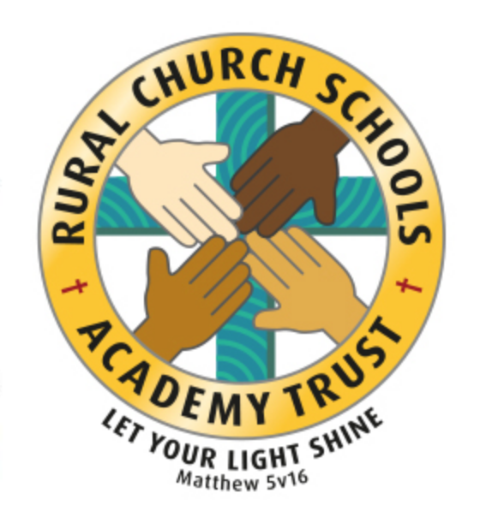

RCSAT Curriculum Overview

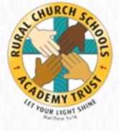
Curriculum Overview 2021

LET YOUR LIGHT SHINE Matthew v5:16

Article 29: Children’s education should develop each child’s personality, talents and abilities to the fullest. It should encourage children to respect others, human rights and their own and other cultures. It should also help them learn to live peacefully, protect the environment and respect other people.

Our Curriculum Policy details our intent behind our curriculum, how we implement it and our desired impact. At RCSAT, the school curriculum consists of all those activities designed or encouraged within its organisational framework to provide the intellectual, emotional, personal, social, spiritual and physical development of all its pupils. It includes not only the subject specific curriculum but also the ‘informal’ programme of enrichment and extra-curricular activities.
The curriculum at RCSAT, developed over a number of years, is firmly rooted in and stems directly from our Vision, Mission and Core Values;
Our Vision – ‘Let your Light shine’ Matthew v5:16
Our Mission – ‘A Caring Christian Family Where We Grow Together’
Our Core Values – WE aim to create an enjoyable, inclusive, safe and nurturing environment that allows all children to develop spiritually, morally and socially. – every child is a child of God, made to contribute to our world.
WE aim to create an inspiring environment, which encourages enthusiasm for lifelong learning and establishes an expectation of high standards – knowing the way, showing the way and going the way.
WE aim to encourage caring, sensitive and inclusive attitudes where individuals feel secure, valued and respected by others. – like Jesus showed us through his teachings

WE aim to provide a broad and connected curriculum which challenges and develops the potential of each child – as Jesus needed his disciples to support and guide, so we look to others with more knowledge

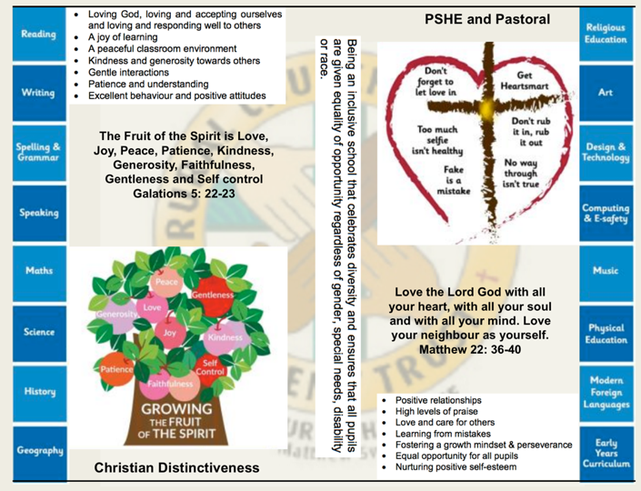
WE aim to develop a positive relationship between home, school and our wider community- as a family – as brothers and sisters.

The RCSAT curriculum is designed to
Embody - the Christian values we live by
Enable – all children to flourish in mind, body and spirit
Ensure – that all pupils are given the experiences to ‘Let their Light Shine.’

Intent:
The schools within RCSAT are strongly committed to helping our children grow and develop the skills required to be successful in life. Our curriculum is designed to promote every child’s individuality giving them the skills, knowledge and understanding to prepare them for the future. At RCSAT, our Connected Curriculum is planned around the development of Knowledge, Skills and Understanding. We ensure a curriculum that nurtures fascination and imagination and promotes an appreciation of creativity & individuality. One that also works in strong partnership with parents and carers to ensure high standards, engendering a strong sense of community, where all children and families are key to the delivery of a challenging, inspirational and innovative curriculum.
As a trust, we provide varied opportunities throughout their time with us, which promote independent, interactive and collaborative learning that builds on the children’s natural curiosity and eagerness to learn. We teach children to aspire to be the best possible version of themselves through our key drivers.
Our key drivers are:
- Inspirational and connected curriculum which instils a love of learning
- Curiosity and appreciation of God’s world through our Christian Values
- A culture of care for everyone in our community and in the world around us (RRSA, Global Learning, British Values)
- Aspiring to become the best person God created us to be – Let your light shine (Matthew 5:16)
Academic success comes through creativity and problem solving; responsibility and resilience, as well as physical development, well-being and mental health all being key elements in supporting the whole child through their learning journey.
Our curriculum also celebrates diversity and utilises the skills and knowledge of the community to enhance our curriculum while supporting the children’s emotional and spiritual development.
Implementation:
Our curriculum is driven by a desire to develop the whole child and therefore delivers much more than just the National Curriculum. Our connected curriculum provides opportunities for the children to learn about managing themselves, relationships and situations.
Our curriculum is not simply a set of encounters from which children form ad hoc memories; it is designed to be remembered in detail – to be stored in our children’s long-term memories so that they can later build on it, forming an ever wider and deeper pool of knowledge. Our curriculum is connected. It is planned vertically between year groups, horizontally within the academic year and diagonally to build on prior knowledge.
Autumn Term | Spring Term | Summer Term
History based enquiry | STEM based enquiry | Geography based enquiry

Our connected curriculum stems from a key question linked to a specific concept which then underpins the children’s learning. Knowledge around this concept is delivered through primary sources such as high-quality texts, music, art and technologies, enabling connections to be made across a range of National Curriculum subjects. Our teachers skillfully plan to ensure the children in their class experience a curriculum that inspires a love for learning.
Our curriculum is predominantly organised around rich and engaging, high-quality texts, making links and connecting to all curriculum areas where relevant. There is always an overarching text which connects the curriculum across the school. Beneath which sit key texts in each year group. Subject leads ensure progression and coverage of knowledge, skills and understanding are weaved into a meaningful and cohesive curriculum drawing in learning based on local, national and international events
Medium term plans outline the learning to take place for the term and are developed as mind maps using the phrases; As Artists, As Geographers, As Historians, As Writers, As Readers, As Mathematicians, As Musicians, As Programmers, As Designers, As Performers, As respectful, responsible citizens to frame ideas and concepts to be taught. The core basic skills of English and Maths are planned and delivered to reflect the National Curriculum 2014 changes and many elements of the new statutory orders are reflected in our practice.
We also feel that the following are necessary to support the implementation of our connected curriculum;
Learning Environment – We work hard to make sure that our learning environment supports the development of the whole child both inside, outside and beyond. Our classrooms are well organised and resourced allowing children to choose resources independently to support their learning.
Our outdoor areas have been developed to enhance our connected curriculum with developments such as: running paths, outdoor stage, mini woodland, outdoor reading provision, wilderness area and forest schools. This enables pupils to explore at break and lunch-times and gives teachers a range of resource to tap into to support teaching and learning at various points within the year.
Learning Partners – It is important that as a school we engage with external partner, locally, nationally and internationally to bring added dimensions to our curriculum offer. We partner with artists, musicians, coaches, poets, cultural organisations, engineers, other schools to bring expertise and difference to our curriculum offer. These may be short term projects over a few weeks or much longer endeavours. It is through these partnerships that we may light a spark of interest, enthusiasm and passion within our children that they may carry forward with them into their future lives and schooling.
New Pedagogies – As we continue to develop our curriculum, our approach to teaching and learning also develops. We take a blended learning approach where multiple disciplines will be touched upon within a lesson. It may be a ‘Science’ based lesson where problem solving, maths, literacy and art disciplines are enveloped within the taught session. Project based inquiry learning coupled with direct instruction ensure that our curriculum is relevant and provides children with opportunities to develop the skills of communication, collaboration, critical thinking, citizenship and creativity whilst also building their own character.
Impact:
Through our connected approach:
Our children will have the capacity to control and express their emotions, and handle interpersonal relationships whilst keeping themselves safe.
Our children will become confident and successful lifelong learners, demonstrating the Christian Values to ensuring they let their individual lights shine as they make the right choices about their learning.
Our curriculum has an ambition for high achievement of all pupils irrespective of their background or starting point.
Our curriculum promotes a love of learning.

The curriculum also includes those features which produce the school's ethos (i.e. the ‘hidden curriculum’) such as the quality of relationships and the values exemplified by the way the school sets about its task.
Our aim is to provide a curriculum which will firstly expand the pupil’s knowledge, experience and imaginative understanding, and thus his/her awareness of moral and Christian values and capacity for enjoyment, and secondly, enable the pupil to enter the world after formal education is over as an active participant in society and a responsible contributor to it, capable of achieving as much independence as possible.
There is an Act of Worship every day. Worship is a time where we come together to reflect on the school’s vision and to learn about the ‘person, love & work of Jesus’ which is central to the school’s vision and curriculum The daily Act of Worship promotes the Christian and Learning values which permeate the ethos of the school. As such, Worship is an essential part of the school day and the contributions of staff, pupils, clergy and other visitors are valued highly.

4

Music

The Vocabulary, Knowledge and Skills for Music are delivered through the following topics and Curriculum content is taught across the year as shown:

Year Group | Autumn 1 | Autumn 2 | Spring 1 | Spring 2 | Summer 1 | Summer 2
Year  1/ 2 | Unit 1 Ourselves  Unit 2 Number | Unit 3 Animals  Unit 4 weather  . | Unit 5 Machines  Unit 6 Seasons | Unit 7 Our school  Unit 8 Pattern | Unit 9 Story time  Unit 10 Our bodies | Unit 11 Travel  Unit 12 Water
Year  3/ 4 | Unit 1 Environment  Unit 2 Building | Unit 3 Sounds  Unit 4 Poetry | Unit 5 China  Unit 6 Time | Unit 7 In the past  Unit 8 Communication | Unit 9 Human body  Unit 10 French | Unit 11 Ancient worlds  Unit 12 Food and drink
Year  5/ 6 | Unit 1 Our community  Love music trust- brass | Unit 2 Solar system  Love music trust- brass | Unit 3 Life cycles  Love music trust- brass | Unit 4 Keeping healthy  Love music trust- brass | Unit 5 At the movies  Love music trust- brass | Unit 6 Celebration  Love music trust- brass
Year A

Year B
Year Group | Autumn 1 | Autumn 2 | Spring 1 | Spring 2 | Summer 1 | Summer 2
Year  1/ 2 | Unit 1 Ourselves  Unit 2 Toys | Unit 3 Our land  Unit 4 Our bodies | Unit 5 Animals  Unit 6 Number | Unit 7 Story time  Unit 8 seasons | Unit 9 Weather  Unit 10 Pattern | Unit 11 Water  Unit 12 Travel
Year  3/ 4 | Unit 1 Poetry  Unit 2 Environment | Unit 3 Sounds  Unit 4 Recycling | Unit 5 Building  Unit 6 Around the world  . | Unit 7 Ancient worlds  Unit 8 Singing Spanish | Unit 9 Communication  Unit 10 Time | Unit 11 In the past  Unit 12 Food and drink
Year  5/ 6 | Unit 1 World Unite  Love music trust- brass | Unite 2 Journeys  Love music trust- brass | Unit 3 Growth  Love music trust- brass | Unit 4 Roots  Love music trust- brass | Unit 5 Class awards  Love music trust- brass | Unit 6 Moving on  Love music trust- brass

Please follow this link for the Music Express Skills Progression Document.

Please follow this link for the Skills by year group document

Why is Music Important?
Music is a powerful, unique form of communication that can change the way pupils feel, think and act. It brings together intellect and feeling and enables personal expression, reflection and emotional development. As an integral part of culture, past and present, it helps pupils understand themselves and relate to others, forging important links between the home, school and the wider world. The teaching of music develops pupils’ ability to listen and appreciate a wide variety of music and to make judgements about musical quality. It encourages active involvement in different forms of amateur music making, both individual and communal, developing a sense of group identity and togetherness. It also increases self-discipline and creativity, aesthetic sensitivity and fulfilment.

RCSAT’s Vision for Music

On completion of the Music curriculum at RCSAT, pupils will have:
- Explored and created new ideas in music and performed with confidence.
- Played a musical instrument and sang with control and expression.
- Good awareness and appreciation of different musical styles and genres.
- Listened thoughtfully and used musical vocabulary to articulate their responses to music.
- Developed an understanding of the elements of music.
- A knowledge of composers and musicians from different points in history.
- Accessed further music opportunities outside of the classroom.
- An enjoyment of music.

A Year 1 Musician at RCSAT

- I can use my voice to sing songs and chant rhymes.
- I can play tuned and untuned instruments musically.
- I can create short rhythmic patterns.
- I can combine sounds with my voice and with instruments.
- I can copy short rhythmic and melodic patterns.
- I can make a sequence of sounds.
- I can respond to different moods in music.
- I can say whether I like or dislike a piece of music.
- I can choose sounds to represent different things.
- I can follow instructions about when to play and sing.
- I can move to the pulse.

A Year 2 Musician at RCSAT

- I can sing and follow a melody.
- I can perform simple patterns and accompaniments keeping a steady pulse.
- I can compose simple rhythmic patterns.
- I can recognise changes in tempo.
- I can order sounds to create a beginning, middle and an end.
- I can create music in response to different starting points.

  - I can choose sounds which create an effect.
  - I can use symbols to represent sounds.
  - I can make connections between notations and musical sounds.
  - I can listen out for particular things when listening to music.
  - I can improve my own work.

A Year 3 Musician at RCSAT

- I can sing a tune with expression.
- I can use different elements in my composition.
- I can use musical words to describe a piece of music and compositions.
- I can use musical words to describe what I like and do not like about a piece of music.
- I can recognise different styles of music.
- I can improve my work; explaining how it has been improved.

A Year 4 Musician at RCSAT

- I can create chord sequences on my ukulele.
- I can compose melodies.
- I can create accompaniments for tunes using different chords.
- I can combine different sounds to create a specific mood or feeling.
- I can sing songs from memory with accurate pitching.
- I can improvise using repeated strumming patterns.
- I can use notation to record my compositions.
- I can play simple notated tunes.
- I can explain why silence is often needed in music and explain what effect it has.
- I can identify the character of a piece of music.
- I can identify and describe the different purposes of music.
- I can begin to identify various styles of music, e.g. pop, classical, jazz, Chinese.
- I can perform solos and in ensembles.
- I can understand the history of the ukulele.

A Year 5 Musician at RCSAT

- I can breathe in the correct place when singing.
- I can maintain my part whilst others are performing their part.

- I can improvise within a group using melodic and rhythmic phrases.
- I can change sounds or organise them differently to change the effect.
- I can compose music which meets specific criteria.
- I can use my music diary to record aspects of the composition process.
- I can choose the most appropriate tempo for a piece of music.
- I can describe, compare and evaluate music using musical vocabulary.
- I can explain why I think music is successful or unsuccessful.
- I can suggest improvement to my own work and that of others.

A Year 6 Musician at RCSAT

- I can sing in harmony with increasing confidence.
- I can perform parts from memory.
- I can take the lead in a performance.
- I can evaluate how the venue, occasion and purpose affects the way a piece of music is created.
- I can analyse features within different

