**Multiplication**

Introduction

When we multiply we are adding together equal groups.

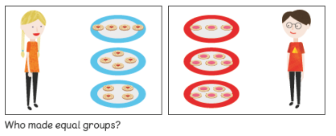

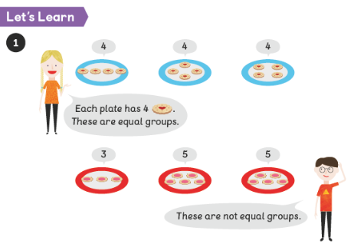

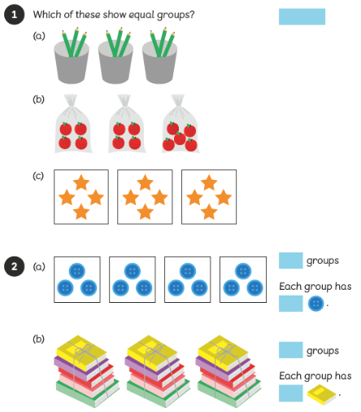



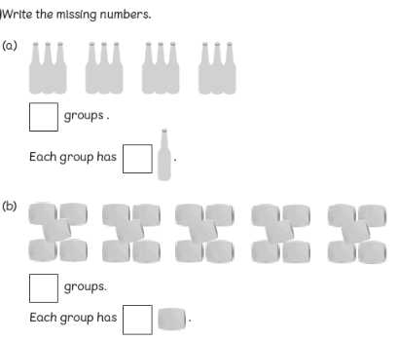

**Adding equal groups**

5 + 5 + 5 + 5

Count 4 fives

5, 10, 15, 20

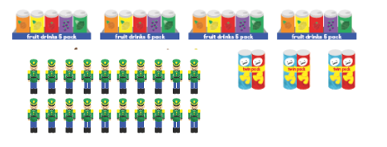

10 + 10

Count 2 tens

10, 20

2 + 2 + 2

Count 3 twos

2, 4, 6

**Can you count how many objects there are all together by counting in 2s?**

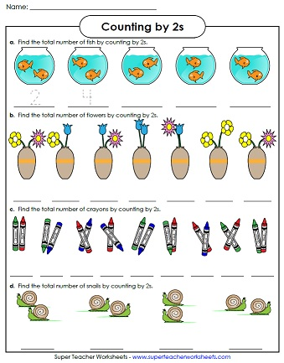

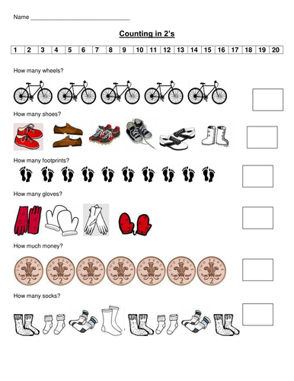

2 + 2 + 2 + 2 =

2 + 2 + 2 + 2 + 2 + 2 =

**Can you count how many there are altogether by counting in 10s?**

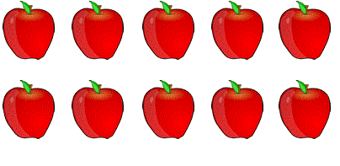



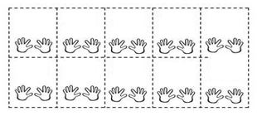

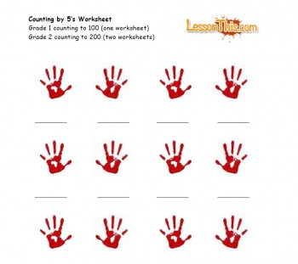Can you count how many there altogether by counting in 5s?

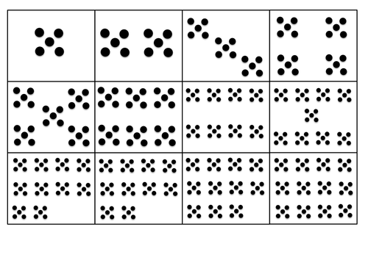

5 10 15 20 25 30 35 40